Attachment 2-1 Model Assumptions

# Introduction

The following model simulations were prepared to evaluate the impacts of different project:

* Existing
* Proposed Project
* Refined Alternative 2b

Sections 2 and 3 describe the assumptions used for each model simulation. Section 4 lists references cited.

The assumptions for all model simulations are also summarized in table format in the following attachments:

* Appendix H Attachment 1-2 CalSim II Model Assumptions Callouts
* Appendix H Attachment 1-3 DSM2 Model Assumptions Callouts
* Appendix H Attachment 1-4 Scenario Related Changes to CalSim II and DSM2
* Appendix H Attachment 1-5 SWP Contribution
* Appendix H Attachment 1-6 DSM2 – PTM
* Appendix H Attachment 1-7 Model Limitations
* Appendix H Attachment 1-8 CalSim II Assumptions and Real Time Operations
* Appendix H Attachment 2-2 CalSim II Model Assumptions Callouts
* Appendix H Attachment 2-3 DSM2 Model Assumptions Callouts

Any use of results of model simulations should observe limitations of the models used as well as the limitations to the modeled alternatives. These results should only be used for comparative purposes. More information regarding limitations of the models used is included Appendix H Attachment 1-7 Model Limitations.

# Assumptions for the Existing Conditions

This section presents the assumptions used in developing the CalSim II and DSM2 model simulations of the Existing Conditions considered for the EIR.

The Existing Conditions represents SWP operations to comply with the “current” regulatory environment (2019). The Existing Conditions assumptions include existing facilities and ongoing programs that existed as of April 22, 2019- publication date of the Notice of Preparation (NOP).

The Existing Conditions assumptions also include facilities and programs that received approvals and permits by April, 2019 because those programs were consistent with existing management direction as of the NOP.

## CalSim II Assumptions for the Existing Conditions

The following is a description of the assumptions tabulated in Appendix H Attachment 1-2 CalSim II Model Assumptions Callouts.

### Hydrology

#### Inflows/Supplies

The CalSim II model includes the historical hydrology.

#### Level of Development

CalSim II uses a hydrology which is the result of an analysis of agricultural and urban land use and population estimates. The assumptions used for Sacramento Valley land use result from aggregation of historical survey and projected data developed for the California Water Plan Update (Bulletin 160-98). Generally, land use projections are based on Year 2020 estimates (hydrology serial number 2020D09E), however the San Joaquin Valley hydrology reflects draft 2030 land use assumptions developed by Reclamation. Where appropriate Year 2020 projections of demands associated with water rights and CVP and SWP water service contracts have been included. Specifically, projections of full build out are used to describe the American River region demands for water rights and CVP contract supplies, and California Aqueduct and the Delta Mendota Canal SWP/CVP contractor demands are set to full contract amounts.

CVP Settlement Contractor Consumptive Use of Applied Water (CUAW) Demands are modified to match historical annual volumes and monthly distributions, based on historical data from 2000 – 2016. The monthly distributions of annual contract amounts were also modified to match the distributions of CUAW demand.

#### Demands, Water Rights, CVP/SWP Contracts

CalSim II demand inputs are preprocessed monthly time series for a specified level of development (e.g. 2020) and according to hydrologic conditions. Demands are classified as CVP project, SWP project, local project or non-project. CVP and SWP demands are separated into different classes based on the contract type. A description of various demands and classifications included in CalSim II is provided in the 2008 OCAP BA Appendix D (USBR, 2008a).

The detailed listing of CVP and SWP contract amounts and other water rights assumptions are included in the delivery specification tables in Appendix H Attachment 1-2 CalSim II Model Assumptions Callouts.

### Facilities

All CVP-SWP existing facilities are simulated based on operations criteria under current regulatory environment.

CalSim II includes representation of all the existing CVP and SWP storage and conveyance facilities. Assumptions regarding selected key facilities are included in the callout tables in Appendix H Attachment 1-2 CalSim II Model Assumptions Callouts.

CalSim II also represents the flood control weirs such as the Fremont Weir located along the Sacramento River at the upstream end of the Yolo Bypass (Reclamation, 2017).

The Existing Conditions also includes the Freeport Regional Water Project, located along the Sacramento River near Freeport and the City of Stockton Delta Water Supply Project (30 mgd capacity).

A brief description of the key export facilities that are located in the Delta and included under the Existing Conditions run is provided below.

The Delta serves as a natural system of channels to transport river flows and reservoir storage to the CVP and SWP facilities in the south Delta, which export water to the projects’ contractors through two pumping plants: CVP’s C.W. Jones Pumping Plant and SWP’s Harvey O. Banks Pumping Plant. Jones and Banks Pumping Plants supply water to agricultural and urban users throughout parts of the San Joaquin Valley, South Lahontan, Southern California, Central Coast, and South San Francisco Bay Area regions.

The Contra Costa Canal and the North Bay Aqueduct supply water to users in the northeastern San Francisco Bay and Napa Valley areas.

#### Fremont Weir

Fremont Weir is a flood control structure located along the Sacramento River at the head of the Yolo Bypass.

#### CVP C.W. Bill Jones Pumping Plant (Tracy PP) Capacity

The Jones Pumping Plant consists of six pumps including one rated at 800 cfs, two at 850 cfs, and three at 950 cfs. Maximum pumping capacity is assumed to be 4,600 cfs with the 400 cfs Delta Mendota Canal (DMC) –California Aqueduct Intertie that became operational in July 2012.

#### SWP Banks Pumping Plant Capacity

SWP Banks pumping plant has an installed capacity of about 10,300 cfs. The SWP water rights for diversions specify a maximum of 10,300 cfs, but the U. S. Army Corps’ of Engineers (ACOE) permit for SWP Banks Pumping Plant allows a maximum pumping of 6,680 cfs. With additional diversions depending on Vernalis flows the total diversion can go up to 10,300 cfs during December 15 – March 15. Additional capacity of 500 cfs (pumping limit up to 7,180 cfs) is allowed to reduce impact of NMFS BO Action IV.2.1 on the SWP.

#### CCWD Intakes

The Contra Costa Canal originates at Rock Slough, about four miles southeast of Oakley, and terminates after 47.7 miles at Martinez Reservoir. Historically, diversions at the unscreened Rock Slough facility (Contra Costa Canal Pumping Plant No. 1) have ranged from about 50 to 250 cfs. The canal and associated facilities are part of the CVP; but are operated and maintained by the Contra Costa Water District (CCWD). CCWD also operates a diversion on Old River and the Alternative Intake Project (AIP), the new drinking water intake at Victoria Canal, about 2.5 miles east of Contra Costa Water District’s (CCWD) intake on the Old River. CCWD can divert water to the Los Vaqueros Reservoir to store good quality water when available and supply to its customers.

### Regulatory Standards

The regulatory standards that govern the operations of the CVP and SWP facilities under the Existing Conditions are briefly described below. Specific assumptions related to key regulatory standards are also outlined below.

#### D-1641 Operations

The SWRCB Water Quality Control Plan (WQCP) and other applicable water rights decisions, as well as other agreements are important factors in determining the operations of both the Central Valley Project (CVP) and the State Water Project (SWP).

The December 1994 Accord committed the CVP and SWP to a set of Delta habitat protective objectives that were incorporated into the 1995 WQCP and later, were implemented by D-1641. Significant elements in D-1641 include X2 standards, export/inflow (E/I) ratios, Delta water quality standards, real-time Delta Cross Channel operation, and San Joaquin flow standards.

#### Coordinated Operations Agreement (COA)

The CVP and SWP use a common water supply in the Central Valley of California. Reclamation and DWR have built water conservation and water delivery facilities in the Central Valley in order to deliver water supplies to project contractors. The water rights of the projects are conditioned by the SWRCB to protect the beneficial uses of water within each respective project and jointly for the protection of beneficial uses in the Sacramento Valley and the Sacramento-San Joaquin Delta Estuary. The agencies coordinate and operate the CVP and SWP to meet the joint water right requirements in the Delta.

The Coordinated Operations Agreement (COA), signed in 1986, defines the project facilities and their water supplies, sets forth procedures for coordination of operations, identifies formulas for sharing joint responsibilities for meeting Delta standards as they existed in SWRCB Decision 1485 (D-1485), identifies how unstored flow will be shared, sets up a framework for exchange of water and services between the Projects, and provides for periodic review of the agreement.

DWR and Reclamation re-negotiated COA in 2018. The amendment stipulates a change in responsibility for making storage withdrawals to meet in-basin use (as noted in Table 1) and a change in export capacity when exports are constrained (Table 2).

Table 1. Sharing of Responsibility for Meeting In-basin Use

| – | CVP | SWP |
| --- | --- | --- |
| W | 80% | 20% |
| AN | 80% | 20% |
| BN | 75% | 25% |
| D | 65% | 35% |
| C | 60% | 40% |

Note:

* = This cell is blank

Table 2. Sharing of Applicable Export Capacity When Exports Are Constrained

| Water Condition | CVP | SWP |
| --- | --- | --- |
| Balanced Water Conditions | 65% | 35% |
| Excess Water Conditions | 60% | 40% |

#### CVPIA (b)(2) Assumptions

The Existing Conditions includes a dynamic representation of the Central Valley Project Improvement Act (CVPIA) 3406(b)(2) water allocation, management and related actions (B2). The selection of discretionary actions for use of B2 water in each year was based on a May 2003 Department of the Interior policy decision. The use of B2 water is assumed to continue in conjunction with the USFWS and NMFS BO RPA actions. CalSim II does not dynamically account for the use of (b)(2) water, but rather assumes pre-determined upstream fish objectives for Clear Creek. Other (b)(2) actions are assumed to be accommodated by USFWS and NMFS BiOp RPA actions.

#### Continued CALFED Agreements

The Environmental Water Account (EWA) was established in 2000 by the CALFED Record of Decision (ROD). The EWA was initially identified as a 4-year cooperative effort intended to operate from 2001 through 2004 but was extended through 2007 by agreement between the EWA agencies. It is uncertain, however, whether the EWA will be in place in the future and what actions and assets it may include. Because of this uncertainty, the EWA has not been included in the current CalSim II implementation.

One element of the EWA available assets is the Lower Yuba River Accord (LYRA) Component 1 water. In the absence of the EWA and implementation in CalSim II, the LYRA Component 1 water is assumed to be transferred to South of Delta (SOD) State Water Project (SWP) contractors to help mitigate the impact of the NMFS BO and D1641 on SWP exports during April and May. An additional 500 cfs of capacity is permitted at Banks Pumping Plant from July through September to export this transferred water.

#### USFWS Delta Smelt BO Actions

The USFWS Delta Smelt BO was released on December 15, 2008, in response to Reclamation’s request for formal consultation with the USFWS on the coordinated operations of the Central Valley Project (CVP) and State Water Project (SWP) in California. To develop CalSim II modeling assumptions for the RPA documented in this BO, DWR led a series of meetings that involved members of fisheries and project agencies. This group has prepared the assumptions and CalSim II implementations to represent the RPA in the CalSim II model. The following actions of the USFWS BO RPA have been included in the Existing Conditions CalSim II model simulation:

* Action 1: Adult Delta smelt migration and entrainment (RPA Component 1, Action 1 – First Flush)
* Action 2: Adult Delta smelt migration and entrainment (RPA Component 1, Action 2)
* Action 3: Entrainment protection of larval and juvenile Delta smelt (RPA Component 2)
* Action 4: Estuarine habitat during Fall (RPA Component 3)
* Action 5: Temporary spring head of Old River barrier and the Temporary Barrier Project (RPA Component 2)

A detailed description of the assumptions that have been used to model each action is included in the technical memorandum “Representation of U.S. Fish and Wildlife Service Biological Opinion Reasonable and Prudent Alternative Actions for CalSim II Planning Studies”, prepared by an interagency working group under the direction of the lead agencies. This technical memorandum is included in the Appendix 5A of the LTO EIS (Reclamation 2015b).

#### NMFS BO Salmon Actions

The NMFS Salmon BO on long-term operations of the CVP and SWP was released on June 4, 2009. To develop CalSim II modeling assumptions for the RPA’s documented in this BO, DWR led a series of meetings that involved members of fisheries and project agencies. This group has prepared the assumptions and CalSim II implementations to represent the RPA in the CalSim II model for future planning studies. The following NMFS BO RPA’s have been included in the Existing Conditions CalSim II model simulation:

* Action I.1.1: Clear Creek spring attraction flows
* Action I.4: Wilkins Slough operations
* Action II.1: Lower American River flow management
* Action III.1.3: Stanislaus River flows below Goodwin Dam
* Action IV.1.2: Delta Cross Channel gate operations
* Action IV.2.1: San Joaquin River flow requirements at Vernalis and Delta export restrictions
* Action IV.2.3: Old and Middle River flow management

For Action I.2.1, which calls for a percentage of years that meet certain specified end-of-September and end-of-April storage and temperature criteria resulting from the operation of Lake Shasta, no specific CalSim II modeling code is implemented to simulate the performance measures identified.

A detailed description of the assumptions that have been used to model each action is included in the technical memorandum “Representation of National Marine Fisheries Service Biological Opinion Reasonable and Prudent Alternative Actions for CalSim II Planning Studies”, prepared by an interagency working group under the direction of the lead agencies. This technical memorandum is included in the in Appendix 5A of the LTO EIS (Reclamation 2015c) and is incorporated here by reference.

#### Water Transfers

##### Lower Yuba River Accord (LYRA)

Acquisitions of Component 1 water under the Lower Yuba River Accord, and use of 500 cfs dedicated capacity at Banks PP during July – September, are assumed to be used to reduce as much of the impact of the Apr – May Delta export actions on SWP contractors as possible.

##### Phase 8 transfers

Phase 8 transfers are not included in the Existing Conditions simulation.

##### Short-term or Temporary Water Transfers

Short term or temporary transfers such as Sacramento Valley acquisitions conveyed through Banks PP are not included in the Existing Conditions simulation.

### Specific Regulatory Assumptions

#### Upper Sacramento Flow Management

Model includes SWRCB WR 90-5 and NMFS BO (Jun 2009) Action I.2.2 achieved as possible through other modeled actions.

#### Lower Feather Flow Management

Model includes 1983 DWR, DFG Agreement (minimum flow 750 – 1,700 cfs, depending on runoff and month).

#### Lower American Flow Management

The 2006 American River Flow Management Standard (ARFMS) is included in the Existing Conditions.

The flow requirements of ARFMS are further described in Reclamation 2006.

#### Delta Outflow (Flow and Salinity)

##### SWRCB D-1641:

All Delta outflow requirements per SWRCB D-1641 are included in the Existing Conditions simulation. Similarly, for the February through June period the X2 standard is included in the Existing Conditions simulation.

##### USFWS BO (December 2008) Action 4:

USFWS BO Action 4 requires additional Delta outflow to manage X2 in the fall months following wet and above normal years to maintain an average X2 for September and October no greater (more eastward) than 74 kilometers following wet years and 81 kilometers following above normal years. In November, the inflow to CVP/SWP reservoirs in the Sacramento Basin should be added to reservoir releases to provide an added increment of Delta inflow and to augment Delta outflow up to the fall X2 target. This action is included in the Existing Conditions simulation.

#### Combined Old and Middle River Flows

USFWS BO restricts south Delta pumping to preserve certain OMR flows in three of its Actions: Action 1 to protect pre-spawning adult Delta smelt from entrainment during the first flush, Action 2 to protect pre-spawning adults from entrainment and from adverse hydrodynamic conditions, and Action 3 to protect larval Delta smelt from entrainment. CalSim II simulates these actions to a limited extent.

Brief description of USFWS BO Actions 1-3 implementations in CalSim is as follows: Action 1 is onset based on a turbidity trigger that takes place during or after December. This action requires limit on exports so that the average daily OMR flow is no more negative than -2,000 cfs for a total duration of 14 days, with a 5-day running average no more negative than -2,500 cfs (within 25 percent of the monthly criteria). Action 1 ends after 14 days of duration or when Action 3 is triggered based on a temperature criterion. Action 2 starts immediately after Action 1 and requires a range of net daily OMR flows to be no more negative than -1,250 to -5,000 cfs (with a 5-day running average within 25 percent of the monthly criteria). The Action continues until Action 3 is triggered. Action 3 also requires net daily OMR flow to be no more negative than -1,250 to -5,000 cfs based on a 14-day running average (with a simultaneous 5-day running average within 25 percent). Although the range is similar to Action 2, the Action implementation is different. Action 3 continues until June 30 or when water temperature reaches a certain threshold. A more detailed description is included in the Appendix 5A of the LTO EIS (Reclamation 2015b).

NMFS BO Action 4.2.3 requires OMR flow management to protect emigrating juvenile winter-run, yearling spring-run, and Central Valley steelhead within the lower Sacramento and San Joaquin rivers from entrainment into south Delta channels and at the export facilities in the south Delta. This action requires reducing exports from January 1 through June 15 to limit negative OMR flows to -2,500 to -5,000 cfs. CalSim II assumes OMR flows required in NMFS BO are covered by OMR flow requirements developed for actions 1 through 3 of the USFWS BO as described in the Appendix 5A of the LTO EIS (Reclamation 2015c).

#### South Delta Export-San Joaquin River Inflow Ratio

NMFS BO Action 4.2.1 requires exports to be capped at a certain fraction of San Joaquin River flow at Vernalis during April and May while maintaining a health and safety pumping of 1,500 cfs.

#### Exports at the South Delta Intakes

Exports at Jones and Banks Pumping Plant are restricted to their permitted capacities per SWRCB D-1641 requirements. In addition, the south Delta exports are subjected to Vernalis flow-based export limits during April and May as required by Action 4.2.1. Additional 500 cfs pumping is allowed to reduce impact of NMFS BO Action 4.2.1 and D1641 on SWP during the July through September period.

Under D-1641 the combined export of the CVP Tracy Pumping Plant and SWP Banks Pumping Plant is limited to a percentage of Delta inflow. The percentage ranges from 35 to 45 percent during February depending on the January eight river index and is 35 percent during March through June months. For the rest of the months 65 percent of the Delta inflow is allowed to be exported.

A minimum health and safety pumping of 1,500 cfs is assumed from January through June.

#### Delta Water Quality

The Existing Conditions simulation includes SWRCB D-1641 salinity requirements. However, not all salinity requirements are included as CalSim II is not capable of predicting salinities in the Delta. Instead, empirically based equations and models are used to relate interior salinity conditions with the flow conditions. DWR’s Artificial Neural Network (ANN) trained for salinity is used to predict and interpret salinity conditions at the Emmaton, Jersey Point, and Rock Slough stations. Emmaton and Jersey Point standards are for protecting water quality conditions for agricultural use in the western Delta and they are in effect from April 1 to August 15. The EC requirement at Emmaton varies from 0.45 mmhos/cm to 2.78 mmhos/cm, depending on the water year type. The EC requirement at Jersey Point varies from 0.45 to 2.20 mmhos/cm, depending on the water year type. The Rock Slough standard is for protecting water quality conditions for M&I use for water exported through the Contra Costa Canal. It is a year-round standard that requires a certain number of days in a year with chloride concentration less than 150 mg/L. The number of days requirement is dependent upon the water year type.

#### San Joaquin River Restoration Program

Friant Dam releases required by the San Joaquin River Restoration Program are included in the Existing Conditions. More detailed description of the San Joaquin River Restoration Program is presented in the Appendix 3A “*No Action Alternative: Central Valley Project and State Water Project Operations*” of the LTO EIS (Reclamation 2015a).

### Operations Criteria

#### Delta Cross Channel Gate Operations

SWRCB D-1641 DCC standards provide for closure of the DCC gates for fisheries protection at certain times of the year. From November through January, the DCC may be closed for up to 45 days. From February 1 through May 20, the gates are closed every day. The gates may also be closed for 14 days during the May 21 through June 15 time period. Reclamation determines the timing and duration of the closures after discussion with USFWS, CDFW, and NMFS.

NMFS BO Action 4.1.2 requires gates to be operated as described in the BO based on the presence of salmonids and water quality from October 1 through December 14; and gates to be closed from December 15 to January 31, except for short-term operations to maintain water quality. CalSim II includes the NMFS BO DCC gate operations in addition to the D-1641 gate operations. When the daily flows in the Sacramento River at Wilkins Slough exceed 7,500 cfs (flow assumed to flush salmon into the Delta), DCC is closed for a certain number of days in a monthas described in Appendix 5A of the LTO EIS (Reclamation 2015b). During October 1 – December 14, if the flow trigger condition is such that additional days of DCC gates closure is called for, however water quality conditions are a concern and the DCC gates remain open, then Delta exports are limited to 2,000 cfs for each day in question.

#### Allocation Decisions

CalSim II includes allocation logic for determining deliveries to north-of-Delta and south-of-Delta CVP and SWP contractors. The delivery logic uses runoff forecast information, which incorporates uncertainty in the hydrology, and standardized rule curves (i.e. Water Supply Index versus Demand Index Curve). The rule curves relate forecasted water supplies to deliverable “demand,” and then use deliverable “demand” to assign subsequent delivery levels to estimate the water available for delivery and carryover storage. Updates of delivery levels occur monthly from January 1 through May 1 for the SWP and March 1 through May 1 for the CVP as runoff forecasts become more certain. The south-of-Delta SWP delivery is determined based on water supply parameters and operational constraints. The CVP system wide delivery and south-of-Delta delivery are determined similarly upon water supply parameters and operational constraints with specific consideration for export constraints.

#### San Luis Operations

CalSim II sets targets for San Luis storage each month that are dependent on the current South-of-Delta allocation and upstream reservoir storage. When upstream reservoir storage is high, allocations and San Luis fill targets are increased. During a prolonged drought when upstream storage is low, allocations and fill targets are correspondingly low. For the Existing Conditions simulation, the San Luis rule curve is managed to minimize situations in which shortages may occur due to lack of storage or exports.

#### New Melones Operations

In addition to flood control, New Melones is operated for four different purposes: fishery flows, water quality, Bay-Delta flow, and water supply.

##### Fishery

In the Existing Conditions, fishery flows refer to flow requirements of the 2009 NMFS BO Action III.1.3 (NMFS 2009). These flows are patterned to provide fall attraction flows in October and outmigration pulse flows in spring months (April 15 through May 15 in all years) and total up to 98.9 TAF to 589.5 TAF annually depending on the hydrological conditions based on the New Melones water supply forecast (the end-of-February New Melones Storage, plus the March - September forecast of inflow to the reservoir) (Tables 3 through 5).

Table 3. Annual Fishery Flow Allocation in New Melones

| New Melones Water Supply Forecast (TAF) | Fishery Flows (TAF) |
| --- | --- |
| 0 to 1,399.9 | 185.3 |
| 1,400 to 1,999.9 | 234.1 |
| 2,000 to 2,499.9 | 346.7 |
| 2,500 to 2,999.9 | 483.7 |
| ≥3,000 | 589.5 |

Table 4. Monthly “Base” Flows for Fisheries Purposes Based on the Annual Fishery Volume

| Annual Fishery Flow Volume (TAF) | Base Flow (CFS) for Oct | Base Flow (CFS) for Nov | Base Flow (CFS) for Dec | Base Flow (CFS) for Jan | Base Flow (CFS) for Feb | Base Flow (CFS) for Mar | Base Flow (CFS) for Apr  1–15 | Base Flow (CFS) for May  16–31 | Base Flow (CFS) for Jun | Base Flow (CFS) for Jul | Base Flow (CFS) for Aug | Base Flow (CFS) for Sep |
| --- | --- | --- | --- | --- | --- | --- | --- | --- | --- | --- | --- | --- |
| 98.9 | 110 | 200 | 200 | 125 | 125 | 125 | 250 | 250 | 0 | 0 | 0 | 0 |
| 185.3 | 577.4 | 200 | 200 | 212.9 | 214.3 | 200 | 200 | 150 | 150 | 150 | 150 | 150 |
| 234.1 | 635.5 | 200 | 200 | 219.4 | 221.4 | 200 | 500 | 284.4 | 200 | 200 | 200 | 200 |
| 346.7 | 774.2 | 200 | 200 | 225.8 | 228.6 | 200 | 1,471.4 | 1,031.3 | 363.3 | 250 | 250 | 250 |
| 483.7 | 796.8 | 200 | 200 | 232.3 | 235.7 | 1,521 | 1,614.3 | 1,200 | 940 | 300 | 300 | 300 |
| 589.5 | 841.9 | 300 | 300 | 358.1 | 364.3 | 1,648.4 | 2,442.9 | 1,725 | 1,100 | 429 | 400 | 400 |

Table 5. April 15 through May 15 “Pulse” Flows for Fisheries Purposes Based on the Annual Fishery Volume

| Annual Fishery Flow Volume (TAF) | Fishery Pulse Flows (CFS) April 15–30 | Fishery Pulse Flows (CFS) May 1–15 |
| --- | --- | --- |
| 185.3 | 687.5 | 666.7 |
| 234.1 | 1,000.0 | 1,000.0 |
| 346.7 | 1,625.0 | 1,466.7 |
| 483.7 | 1,212.5 | 1,933.3 |
| 589.5 | 925.0 | 2,206.7 |

##### Water Quality

Water quality releases include releases to meet the State Water Resources Control Board (SWRCB) Decision 1641 (D-1641) salinity objectives at Vernalis and the Decision 1422 (D-1422) dissolved oxygen objectives at Ripon. The Vernalis water quality requirement (SWRCB D-1641) is an electrical conductivity (EC) requirement of 700 and 1000 micromhos/cm for the irrigation (Apr-Aug) and non-irrigation (Sep-Mar) seasons, respectively.

Additional releases are made to the Stanislaus River below Goodwin Dam if necessary, to meet the D-1422 dissolved oxygen content objective. Surrogate flows representing releases for DO requirement in CalSim II are presented in Table 6. The surrogate flows are reduced for critical years where New Melones water supply forecast (the end-of-February New Melones Storage, plus the March - September forecast of inflow to the reservoir) is less than 940 TAF. These flows are met through releases from New Melones without any annual volumetric limit.

Table 6. Surrogate flows for D1422 DO requirement at Vernalis (TAF)

| Month | Non-Critical Years | Critical Years |
| --- | --- | --- |
| January | 0.0 | 0.0 |
| February | 0.0 | 0.0 |
| March | 0.0 | 0.0 |
| April | 0.0 | 0.0 |
| May | 0.0 | 0.0 |
| June | 15.2 | 11.9 |
| July | 16.3 | 12.3 |
| August | 17.4 | 12.3 |
| September | 14.8 | 11.9 |
| October | 0.0 | 0.0 |
| November | 0.0 | 0.0 |
| December | 0.0 | 0.0 |

##### Bay-Delta Flows

Bay-Delta flow requirements are defined by D-1641 flow requirements at Vernalis (not including pulse flows during the April 15 - May 16 period). These flows are met through releases from New Melones without any annual volumetric limit. D-1641 requires the flow at Vernalis to be maintained during the February through June period. The flow requirement is based on the required location of “X2” and the San Joaquin Valley water year hydrologic classification (60-20-20 Index) as summarized in Table 7.

Table 7. Bay-Delta Vernalis Flow Objectives (average monthly cfs)

| 60-20-20 Index | Flow Required if X2 is West of Chipps Island | Flow required if X2 is East of Chipps Island |
| --- | --- | --- |
| Wet | 3,420 | 2,130 |
| Above Normal | 3,420 | 2,130 |
| Below Normal | 2,280 | 1,420 |
| Dry | 2,280 | 1,420 |
| Critical | 1,140 | 710 |

##### Water Supply

Water supply refers to deliveries from New Melones to water rights holders (Oakdale Irrigation District and South San Joaquin Irrigation District) and CVP eastside contractors (Stockton East Water District and Central San Joaquin Water Control District). Water is provided to Oakdale ID and South San Joaquin ID in accordance with their 1988 Settlement Agreement with Reclamation (up to 600 TAF based on hydrologic conditions), limited by consumptive use. The conservation account of up to 200 TAF storage capacity defined under this agreement is not modeled in CalSim II.

##### Water Supply-CVP Eastside Contractors

Annual allocations are determined using New Melones water supply forecast (the end-of- February New Melones Storage, plus the March - September forecast of inflow to the reservoir) for Stockton East WD and Central San Joaquin WCD (Table 8) and are distributed throughout a year using monthly patterns.

Table 8. CVP Contractor Allocations

| New Melones Water Supply Forecast (TAF) | CVP Contractor Allocation (TAF) |
| --- | --- |
| <1,400 | 0 |
| 1,400 to 1,800 | 49 |
| >1,800 | 155 |

## DSM2 Assumptions for Existing Conditions

The following is a description of the assumptions listed in Appendix H Attachment 1-3 DSM2 Model Assumptions Callouts.

### River Flows

For DSM2 simulation, the river flows at the DSM2 boundaries are based on the monthly flow time series from CalSim II.

### Tidal Boundary

The tidal boundary condition at Martinez is based on an adjusted astronomical tide normalized for sea level rise (Ateljevich and Yu, 2007).

### Water Quality

#### Martinez EC

The Martinez EC boundary condition in the DSM2 planning simulation is estimated using the G-model based on the net Delta outflow simulated in CalSim II and the pure astronomical tide (Ateljevich, 2001), as modified to account for the salinity changes related to the sea level rise using the correlations derived based on the three-dimensional (UnTRIM) modeling of the Bay-Delta with sea level rise at Year 2030.

#### Vernalis EC

For the DSM2 simulation, the Vernalis EC boundary condition is based on the monthly San Joaquin EC time series estimated in CalSim II.

### Morphological Changes

No additional morphological changes were assumed as part of the Existing Conditions. The DSM2 model and grid developed as part of the 2009 recalibration effort (CH2M HILL, 2009) was used for modeling.

### Facilities

#### Delta Cross Channel

Delta Cross Channel gate operations are modeled in DSM2. The number of days in a month the DCC gates are open is based on the monthly time series from CalSim II.

#### South Delta Temporary Barriers

South Delta Temporary Barriers are included in the Existing Conditions simulation. The three agricultural temporary barriers located on Old River, Middle River and Grant Line Canal are included in the model. The fish barrier located at the Head of Old River is also included in the model.

#### Clifton Court Forebay Gates

Clifton Court Forebay gates are operated based on the Priority 3 operation, where the gate operations are synchronized with the incoming tide to minimize the impacts to low water levels in nearby channels. The Priority 3 operation is described in the 2008 OCAP BA Appendix F Section 5.2 (USBR, 2008b).

### Operations Criteria

#### South Delta Temporary Barriers

South Delta Temporary Barriers are operated based on San Joaquin flow conditions. Head of Old River Barrier is assumed to be installed in both the spring and fall months from April 1 to May 31 and September 16 to November 30. The agricultural barriers on Old and Middle Rivers are assumed to be installed starting from May 16 and the one on Grant Line Canal from June 1. All three agricultural barriers are allowed to operate until November 30. The tidal gates on Old and Middle River agricultural barriers are assumed to be tied open from May 16 to May 31.

#### Suisan Marsh Salinity Control Gate

The radial gates in the Montezuma Slough Salinity Control Gate Structure are assumed to be tidally operating from October through February each year, to minimize propagation of high salinity conditions into the interior Delta.

# Assumptions for Proposed Project

This section presents the assumptions used in developing the CalSim II and DSM2 simulations of Proposed Project.

## CalSim II Assumptions for Proposed Project

The following is a description of the assumptions listed in Appendix H Attachment 1-2 CalSim II Model Assumptions Callouts.

### Hydrology

#### Inflows/Supplies

Same as the Existing Conditions.

#### Level of Development

Same as the Existing Conditions.

#### Demands, Water Rights, CVP/SWP Contracts

Same as the Existing Conditions.

### Facilities

Same as the Existing Conditions.

#### Fremont Weir

Same as the Existing Conditions.

#### CVP C.W. Bill Jones Pumping Plant (Tracy PP) Capacity

Same as the Existing Conditions.

#### SWP Banks Pumping Plant Capacity

Same as the Existing Conditions.

#### CCWD Intakes

Same as the Existing Conditions.

### Regulatory Standards

The regulatory standards that govern the operations of the CVP and SWP facilities are briefly described below. Specific assumptions related to key regulatory standards are also outlined below.

#### D-1641 Operations

Same as the Existing Conditions.

#### Coordinated Operations Agreement (COA)

Same as the Existing Conditions.

#### CVPIA (b)(2) Assumptions

Same as the Existing Conditions.

#### Clear Creek Flows

Same as the Existing Conditions.

#### Continued CALFED Agreements

Same as the Existing Conditions.

#### USFWS Delta Smelt BO Actions

The USFWS Delta Smelt BO RPA actions are replaced with actions developed for Proposed Project as summarized below and described further in this document.

#### NMFS BO Salmon Actions

The NMFS Salmon BO RPA actions are replaced with actions developed for Proposed Project as summarized below and described further in this document.

#### Water Transfers

Same as the Existing Conditions.

### Specific Regulatory Assumptions

#### Upper Sacramento Flow Management

Same as the Existing Conditions.

#### Lower Feather Flow Management

Same as the Existing Conditions.

#### Lower American Flow Management

Model includes Water Forum’s 2017 Lower American Flow Management Standard where the flows range from 500 to 2000 cfs based on time of year and annual hydrology. Planning minimum storage is represented in CalSim with a 275 taf end-of December storage target in Folsom.

#### Delta Outflow (Flow and Salinity)

##### SWRCB D-1641:

Same as the Existing Conditions.

##### Delta Smelt Summer-Fall Habitat Action:

Additional Delta outflow to manage X2 in Fall months following wet and above normal years to maintain an average X2 for September and October no greater (more eastward) than 80 kilometers. This action is modeled in the Proposed Project simulation.

#### Combined Old and Middle River Flows

Reclamation and DWR propose to operate the CVP and SWP in a manner that maximizes exports while minimizing entrainment of fish and protecting critical habitat.

Proposed OMR management is modeled as follows:

Projects operate to an OMR index no more negative than a 14-day moving average of -5,000 cfs between January 1 and June 30 except for the following conditions:

* Integrated Early Winter Pulse Protection: After December 1, and when the 3-day average turbidity is 50 NTU or greater at Sacramento River at Freeport and Sacramento River at Freeport Flow is 25,000 cfs or greater, Reclamation and DWR propose to operate to -2,000 cfs of the 14-day average OMR index for 14 days. The same model index of SAC_RI developed for the USFWS RPA Action I representation is used in the model to determine when the turbidity exceeds 50 NTU.
* Turbidity Bridge Avoidance: For January and February in any water year type, if the Turbidity trigger is reached (SAC_RI greater than or equal to 20,000 cfs), Projects operate to 14-day average OMR Index if -2000 cfs for five days. For March through June of Wet and Above Normal years, it is assumed that there will be one event of turbidity bridge avoidance in each month (-2000 cfs for five days).
* OMR Flexibility: It is assumed that there may be storm-related OMR management flexibility in January and February. In wet years, it is assumed that storm events will coincide with turbidity bridge events and no OMR flexibility is modeled. In Above Normal and Below Normal years, it is assumed that there will be one opportunity in January and one opportunity in February to operate to a more negative OMR index than -6,000 cfs. This is modeled as 14-day OMR index of -6,000 cfs for 7 days in each month. In dry years, it is assumed that one opportunity occurs either in January or February but not both months.
* Species-specific single-year loss threshold: Even though salvage or loss cannot be modeled using CalSim, it is assumed that this threshold would be reached by March and April of wet, above normal, below normal, and dry years and species-specific offramp would be met by June. The OMR restriction for this condition is modeled as a 14-day average OMR index of -3,500 cfs in March and April of all wet, above normal, below normal, and dry year-types.
* Adult Longfin Smelt Entrainment Protection - This action was not modeled in CalSim II due to the lack of data needed to develop a simplifying assumption, however it is conceivable that this action could result in a significant range of required OMR. The tools and processes described in Section 3.3.1 are new and it is uncertain as to what level of OMR restriction would result from those tools and processes.
* Larval and Juvenile Longfin Smelt Criteria – This action was not modeled in CalSim II due to the lack of data needed to develop a simplifying assumption, however it is conceivable that this action could result in a significant range of required OMR. The tools and processes described in Section 3.3.1 are new and it is uncertain as to what level of OMR restriction would result from those tools and processes.
* Delta Smelt Larval – This action was not modeled in CalSim II due to the lack of data needed to develop a simplifying assumption, however it is conceivable that this action could result in a significant range of required OMR. The tools and processes described in Section 3.3.1 are new and it is uncertain as to what level of OMR restriction would result from those tools and processes.

#### South Delta Export-San Joaquin River Inflow Ratio

NMFS BO Action 4.2.1 would not be implemented under this alternative.

#### Exports at the South Delta Intakes

Same as the Existing Conditions.

#### Delta Water Quality

Same as the Existing Conditions.

#### San Joaquin River Restoration Program

Same as the Existing Conditions.

### Operations Criteria

#### Fremont Weir Operations

Same as the Existing Conditions.

#### Delta Cross Channel Gate Operations

Same as the Existing Conditions.

#### Allocation Decisions

Same as the Existing Conditions.

#### San Luis Operations

Same as the Existing Conditions.

#### New Melones Operations

In addition to flood control, New Melones is operated for three different purposes: fishery flows, water quality, and water supply.

##### Fishery

These flows are patterned to provide fall attraction flows in October and outmigration pulse flows in spring months (April 15 through May 15 in all years), and total up to 98.9 TAF to 483.7 TAF annually depending on the hydrological conditions based on the San Joaquin 60-20-20 Index (Tables 9 through 11).

Table 9. Annual Fishery Flow Allocation

| 60-20-20 Index | Fishery Flows (TAF) |
| --- | --- |
| Critical | 185.3 |
| Dry | 234.1 |
| Below Normal | 346.7 |
| Above Normal | 346.7 |
| Wet | 483.7 |

Table 10. Monthly “Base” Flows for Fishery Purposes Based on the Annual Fishery Volume

| Annual Fishery Flow Volume (TAF) | Base Flow (CFS) for Oct. | Base Flow (CFS) for Nov. | Base Flow (CFS) for Dec. | Base Flow (CFS) for Jan. | Base Flow (CFS) for Feb. | Base Flow (CFS) for Mar. | Base Flow (CFS) for Apr. 1–14 | Base Flow (CFS) for May 16–31 | Base Flow (CFS) for June | Base Flow (CFS) for July | Base Flow (CFS) for Aug. | Base Flow (CFS) for Sept. |
| --- | --- | --- | --- | --- | --- | --- | --- | --- | --- | --- | --- | --- |
| 185.3 | 577.4 | 200 | 200 | 212.9 | 214.3 | 200 | 200 | 150 | 150 | 150 | 150 | 150 |
| 234.1 | 635.5 | 200 | 200 | 219.4 | 221.4 | 200 | 500 | 284.4 | 200 | 200 | 200 | 200 |
| 346.7 | 774.2 | 200 | 200 | 225.8 | 228.6 | 200 | 1,471.4 | 1,031.3 | 363.3 | 250 | 250 | 250 |
| 483.7 | 796.8 | 200 | 200 | 232.3 | 235.7 | 1,521 | 1,614.3 | 1,200 | 940 | 300 | 300 | 300 |

Table 11. April 15 through May 15 “Pulse” Flows for Fishery Purposes Based on the Annual Fishery Volume

| Annual Fishery Flow Volume (TAF) | Fishery Pulse Flows (CFS)  April 15–30 | Fishery Pulse Flows (CFS)  May 1–15 |
| --- | --- | --- |
| 185.3 | 687.5 | 666.7 |
| 234.1 | 1,000.0 | 1,000.0 |
| 346.7 | 1,625.0 | 1,466.7 |
| 483.7 | 1,212.5 | 1,933.3 |

##### Water Quality

Releases are made to the Stanislaus River below Goodwin Dam to meet the D-1422 dissolved oxygen content objective. Surrogate flows representing releases for dissolved oxygen requirement in CalSim II are presented in Table 12. The surrogate flows are reduced for critical years under the San Joaquin 60-20-20 Index. These flows are met through releases from New Melones without any annual volumetric limit.

Table 12. Surrogate flows representing releases for dissolved oxygen requirement in CalSim II

| Month | Non-Critical Years | Critical Years |
| --- | --- | --- |
| January | 0.0 | 0.0 |
| February | 0.0 | 0.0 |
| March | 0.0 | 0.0 |
| April | 0.0 | 0.0 |
| May | 15.2 | 11.9 |
| June | 16.3 | 12.3 |
| July | 17.4 | 12.3 |
| August | 14.8 | 11.9 |
| September | 0.0 | 0.0 |
| October | 0.0 | 0.0 |
| November | 0.0 | 0.0 |
| December | 0.0 | 0.0 |

##### Water Supply

Water supply refers to deliveries from New Melones to water rights holders (Oakdale Irrigation District [ID] and South San Joaquin ID) and CVP eastside contractors (Stockton East Water District [WD] and Central San Joaquin Water Control District [WCD]).

Water is provided to Oakdale ID and South San Joaquin ID in accordance with their 1988 Settlement Agreement with Reclamation (up to 600 TAF based on hydrologic conditions), limited by consumptive use. The conservation account of up to 200 TAF storage capacity defined under this agreement is not modeled in CalSim II.

###### Water Supply-CVP Eastside Contractors

Annual allocations are determined using the San Joaquin 60-20-20 Index for Stockton East WD and Central San Joaquin WCD (Table 13) and are distributed throughout 1 year using monthly patterns.

Table 13. Annual allocations for Stockton East WD and Central San Joaquin WCD

| 60-20-20 Index | CVP Contractor Allocation (TAF) |
| --- | --- |
| Critical | 0 |
| Dry | 49 |
| Below Normal, Above Normal, and Wet | 155 |

## DSM2 Assumptions for Proposed Project

The following is a description of the assumptions listed in Appendix H Attachment 1-3 DSM2 Model Assumptions Callouts.

### River Flows

Same as the Existing Conditions.

### Tidal Boundary

Same as the Existing Conditions.

### Water Quality

#### Martinez EC

Same as the Existing Conditions.

#### Vernalis EC

Same as the Existing Conditions.

### Morphological Changes

Same as the Existing Conditions.

### Facilities

#### Delta Cross Channel

Same as the Existing Conditions.

#### South Delta Temporary Barriers

The three agricultural temporary barriers located on Old River, Middle River and Grant Line Canal are included in the model; however, the fish barrier located at the Head of Old River is not included in the model.

#### Clifton Court Forebay Gates

Same as the Existing Conditions.

### Operations Criteria

#### South Delta Temporary Barriers

South Delta Temporary Barriers are operated based on San Joaquin flow conditions. The agricultural barriers on Old and Middle Rivers are assumed to be installed starting from May 16 and the one on Grant Line Canal from June 1. All three agricultural barriers are allowed to operate until November 30. The tidal gates on Old and Middle River agricultural barriers are assumed to be tied open from May 16 to May 31. Head of Old River Barrier would not be installed.

#### Suisan Marsh Salinity Control Gate

The radial gates in the Suisan Marsh Salinity Control Gate Structure are assumed to be tidally operating from October through February each year and from July through August during Below Normal years, to minimize propagation of high salinity conditions into the interior Delta.

Gate operations occur in October through February. Gates open when upstream water level is 0.3 ft above downstream water level. Gates close when current is less than -0.1 fps. Gates are open in March through September.

DWR proposes Suisun Marsh Salinity Control Gates operations in July and August of Below Normal Water year types.

# Assumptions for Refined Alternative 2b

This section presents the assumptions used in developing the CalSim II and DSM2 simulations of ALT2B.

## CalSim II Assumptions for Refined Alternative 2b

The following is a description of the assumptions listed in Appendix H Attachment 1-2 CalSim II Model Assumptions Callouts.

### Hydrology

#### Inflows/Supplies

Same as the Existing Conditions.

#### Level of Development

Same as the Existing Conditions.

#### Demands, Water Rights, CVP/SWP Contracts

Same as the Existing Conditions.

### Facilities

Same as the Existing Conditions.

#### Fremont Weir

Same as the Existing Conditions.

#### CVP C.W. Bill Jones Pumping Plant (Tracy PP) Capacity

Same as the Existing Conditions.

#### SWP Banks Pumping Plant Capacity

Same as the Existing Conditions.

#### CCWD Intakes

Same as the Existing Conditions.

### Regulatory Standards

Same as the Existing Conditions.

#### D-1641 Operations

Same as the Existing Conditions.

#### Coordinated Operations Agreement (COA)

Same as the Existing Conditions.

#### CVPIA (b)(2) Assumptions

Same as the Existing Conditions.

#### Clear Creek Flows

Same as the Existing Conditions.

#### Continued CALFED Agreements

Same as the Existing Conditions.

#### USFWS Delta Smelt BO Actions

Same as the Proposed Project.

#### NMFS BO Salmon Actions

Same as the Proposed Project.

#### Water Transfers

Same as the Existing Conditions.

### Specific Regulatory Assumptions

#### Upper Sacramento Flow Management

Same as the Existing Conditions.

#### Lower Feather Flow Management

Same as the Existing Conditions.

#### Lower American Flow Management

Same as the Proposed Project.

#### Delta Outflow (Flow and Salinity)

##### SWRCB D-1641:

Same as the Existing Conditions.

##### Delta Smelt Summer-Fall Habitat Action:

Additional Delta outflow to manage X2 in Fall months following wet and above normal years to maintain an average X2 for September and October no greater (more eastward) than 80 kilometers. This action is modeled in the Alternative 2B simulation.

Additional 100 TAF volume of water to supplement Delta outflow in summer or fall months of a wet or above normal year. This action is modeled with 100 TAF of additional outflow in August of wet and above normal years.

#### Combined Old and Middle River Flows

Reclamation and DWR propose to operate the CVP and SWP in a manner that maximizes exports while minimizing entrainment of fish and protecting critical habitat.

Proposed OMR management is modeled as follows:

Projects operate to an OMR index no more negative than a 14-day moving average of -5,000 cfs between January 1 and June 30 except for the following conditions:

* Integrated Early Winter Pulse Protection: After December 1, and when the 3-day average turbidity is 50 NTU or greater at Sacramento River at Freeport and Sacramento River at Freeport Flow is 25,000 cfs or greater, Reclamation and DWR propose to operate to -2,000 cfs of the 14-day average OMR index for 14 days. The same model index of SAC_RI developed for the USFWS RPA Action I representation is used in the model to determine when the turbidity exceeds 50 NTU.
* Turbidity Bridge Avoidance: For January and February in any water year type, if the Turbidity trigger is reached (SAC_RI greater than or equal to 20,000 cfs), Projects operate to 14-day average OMR Index if -2000 cfs for five days. For March through June of Wet and Above Normal years, it is assumed that there will be one event of turbidity bridge avoidance in each month (-2000 cfs for five days).
* OMR Flexibility: It is assumed that there may be storm-related OMR management flexibility in January and February. In wet years, it is assumed that storm events will coincide with turbidity bridge events and no OMR flexibility is modeled. In Above Normal and Below Normal years, it is assumed that there will be one opportunity in January and one opportunity in February to operate to a more negative OMR index than -6,250 cfs. This is modeled as 14-day OMR index of -6,250 cfs for 6 days in each month. In dry years, it is assumed that one opportunity occurs either in January or February but not both months.
* Species-specific single-year loss threshold: Even though salvage or loss cannot be modeled using CalSim, it is assumed that this threshold would be reached by March and April of wet, above normal, below normal, and dry years and species-specific offramp would be met by June. The OMR restriction for this condition is modeled as a 14-day average OMR index of -3,500 cfs in March and April of all wet, above normal, below normal, and dry year-types.
* Adult Longfin Smelt Entrainment Protection - This action was not modeled in CalSim II due to the lack of data needed to develop a simplifying assumption, however it is conceivable that this action could result in a significant range of required OMR. The tools and processes described in Section 3.3.1 are new and it is uncertain as to what level of OMR restriction would result from those tools and processes.
* Larval and Juvenile Longfin Smelt Criteria – This action was not modeled in CalSim II due to the lack of data needed to develop a simplifying assumption, however it is conceivable that this action could result in a significant range of required OMR. The tools and processes described in Section 3.3.1 are new and it is uncertain as to what level of OMR restriction would result from those tools and processes.
* Delta Smelt Larval – This action was not modeled in CalSim II due to the lack of data needed to develop a simplifying assumption, however it is conceivable that this action could result in a significant range of required OMR. The tools and processes described in Section 3.3.1 are new and it is uncertain as to what level of OMR restriction would result from those tools and processes.

#### South Delta Export-San Joaquin River Inflow Ratio

Spring Maintenance Flow, modeled as maximum allowable SWP Export is the maximum of 600 CFS or 40% of the total permittable export under NMFS BO Action 4.2.1 in April-May. SWP export limitations only occur when Delta Outflow is less than 44,500 cfs.

#### Exports at the South Delta Intakes

Same as the Existing Conditions.

#### Delta Water Quality

Same as the Existing Conditions.

#### San Joaquin River Restoration Program

Same as the Existing Conditions.

### Operations Criteria

#### Fremont Weir Operations

Same as the Existing Conditions.

#### Delta Cross Channel Gate Operations

Same as the Existing Conditions.

#### Allocation Decisions

Same as the Existing Conditions.

#### San Luis Operations

Same as the Existing Conditions.

#### New Melones Operations

Same as the Proposed Project.

## DSM2 Assumptions for Refined Alternative 2b

The following is a description of the assumptions listed in Appendix H Attachment 1-3 DSM2 Model Assumptions Callouts.

### River Flows

Same as the Existing Conditions.

### Tidal Boundary

Same as the Existing Conditions.

### Water Quality

#### Martinez EC

Same as the Existing Conditions.

#### Vernalis EC

Same as the Existing Conditions.

### Morphological Changes

Same as the Existing Conditions.

### Facilities

#### Delta Cross Channel

Same as the Existing Conditions.

#### South Delta Temporary Barriers

Same as the Proposed Project.

#### Clifton Court Forebay Gates

Same as the Existing Conditions.

### Operations Criteria

#### South Delta Temporary Barriers

Same as the Proposed Project.

#### Suisan Marsh Salinity Control Gate

Same as the Proposed Project.

# References

CH2M HILL, 2009. DSM2 Recalibration. Prepared for California Department of Water Resources, October, 2009.

DWR et al. (California Department of Water Resources, Bureau of Reclamation, U.S. Fish and Wildlife Service, and National Marine Fisheries Service). 2013. Environmental Impact Report/ Environmental Impact Statement for the Bay Delta Conservation Plan. Draft. December.

National Marine Fisheries Service (NMFS), 2009. Biological Opinion and Conference Opinion on the Long-Term Operations of the Central Valley Project and State Water Project.

OID, SSJID, SEWD (Oakdale Irrigation District, South San Joaquin Irrigation District, Stockton East Water District). 2012. Letter to Ms. Janice Piñero, Bureau of Reclamation, Comments on Scope of the Environmental Impact Statement Concerning Modifications to the Continued Long-Term Operation of the Central Valley Project, In A Coordinated Manner with the State Water Project. June 28.

SWRCB, 2000. Revised Water Right Decision 1641, March 15, 2000.

U.S. Bureau of Reclamation, 1989. Report on Refuge Water Supply Investigations, March 1989.

U.S. Bureau of Reclamation, 2006. Lower American River Flow Management Standard. Draft Report. July 31, 2006.

U.S. Bureau of Reclamation, 2008a. Central Valley Project and State Water Project Operations Criteria and Plan Biological Assessment, Appendix D CalSim-II Model, May 2008.

U.S. Bureau of Reclamation, 2008b. Central Valley Project and State Water Project Operations Criteria and Plan Biological Assessment, Appendix F DSM2 Model, May 2008.

U.S. Bureau of Reclamation, 2012a. Delta Cross Channel Temporary Closure Multi-Year Study Final Environmental Assessment, September 2012.

U.S. Bureau of Reclamation, 2015a. Coordinated Long-Term Operation of the Central Valley Project and State Water Project, Final Environmental Impact Statement, Appendix 3A No Action Alternative: Central Valley Project and State Water Project Operations, November 2015.

U.S. Bureau of Reclamation, 2015b. Coordinated Long-Term Operation of the Central Valley Project and State Water Project, Final Environmental Impact Statement, Section B.10 of Appendix 5A USFWS RPA Implementation, November 2015.

U.S. Bureau of Reclamation, 2015c. Coordinated Long-Term Operation of the Central Valley Project and State Water Project, Final Environmental Impact Statement, Section B.11 of Appendix 5A NMFS RPA Implementation, November 2015.

U.S. Bureau of Reclamation, 2017. Yolo Bypass Salmonid Habitat Restoration & Fish Passage. Draft Environmental Impact Statement Environmental Impact Report, December 2017.

U.S. Fish and Wildlife Service, 2008. Formal Endangered Species Act Consultation on the Proposed Coordinated Operations of the Central Valley Project (CVP) and State Water Project (SWP).

Attachment 2-2 CalSim II Model Assumptions Callouts

# Introduction

The assumptions for all model simulations are summarized in Appendix H Attachment 2-1 Model Assumptions.

# CalSim II Modeling Assumptions Callouts

The following matrix summarizes the assumptions used for the CalSim II models:

* Existing Condition
* Proposed Project
* Refined Alternative 2b

This page intentionally left blank

Table 2-1. Summary of Assumptions used for CalSim II Models - Tables 2-1 a through 2-1 ee

Notes for Tables 2-1 a through Table 2-1 ee are provided following Table 2-1 ee

Table 2-1 a. General

| **–** | **Existing** | **Proposed Project** | **Refined Alternative 2b** |
| --- | --- | --- | --- |
| Planning horizon | Year 2030 | Same as Existing | Same as Existing |
| Period of simulation | 82 years (1922-2003) | Same as Existing | Same as Existing |

Table 2-1 b. Hydrology

| **–** | **Existing** | **Proposed Project** | **Refined Alternative 2b** |
| --- | --- | --- | --- |
| Inflows/Supplies | Inflows based on Historical Hydrology23, 25 | Same as Existing | Same as Existing |
| Level of development | 2030 level2 | Same as Existing | Same as Existing |

Table 2-1 c. Demands, Water Rights, and CVP/SWP Contracts: Sacramento River Region (excluding American River)

| **–** | **Existing** | **Proposed Project** | **Refined Alternative 2b** |
| --- | --- | --- | --- |
| CVP3 | Land-use based, full build-out of contract amounts, except for Settlement Contractors represented with historical diversions. | Same as Existing | Same as Existing |
| SWP (FRSA) | Land-use based, limited by contract amounts4,7 | Same as Existing | Same as Existing |
| Non-project | Land use based, limited by water rights and SWRCB Decisions for Existing Facilities | Same as Existing | Same as Existing |
| Antioch Water Works | Pre-1914 water right | Same as Existing | Same as Existing |
| Federal refuges | Firm Level 2 water supply needs5 | Same as Existing | Same as Existing |

Table 2-1 d. Demands, Water Rights, and CVP/SWP Contracts: Sacramento River Region - American River

| **–** | **Existing** | **Proposed Project** | **Refined Alternative 2b** |
| --- | --- | --- | --- |
| Water rights | Year 2025, full water rights6 | Same as Existing | Same as Existing |
| CVP | Year 2025, full contracts except for Settlement Contractors at historical diversions, including Freeport Regional Water Project6 | Same as Existing | Same as Existing |

Table 2-1 e. Demands, Water Rights, and CVP/SWP Contracts: San Joaquin River Region8

| **–** | **Existing** | **Proposed Project** | **Refined Alternative 2b** |
| --- | --- | --- | --- |
| Friant Unit | Limited by contract amounts, based on current allocation policy26 | Same as Existing | Same as Existing |
| Lower Basin | Land-use based, based on district level operations and constraints24 | Same as Existing | Same as Existing |
| Stanislaus River9, 17 | Land-use based, Revised Operations Plan (2008 model assumptions) and NMFS BO (Jun 2009) Actions III.1.2 and III.1.3 | Land-use based, Stepped Release Plan (SRP) | Same as Proposed Project |

Table 2-1 f. Demands, Water Rights, and CVP/SWP Contracts: San Francisco Bay, Central Coast, Tulare Lake and South Coast Regions (CVP/SWP project facilities)

| **–** | **Existing** | **Proposed Project** | **Refined Alternative 2b** |
| --- | --- | --- | --- |
| CVP | Demand based on contract amounts3 | Same as Existing | Same as Existing |
| CCWD | 195 TAF/yr CVP contract supply and water rights.10 Modified the hydrology in the Los Vaqueros watershed as well as CCWD’s operations to reflect the most recent studies and operational agreements | Same as Existing | Same as Existing |
| SWP4,11 | Demand based on full Table A amounts | Same as Existing | Same as Existing |
| Article 56 | Based on 2001-08 contractor requests | Same as Existing | Same as Existing |
| Article 21 | MWD demand up to 200 TAF/month (December to March) subject to conveyance capacity, KCWA demand up to 180 TAF/month and other contractor demands up to 34 TAF/month in all months,subject to conveyance capacity | Same as Existing | Same as Existing |
| North Bay Aqueduct (NBA) | 77 TAF/yr demand under SWP contracts. Up to 2.635 TAF/mon of excess flow (i.e. when Standard Water Right Term 91 is not in effect, UWFE used as surrogate) under Fairfield, Vacaville and Benicia Settlement Agreement. NOD Allocation Settlement Agreement terms for Napa and Solano15 | Same as Existing | Same as Existing |
| Federal refuges | Firm Level 2 water needs5 | Same as Existing | Same as Existing |

Table 2-1 g. Facilities: System-Wide

| **–** | **Existing** | **Proposed Project** | **Refined Alternative 2b** |
| --- | --- | --- | --- |
| Systemwide | Existing facilities | Same as Existing | Same as Existing |

Table 2-1 h. Facilities: Sacramento River Region

| **–** | **Existing** | **Proposed Project** | **Refined Alternative 2b** |
| --- | --- | --- | --- |
| Shasta Lake | Existing, 4,552 TAF capacity | Same as Existing | Same as Existing |
| Red Bluff Diversion Dam | Diversion dam gates out all year, Pumping Plant operated to deliver CVP water | Same as Existing | Same as Existing |
| Fremont Weir | Existing weir | Same as Existing | Same as Existing |
| Colusa Basin | Existing conveyance and storage facilities | Same as Existing | Same as Existing |
| Lower American River | Hodge criteria for diversion at Fairbairn | Same as Existing | Same as Existing |
| Upper American River6,22 | PCWA American River Pump Station | Same as Existing | Same as Existing |
| Lower Sacramento River | Freeport Regional Water Project12 | Same as Existing | Same as Existing |

Table 2-1 i. Facilities: San Joaquin River Region

| **–** | **Existing** | **Proposed Project** | **Refined Alternative 2b** |
| --- | --- | --- | --- |
| Millerton Lake (Friant Dam) | Existing, 524 TAF capacity | Same as Existing | Same as Existing |
| Lower San Joaquin River | City of Stockton Delta Water Supply Project, 30‑mgd capacity | Same as Existing | Same as Existing |
| SWP Banks Pumping Plant (South Delta) | Physical capacity is 10,300 cfs but 6,680 cfs permitted capacity in all months. Pumping can be up to 10,300 cfs during Dec 15 – Mar 15 depending on Vernalis flow conditions18; additional capacity of 500 cfs (up to 7,180 cfs) allowed Jul – Sep for reducing impact of NMFS BO (Jun 2009) Action IV.2.1 Phase II on SWP19 | Same as Existing | Same as Existing |
| CVP C.W. “Bill” Jones Pumping Plant (formerly Tracy PP) | Permit capacity is 4,600 cfs in all months (allowed for by the Delta-Mendota Canal–California Aqueduct Intertie) | Same as Existing | Same as Existing |
| Upper Delta-Mendota Canal Capacity | Existing plus 400 cfs Delta-Mendota Canal–California Aqueduct Intertie | Same as Existing | Same as Existing |
| CCWD Intakes | Los Vaqueros existing storage capacity, 160 TAF, existing pump locations, Alternative Intake Project (AIP) included13 | Same as Existing | Same as Existing |
| Head of Old River Barrier (HORB) | Temporary Barrier Project operated based on San Joaquin River flow time series from CalSim II output  HORB installed in Fall (Sep 16 – Nov 30)  HORB also installed in Spring (April 1 – May 31) when SJR flow is less than 5,000 cfs | Not installed | Same as Proposed Project |

Table 2-1 j. Facilities: San Francisco Bay Region

| **–** | **Existing** | **Proposed Project** | **Refined Alternative 2b** |
| --- | --- | --- | --- |
| South Bay Aqueduct (SBA) | SBA rehabilitation, 430 cfs capacity from junction with California Aqueduct to Alameda County FC&WSD Zone 7 diversion point | Same as Existing | Same as Existing |

Table 2-1 k. Facilities: South Coast Region

| **–** | **Existing** | **Proposed Project** | **Refined Alternative 2b** |
| --- | --- | --- | --- |
| California Aqueduct East Branch | Existing capacity | Same as Existing | Same as Existing |

Table 2-1 l. Regulatory Standards: North Coast Region – Trinity River

| **–** | **Existing** | **Proposed Project** | **Refined Alternative 2b** |
| --- | --- | --- | --- |
| Minimum flow below Lewiston Dam | Trinity EIS Preferred Alternative (369-815 TAF/yr) | Same as Existing | Same as Existing |
| Trinity River Fall Augmentation Flows | 420 cfs August 1 through September 30 in all but very wet years | Same as Existing | Same as Existing |
| Trinity Reservoir end-of-September minimum storage | Trinity EIS Preferred Alternative (600 TAF as able) | Same as Existing | Same as Existing |

Table 2-1 m. Regulatory Standards: Sacramento River Region - Clear Creek

| **–** | **Existing** | **Proposed Project** | **Refined Alternative 2b** |
| --- | --- | --- | --- |
| Minimum flow below Whiskeytown Dam | Downstream water rights, 1963 Reclamation Proposal to USFWS and NPS, predetermined CVPIA 3406(b)(2) flows20, and NMFS BO (Jun 2009) Action I.1.117 | Same as Existing | Same as Existing |

Table 2-1 n. Regulatory Standards: Sacramento River Region - Upper Sacramento River

| **–** | **Existing** | **Proposed Project** | **Refined Alternative 2b** |
| --- | --- | --- | --- |
| Shasta Lake end-of-September minimum storage | NMFS 2004 Winter-run Biological Opinion, (1900 TAF in non-critically dry years), and NMFS BO (Jun 2009) Action I.2.117 (NMFS BiOp storage objectives not explicitly modeled; achieved through project allocation procedures when hydrologically possible) | 1900 TAF in non-critically dry years (not explicitly modeled - achieved through project allocation profiles when hydrologically possible) | Same as Proposed Project |
| Minimum flow below Keswick Dam | SWRCB WR 90-5, NMFS BO (Jun 2009) Action I.2.2 achieved as possible through other modeled actions17 | Same as Existing | Same as Existing |

Table 2-1 o. Regulatory Standards: Sacramento River Region - Feather River

| **–** | **Existing** | **Proposed Project** | **Refined Alternative 2b** |
| --- | --- | --- | --- |
| Minimum flow below Thermalito Diversion Dam | 2006 Settlement Agreement (700 / 800 cfs) | Same as Existing | Same as Existing |
| Minimum flow below Thermalito Afterbay outlet | 1983 DWR, DFG Agreement (750-1,700 cfs) | Same as Existing | Same as Existing |

Table 2-1 p. Regulatory Standards: Sacramento River Region - Yuba River

| **–** | **Existing** | **Proposed Project** | **Refined Alternative 2b** |
| --- | --- | --- | --- |
| Minimum flow below Daguerre Point Dam | D-1644 Operations (Lower Yuba River Accord)14 | Same as Existing | Same as Existing |

Table 2-1 q. Regulatory Standards: Sacramento River Region - American River

| **–** | **Existing** | **Proposed Project** | **Refined Alternative 2b** |
| --- | --- | --- | --- |
| Minimum flow below Nimbus Dam | American River Flow Management (2006) as required by NMFS BO (Jun 2009) Action II.117 | American River Flow Management Standard, per 2017 Water Forum Agreement with a planning minimum end of September storage target of 275 TAF | Same as Proposed Project |
| Minimum Flow at H Street Bridge | SWRCB D-893 | Same as Existing | Same as Existing |

Table 2-1 r. Regulatory Standards: Sacramento River Region - Lower Sacramento River

| **–** | **Existing** | **Proposed Project** | **Refined Alternative 2b** |
| --- | --- | --- | --- |
| Minimum flow near Rio Vista | SWRCB D-1641 | Same as Existing | Same as Existing |

Table 2-1 s. Regulatory Standards: San Joaquin River Region - Mokelumne River

| **–** | **Existing** | **Proposed Project** | **Refined Alternative 2b** |
| --- | --- | --- | --- |
| Minimum flow below Camanche Dam | FERC 2916-02912, 1996 (Joint Settlement Agreement) (100-325 cfs) | Same as Existing | Same as Existing |
| Minimum flow below Woodbridge Diversion Dam | FERC 2916-02912, 1996 (Joint Settlement Agreement) (25-300 cfs) | Same as Existing | Same as Existing |

Table 2-1 t. Regulatory Standards: San Joaquin River Region - Stanislaus River

| **–** | **Existing** | **Proposed Project** | **Refined Alternative 2b** |
| --- | --- | --- | --- |
| Minimum flow below Goodwin Dam | 1987 Reclamation, CDFW agreement, and flows required for NMFS BO (Jun 2009) Action III.1.2 and III.1.317 | Flows per New Melones SRP | Same as Proposed Project |
| Minimum dissolved oxygen | SWRCB D-1422 | Same as Existing | Same as Existing |

Table 2-1 u. Regulatory Standards: San Joaquin River Region - Merced River

| **–** | **Existing** | **Proposed Project** | **Refined Alternative 2b** |
| --- | --- | --- | --- |
| Minimum flow below Crocker-Huffman Diversion Dam | Davis-Grunsky (180-220 cfs, Nov-Mar), and Cowell Agreement | Same as Existing | Same as Existing |
| Minimum flow at Shaffer Bridge | FERC 2179 (25-100 cfs) | Same as Existing | Same as Existing |

Table 2-1 v. Regulatory Standards: San Joaquin River Region - Tuolumne River

| **–** | **Existing** | **Proposed Project** | **Refined Alternative 2b** |
| --- | --- | --- | --- |
| Minimum flow at Lagrange Bridge | FERC 2299-024, 1995 (Settlement Agreement) (94-301 TAF/yr) | Same as Existing | Same as Existing |

Table 2-1 w. Regulatory Standards: San Joaquin River Region - San Joaquin River

| **–** | **Existing** | **Proposed Project** | **Refined Alternative 2b** |
| --- | --- | --- | --- |
| San Joaquin River below Friant Dam/ Mendota Pool | San Joaquin River Restoration-full flows not included26 | Same as Existing | Same as Existing |
| Maximum salinity near Vernalis | SWRCB D-1641 | Stanislaus contribution per New Melones SRP | – |
| Minimum flow near Vernalis | SWRCB D-1641. VAMP is turned off since the San Joaquin River Agreement has expired16. NMFS BO (Jun 2009) Action IV.2.117 Phase II flows not provided due to lack of agreement for purchasing water. | Stanislaus contribution per New Melones SRP | – |

Table 2-1 x. Regulatory Standards: Sacramento River/San Joaquin Delta Region

| – | Existing | Proposed Project | Refined Alternative 2b |
| --- | --- | --- | --- |
| Delta Outflow Index (flow and salinity) | SWRCB D-1641 and FWS BO (Dec 2008) Action 417 | SWRCB D-1641; X2 of 80 km in September and October of wet and above normal years. | SWRCB D-1641; X2 of 80 km in September and October of wet and above normal years. 100 TAF of additional outflow in August of Wet and Above Normal years. |
| Delta Cross Channel gate operation | SRWCB D-1641 with additional days closed from Oct 1 – Jan 31 based on NMFS BO (Jun 2009) Action IV.1.217 (closed during flushing flows from Oct 1 – Dec 14 unless adverse water quality conditions) | Same as Existing | Same as Existing |
| South Delta export limits (Jones PP and Banks PP) | SWRCB D-1641, Vernalis flow-based export limits Apr 1 – May 31 as required by NMFS BO (June 2009) Action IV.2.117 (additional 500 cfs allowed for Jul – Sep for reducing impact on SWP) | SWRCB D-1641 (additional 500 cfs allowed for Jul – Sep for reducing impact on SWP)19 | Same as Existing |
| Combined Flow in Old and Middle River (OMR) | Adult Longfin Smelt Entrainment Protection  Not explicitly modeled  Adult Delta Smelt (First Flush)  Trigger: 3 station avg > 12 NTU  Period: December 1 to January 31  CalSim assumption: Sacrament River Runoff > 20,000 then OMR = -2,000 cfs for 14 days  Adult Delta Smelt (Turbidity Bridge)  January to March & Sacramento River Runoff > 20,000  OMR = -2,000 cfs for 5 days  Larval and Juvenile Delta & Longfin Smelt  Not explicitly modeled  Winter Run/Steelhead  January 1 to June 30 OMR > -5,000 cfs  Salvage Density (based on 2008-2018 historic data)  March: OMR = 3 days at -3,500 cfs, 5 days at -2,500 cfs  April: OMR – 9 days at -3,500 cfs  May: OMR – 5 days at -3,500 cfs  OMR Flex (storm flex)  No Flex | Adult Longfin Smelt Entrainment Protection  Not explicitly modeled  Adult Delta Smelt (First Flush)  Trigger: Freeport > 50 NTU & Freeport > 25,000 cfs  Period: December 1 to January 31  CalSim assumption: Sacrament River Runoff > 20,000 then OMR = -2,000 cfs for 14 days  Adult Delta Smelt (Turbidity Bridge)  January to March & Sacramento River Runoff > 20,000  OMR = -2,000 cfs for 5 days  Larval and Juvenile Delta & Longfin Smelt  Not explicitly modeled  Winter Run/Steelhead  January 1 to June 30 OMR > -5,000 cfs  Salvage Threshold (assume triggering 50% single year loss thresholds in Wet, Above Normal, Below Normal, and Dry Years)  March: OMR = -3,500 cfs  April: OMR = -3,500 cfs  OMR Flex (storm flex)  If first flush or turbidity bridge are not triggered, then  January: OMR = 7 days at OMR -6,000 cfs (AN and BN years)  February: OMR = 7 days at OMR -6,000 cfs (AN and BN years)  Once in January or February: OMR = 7 days at -6,000 cfs (D) | Adult Longfin Smelt Entrainment Protection  Not explicitly modeled  Adult Delta Smelt (First Flush)  Trigger: Freeport > 50 NTU & Freeport > 25,000 cfs  Period: December 1 to January 31  CalSim assumption: Sacramento River Runoff > 20,000 then OMR = -2,000 cfs for 14 days  Adult Delta Smelt (Turbidity Bridge)  January to March & Sacramento River Runoff > 20,000  OMR = -2,000 cfs for 5 days  Larval and Juvenile Delta & Longfin Smelt  Not explicitly modeled  Winter Run/Steelhead  January 1 to June 30 OMR > -5,000 cfs  Salvage Threshold (assume triggering 50% single year loss thresholds in Wet, Above Normal, Below Normal, and Dry Years)  March: OMR = -3,500 cfs  April: OMR = -3,500 cfs  OMR Flex (storm flex)  If first flush or turbidity bridge are not triggered, then  January: OMR = 6 days at OMR -6,250 cfs (AN and BN years)  February: OMR = 6 days at OMR -6,250 cfs (AN and BN years)  Once in January or February: OMR = 6 days at -6,250 cfs (D) |
| Water Quality (EC) Standards | SWRCB D-1641 | Same as Existing | Same as Existing |
| SJR Inflow to Export Ratio | April to May when SJR < 21,750 cfs  Wet and Above Normal: SJR IE = 4:1  Below Normal: SJR IE = 3:1  Dry: SJR IE = 2:1  Critical: SJR IE = 1:1 | Not implemented | Spring Maintenance Flow, modeled as maximum allowable SWP export is the maximum of 600 cfs or 40% of the total export under the SJR:IE regulation (Existing) when Delta outflow is less than 44,500 cfs. Export restrictions may not violate Health and Safety Requirement of 300 cfs. |
| Summer/Fall Habitat (Fall X2) | September to November  Wet years = 74 km  Above Normal years = 81 km | September to October  Wet and Above Normal years = 80 KM X2  Below Normal = SMSCG operations for 60 days in July and August  Salinity requirements adjusted in Below Normal Years to account for the effect of Suisun Marsh Salinity Control Gates (SMSCG) operations for 60 days  Emmaton (Jul - Aug, BN only)  Jersey Point (Jul - Aug, BN only) | September to October  Wet and Above Normal years = 80 KM X2  Below Normal = SMSCG operations for 60 days in July and August  Salinity requirements adjusted in Below Normal Years to account for the effect of Suisun Marsh Salinity Control Gates (SMSCG) operations for 60 days  Emmaton (Jul - Aug, BN only)  Jersey Point (Jul - Aug, BN only)  Additional export cut of 100 TAF in August of Wet and Above Normal years.  Reduced SWP allocation of 100 TAF in May of Wet and Above Normal years to account for August export cut. |

Table 2-1 y. Operations Criteria: Sacramento River Region

| – | Existing | Proposed Project | Refined Alternative 2b |
| --- | --- | --- | --- |
| Upper Sacramento River: Flow objective for navigation (Wilkins Slough) | Revised flow objective for Wilkins Slough. Flow objective for Wilkins Slough based on month, CVP allocation, and Shasta storage condition to reflect CVP operations for local delivery | Same as Existing | Same as Existing |
| American River: Folsom Dam flood control | Variable 400/600 flood control diagram (without outlet modifications) | Same as Existing | Same as Existing |
| Feather River: Flow at Mouth of Feather River (above Verona) | Maintain the CDFW /DWR flow target of 2,800 cfs for Apr - Sep dependent on Oroville inflow and FRSA allocation | Same as Existing | Same as Existing |

Table 2-1 z. Operations Criteria: San Joaquin River Region

| – | Existing | Proposed Project | Refined Alternative 2b |
| --- | --- | --- | --- |
| Stanislaus River: Flow below Goodwin Dam | 1987 USBR, CDFW agreement, and flows required for NMFS BO (Jun 2009) Action III.1.2 and III.1.317 | Flows per New Melones SRP | Same as Proposed Project |
| San Joaquin River: Salinity at Vernalis | Grasslands Bypass Project (full implementation) | Same as Existing | Same as Existing |

Table 2-1 aa. Operations Criteria: Systemwide – CVP Water Allocation

| – | Existing | Proposed Project | Refined Alternative 2b |
| --- | --- | --- | --- |
| Settlement / Exchange | 100% (75% in Shasta critical years) | Same as Existing | Same as Existing |
| Refuges | 100% (75% in Shasta critical years) | Same as Existing | Same as Existing |
| Agriculture Service | 100% - 0% based on supply. South-of-Delta allocations are additionally limited due to D-1641, FWS BO (Dec 2008), and NMFS BO (Jun 2009) export restrictions17 | Same as Existing | Same as Existing |
| Municipal & Industrial Service | 100% - 50% based on supply. South-of-Delta allocations are additionally limited due to D-1641, FWS BO (Dec 2008), and NMFS BO (Jun 2009) export restrictions17 | Same as Existing | Same as Existing |

Table 2-1 bb. Operations Criteria: Systemwide – SWP Water Allocation

| – | Existing | Proposed Project | Refined Alternative 2b |
| --- | --- | --- | --- |
| North of Delta (FRSA) | Contract-specific  NOD Allocation Settlement Agreement terms for Napa and Solano15 | Same as Existing | Same as Existing |
| South of Delta (including North Bay Aqueduct) | Based on supply; equal prioritization between Ag and M&I based on Monterey Agreement; allocations are limited due to D-1641, FWS BO (Dec 2008), and NMFS BO (Jun 2009) export restrictions27,17  NOD Allocation Settlement Agreement terms for Napa and Solano15 | Same as Existing | Same as Existing |

Table 2-1 cc. Operations Criteria: Systemwide – CVP-SWP Coordinated Operations

| – | Existing | Proposed Project | Refined Alternative 2b |
| --- | --- | --- | --- |
| Sharing of responsibility for in-basin-use | According to Coordinated Operations Agreement (2018), sharing responsibility for meeting Sacramento Valley In-basin use during balance condition with water year type in percentage for CVP and SWP, respectively are:  80/20 in AN and W  75/25 in BN  65/35 in D  60/40 in C  As per NAPA agreement, FRWP and EBMUD 2/3 of the North Bay Aqueduct diversions are considered as Delta export, 1/3 of the North Bay Aqueduct diversion is considered as in-basin use | Same as Existing | Same as Existing |
| Sharing of surplus flows | According to Coordinated Operations Agreement (2018), CVP and SWP sharing responsibility during Unstored Water for Export (UWFE) during balanced condition for all year type is 55% and 45%, respectively. | Same as Existing | Same as Existing |
| Sharing of restricted export capacity for project- specific priority pumping | The percentage sharing of export capacity under export limits due to (1) SWRCB D-1641 (export/inflow ratio, Vernalis 1:1), (2) 2008 USFWS and 2009 NMFS biological opinions Old and Middle River flow requirements, or (3) 2009 NMFS biological opinion San Joaquin River i:e ratio27, 17  60/40 CVP/SWP during excess conditions  65/35 CVP/SWP during balanced conditions  No restrictions on Inter-tie use to meet these shares | Same as Existing | Same as Existing |
| Water transfers | Acquisitions by SWP contractors are wheeled at priority in Banks Pumping Plant over non-SWP users; LYRA included for SWP contractors19 | Same as Existing | Same as Existing |
| Sharing of export capacity for lesser priority and wheeling-related pumping | Cross Valley Canal wheeling (max of 128 TAF/yr), CALFED ROD defined Joint Point of Diversion (JPOD) | Same as Existing | Same as Existing |
| San Luis Reservoir | San Luis Reservoir is allowed to operate to a minimum storage of 100 TAF | Same as Existing | Same as Existing |

Table 2-1 dd. Operations Criteria: Systemwide – CVPIA 3406(b)(2)

| – | Existing | Proposed Project | Refined Alternative 2b |
| --- | --- | --- | --- |
| Policy Decision | Per May 2003 Dept. of Interior decision | Same as Existing | Same as Existing |
| Allocation | 800 TAF, 700 TAF in 40-30-30 dry years, and 600 TAF in 40-30-30 critical years as a function of Ag allocation | Same as Existing | Same as Existing |
| Actions | Pre-determined upstream fish flow objectives below Whiskeytown Dams, non-discretionary NMFS BO (Jun 2009) actions for the American and Stanislaus Rivers, and NMFS BO (Jun 2009) and FWS BO (Dec 2008) actions leading to export restrictions17 | Same as Existing | Same as Existing |
| Accounting Adjustments | Releases for non-discretionary FWS BO (Dec 2008) and NMFS BO (Jun 2009)17 actions may or may not always be deemed (b)(2) actions; in general, it is anticipated, that accounting of these actions using (b)(2) metrics, the sum would exceed the (b)(2) allocation in many years; therefore no additional actions are considered and no accounting logic is included in the model | Same as Existing | Same as Existing |

Table 2-1 ee. Operations Criteria: Systemwide – Water Management Actions: Water Transfer Supplies (long term programs)

| – | Existing | Proposed Project | Refined Alternative 2b |
| --- | --- | --- | --- |
| Lower Yuba River Accord19,25 | Yuba River acquisitions for reducing impact of NMFS BO export restrictions17 on SWP | Same as Existing | Same as Existing |
| Phase 8 | None | Same as Existing | Same as Existing |

Notes for Table 2-1 (Tables 2-1 a through 2-1 ee)

“-“ indicates blank cell.

Notes:

1 These assumptions have been developed under the direction of the Department of Water Resources team for the Voluntary Settlement Agreement (VA) of the Central Valley Project (CVP) and State Water Project (SWP).

2 The Sacramento Valley hydrology used in the Future Conditions CALSIM II model reflects 2020 land-use assumptions associated with Bulletin 160-98. The San Joaquin Valley hydrology reflects draft 2030 land-use assumptions developed by Reclamation. Development of Future-level projected land-use are being coordinated with the California Water Plan Update for future models.

3 CVP contract amounts have been reviewed and updated according to existing and amended contracts, as appropriate. Assumptions regarding CVP agricultural and M&I service contracts and Settlement Contract amounts are listed in table 1, table 2 and table 3 in respect of NOD, American River and SOD accordingly. Summary of CVP contract amounts are tabulated below.

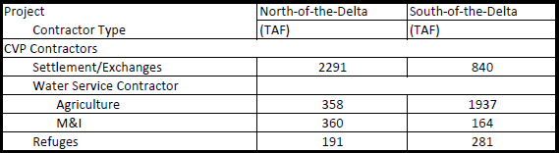

4 SWP contract amounts have been updated as appropriate based on recent Table A transfers/agreements. The contractors’ table A entitlement is obtained from Bulletin 132. Assumptions regarding SWP agricultural and M&I contract amounts are listed in table 4, table 5 and table 6 in respect of NOD, Delta and SOD accordingly. Summary of SWP contract amounts are tabulated below.

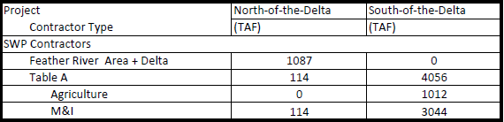

5 Water needs for Federal refuges have been reviewed and updated, as appropriate. Assumptions regarding firm Level 2 refuge water are listed in table 1 and table 3. Refuge Level 4 (and incremental Level 4) water is not included.

6 Assumptions regarding American River water rights and CVP contracts with the Sacramento River Water Reliability Project are listed in table 2. The Sacramento Area Water Forum agreement, its dry year diversion reductions, Middle Fork Project operations and water is not included.

7 Demand for rice straw decomposition water from Thermalito Afterbay was added to the model and updated to reflect historical diversion from Thermalito in the October through January period.

8 The new CalSim-II representation of the San Joaquin River has been included in this model package (CalSim-II San Joaquin River Model, Reclamation, 2005). Updates to the San Joaquin River have been included since the preliminary model release in August 2005. The model reflects the difficulties of on-going groundwater overdraft problems. The 2030 level of development representation of the San Joaquin River Basin does not make any attempt to offer solutions to groundwater overdraft problems. In addition, a dynamic groundwater simulation is not yet developed for the San Joaquin River Valley. Groundwater extraction/ recharge and stream-groundwater interaction are static assumptions and may not accurately reflect a response to simulated actions. These limitations should be considered in the analysis of result

9 The CALSIM II model representation for the Stanislaus River does not necessarily represent Reclamation’s current or future operational policies. A suitable plan for supporting flows has not been developed for NMFS BO (Jun 2009) Action III.1.3.

10 The actual amount diverted is operated in conjunction with supplies from the Los Vaqueros project. The existing Los Vaqueros storage capacity is 160 TAF. Associated water rights to fill Los Vaqueros with Delta excess flows are included, but CCWD’s water right permit and water right license on Mallard Slough are not included.

11 It is assumed that SWP Contractors can take delivery of all Table A allocations and Article 21 supplies. Article 56 provisions are assumed and allow for SWP Contractors to manage storage and delivery conditions such that full Table A allocations can be delivered. Detailed analysis of the South Coast and Tulare regions support these assumptions. NBA Article 21 deliveries are dependent on excess conditions only, all other Article 21 deliveries also require that San Luis Reservoir be at capacity and that Banks PP and the California Aqueduct has available capacity to divert from the Delta for direct delivery.

12 Mokelumne River flows are modified to reflect modified operations associated with EBMUD supplies from the Freeport Regional Water Project.

13 The CCWD Alternate Intake Project, an intake at Victoria Canal, which operates as an alternate Delta diversion for Los Vaqueros Reservoir.

14 D-1644 and the Lower Yuba River Accord is assumed to be implemented. The Yuba River is not dynamically modeled in CALSIM II. Yuba River hydrology and availability of water acquisitions under the Lower Yuba River Accord are based on modeling performed and the Lower Yuba River Accord EIS/EIR study team.

15 This includes draft logic for the updated Allocation Settlement Agreement for four NOD contractors: Butte, Yuba, Napa and Solano.

16 It is assumed that D-1641 requirements will be in place in 2030, and VAMP is turned off.

17 In cooperation with Reclamation, National Marine Fisheries Service, Fish and Wildlife Service, and CA Department of Fish and Game, the CA Department of Water Resources has developed assumptions for implementation of the FWS BO (Dec 15, 2008) and NMFS BO (June 4, 2009) in CALSIM II. The FWS BO and NMFS BO assumptions are documented in the Appendix 5A of the LTO EIS (Reclamation 2015b).

18 Current ACOE permit for Banks PP allows for an average diversion rate of 6,680 cfs in all months. Diversion rate can increase up to 1/3 of the rate of San Joaquin River flow at Vernalis during Dec 15th – Mar 15th up to a maximum diversion of 10,300 cfs, if Vernalis flow exceeds 1,000 cfs.

19 Acquisitions of Component 1 water under the Lower Yuba River Accord and use of 500 cfs dedicated capacity at Banks PP during Jul – Sep, are assumed to be used to reduce as much of the impact of the Apr-May fish related Delta export restrictions on SWP contractors as possible.

20 Delta actions, under USFWS discretionary use of CVPIA 3406(b)(2) allocations, are no longer dynamically operated and accounted for in the CALSIM II model. The Combined Old and Middle River Flow and Delta Export restrictions under the FWS BO (Dec 15, 2008) and the NMFS BO (June 4, 2009) severely limit any discretion that would have been otherwise assumed in selecting Delta actions under the CVPIA 3406(b)(2) accounting criteria. Therefore, it is anticipated that CVPIA 3406(b)(2) account availability for upstream river flows below Whiskeytown, Keswick and Nimbus Dams would be very limited. It appears the integration of BO RPA actions will likely exceed the 3406(b)(2) allocation in all water year types. For these baseline simulations, upstream flows on the Clear Creek and Sacramento River are pre-determined based on CVPIA 3406(b)(2) based operations from the Aug 2008 BA Study 7.0 and Study 8.0 for Existing and Future No Action baselines respectively. The procedures for dynamic operation and accounting of CVPIA 3406(b)(2) are not included in the CALSIM II model.

21 Only acquisitions of Lower Yuba River Accord Component 1 water are included.

22 PCWA American River pumping facility upstream of Folsom Lake is included.

23 Since the release of DCR 2017, EBMUD has replaced their monthly timestep planning model with a physically based, daily timestep model. To be consistent with EBMUD’s planning model, the CalSim II inputs related to the EBMUD operations – Mokelumne River inflow into Delta and allocations from the Freeport Regional Water Project – are updated to match the outputs from Model Run #8079. Key modeling assumptions include projected 2040 level of development; average demand of 230 MGD; and FWRP operations based on the 2016 Drought Management Program Guidelines.

24 For consistency, the CalSim II Tuolumne River operations – New Don Pedro storage along with diversions and channel flows downstream of the New Don Pedro dam – are fixed to the Tuolumne operations modeled in the Water Supply Effect (WSE) spreadsheet model of the State Water Resource Control Board (SWRCB). The model inputs to the WSE model were developed from DCR 2017existing conditions CalSim II model run.

25 Yuba Water Agency (YWA) has recently converted their operations model from a monthly timestep to daily timestep as part of their FERC Relicensing process for a more accurate representation of Yuba River Development Project (YRDP) operations. To be consistent with YWA’s planning model, Yuba River Development Project Model (YRDPM), the CalSim II inputs related to the Yuba River operations have been updated, including Yuba River flow above Daguerre Point Dam and Daguerre Point Dam diversion, and the Yuba River transfer operations.

26 The SJRR flows represented in the CalSim II model so far reflected the long-term flow schedule. A timeseries that reflects the near-term flows is being developed. The near-term SJRR flows can be recaptured using the current facilities before reaching the Delta, which is closer to a CalSim II model run without SJRR flows in terms of the Delta flow and salinity conditions as well as the Delta outflow. As a result, San Joaquin River Restoration flows are turned off.

27 Fall X2 is considered in-basin-use (IBU) even the Delta outflow requirement under X2 condition is met though export restriction.

This page intentionally left blank

# CalSim II Model Delivery Specifications

This compilation of delivery specifications for the CalSim II model provides additional detail in support of Attachment 1-1.

The delivery specifications for the CalSim II model include Central Valley Project (CVP) and State Water Project (SWP) contract amounts and other water rights assumptions used. These specifications are detailed in the following tables:

* Tables 3-1a through 1d. CVP North-of-the-Delta – Future Conditions
* Tables 3-2a and 2b. CVP American River – Future Conditions
* Table 3-3. CVP Delta – Future Conditions
* Tables 3-4a through 4e. CVP South-of-the-Delta – Future Conditions
* Table 3-55. SWP North-of-the-Delta – Future Conditions
* Tables 3-6a and 6b. SWP South-of-the-Delta – Future Conditions

This page intentionally left blank

Table 3-1a. CVP North-of-the-Delta

| CVP Contractor | Geographic Location | CVP Water Service Contracts: AG (TAF/yr) | CVP Water Service Contracts: M&I (TAF/yr) | Settlement / Exchange Contractor (TAF/yr) | Water Rights/ Non-CVP (TAF/yr) | Level 2 Refuges1 (TAF/yr) |
| --- | --- | --- | --- | --- | --- | --- |
| Anderson Cottonwood ID | Sacramento River Redding Subbasin | – | – | 128.0 | – | – |
| Clear Creek CSD | Sacramento River Redding Subbasin | 13.8 | 1.5 | – | – | – |
| Bella Vista WD | Sacramento River Redding Subbasin | 22.1 | 2.4 | – | – | – |
| Shasta CSD | Sacramento River Redding Subbasin | – | 1.0 | – | – | – |
| Sac R. Misc. Users | Sacramento River Redding Subbasin | – | – | 3.4 | – | – |
| Redding, City of | Sacramento River Redding Subbasin | – | – | 21.0 | – | – |
| City of Shasta Lake | Sacramento River Redding Subbasin | 2.5 | 0.3 | – | – | – |
| Mountain Gate CSD | Sacramento River Redding Subbasin |  | 0.4 | – | – | – |
| Shasta County Water Agency | Sacramento River Redding Subbasin | 0.5 | 0.5 | – | – | – |
| Redding, City of/Buckeye | Sacramento River Redding Subbasin | – | 6.1 | – | – | – |
| **Total** | Sacramento River Redding Subbasin | **38.9** | **12.2** | **152.4** | – | **0.0** |
| Corning WD | Corning Canal | 23.0 | – | – | – | – |
| Proberta WD | Corning Canal | 3.5 | – | – | – | – |
| Thomes Creek WD | Corning Canal | 6.4 | – | – | – | – |
| **Total** | Corning Canal | **32.9** | **0.0** | **0.0** | – | **0.0** |

Notes:

“-“ indicates blank cell

1. Level 4 Refuge water needs are not included.

Table 3-1b. CVP North-of-the-Delta

| CVP Contractor | Geographic Location | CVP Water Service Contracts: AG (TAF/yr) | CVP Water Service Contracts: M&I (TAF/yr) | Settlement / Exchange Contractor (TAF/yr) | Water Rights/ Non-CVP (TAF/yr) | Level 2 Refuges1 (TAF/yr) |
| --- | --- | --- | --- | --- | --- | --- |
| Kirkwood WD | Tehama-Colusa Canal | 2.1 | – | – | – | – |
| Glide WD | Tehama-Colusa Canal | 10.5 | – | – | – | – |
| Kanawha WD | Tehama-Colusa Canal | 45.0 | – | – | – | – |
| Orland-Artois WD | Tehama-Colusa Canal | 53.0 | – | – | – | – |
| Colusa, County of | Tehama-Colusa Canal | 20.0 | – | – | – | – |
| Colusa County WD | Tehama-Colusa Canal | 62.2 | – | – | – | – |
| Davis WD | Tehama-Colusa Canal | 4.0 | – | – | – | – |
| Dunnigan WD | Tehama-Colusa Canal | 19.0 | – | – | – | – |
| La Grande WD | Tehama-Colusa Canal | 5.0 | – | – | – | – |
| Westside WD | Tehama-Colusa Canal | 65.0 | – | – | – | – |
| **Total** | **Tehama-Colusa Canal** | **285.8** | **0.0** | **0.0** | **–** | **0.0** |
| Sac. R. Misc. Users2 | Sacramento River | – | – | 1.5 | – | – |
| Glenn Colusa ID | Glenn-Colusa Canal | – | – | 441.5 | – | – |
| Glenn Colusa ID | Glenn-Colusa Canal | – | – | 383.5 | – | – |
| Sacramento NWR | Glenn-Colusa Canal | – | – | – | – | 54.5 |
| Delevan NWR | Glenn-Colusa Canal | – | – | – | – | 24.6 |
| Colusa NWR | Glenn-Colusa Canal | – | – | – | – | 29.3 |
| Colusa Drain M.W.C. | Colusa Basin Drain | – | – | 7.7 | – | – |
| Colusa Drain M.W.C. | Colusa Basin Drain | – | – | 62.3 | – | – |
| **Total** | **Colusa Basin Drain** | **0.0** | **0.0** | **895.0** |  | **108.4** |

Table 3-1c. CVP North-of-the-Delta

| CVP Contractor | Geographic Location | CVP Water Service Contracts: AG (TAF/yr) | CVP Water Service Contracts: M&I (TAF/yr) | | Settlement / Exchange Contractor (TAF/yr) | Water Rights/ Non-CVP (TAF/yr) | Level 2 Refuges1 (TAF/yr) |
| --- | --- | --- | --- | --- | --- | --- | --- |
| Princeton-Cordova-Glenn ID | Sacramento River | – | – | | 67.8 | – | – |
| Provident ID | Sacramento River | – | – | | 54.7 | – | – |
| Maxwell ID | Sacramento River | – | | – | 1.8 | – | – |
| Maxwell ID | Sacramento River | – | | – | 16.2 | – | – |
| Sycamore Family Trust | Sacramento River | – | – | | 31.8 | – | – |
| Roberts Ditch IC | Sacramento River | – | – | | 4.4 | – | – |
| Sac R. Misc. Users2 | Sacramento River | – | – | | 4.9 | – | – |
| Sac R. Misc. Users2 | Sacramento River | – | – | | 9.5 | – | – |
| Total | Sacramento River | 0.0 | 0.0 | | 191.2 | – | 0.0 |
| Reclamation District 108 | Sacramento River | – | | – | 12.9 | – | – |
| Reclamation District 108 | Sacramento River | – | | – | 219.1 | – | – |
| River Garden Farms | Sacramento River | – | – | | 29.8 | – | – |
| Meridian Farms WC | Sacramento River | – | – | | 35.0 | – | – |
| Pelger Mutual WC | Sacramento River | – | – | | 8.9 | – | – |
| Reclamation District 1004 | Sacramento River | – | – | | 71.4 | – | – |
| Carter MWC | Sacramento River | – | – | | 4.7 | – | – |
| Sutter MWC | Sacramento River | – | – | | 226.0 | – | – |
| Tisdale Irrigation & Drainage Co. | Sacramento River | – | – | | 9.9 | – | – |
| Sac R. Misc. Users2 | Sacramento River | – | – | | 103.4 | – | – |
| Sac R. Misc. Users2 | Sacramento River | – | – | | 0.9 | – | – |
| Feather River WD export | Sacramento River | 20.0 | – | | – | – | – |
| Total | Sacramento River | 20.0 | 0.0 | | 722.1 | – | 0.0 |

Notes:

“-“ indicates blank cell

1. Level 4 Refuge water needs are not included.

Table 3-1d. CVP North-of-the-Delta

| CVP Contractor | Geographic Location | CVP Water Service Contracts (TAF/yr) AG | CVP Water Service Contracts (TAF/yr) M&I | Settlement / Exchange Contractor (TAF/yr) | Water Rights/ Non-CVP (TAF/yr) | Level 2 Refuges1 (TAF/yr) |
| --- | --- | --- | --- | --- | --- | --- |
| Sutter NWR | Sutter bypass water for Sutter NWR | – | – | – | – | 25.7 |
| Gray Lodge WMA | Feather River | – | – | – | – | 41.3 |
| Butte Sink Duck Clubs | Feather River | – | – | – | – | 15.6 |
| **Total** | **Feather River** | **0.0** | **0.0** | **0.0** | **–** | **82.6** |
| Sac. R. Misc. Users2 | Sacramento River DSA 65 | – | – | 56.8 | – | – |
| City of West Sacramento | Sacramento River DSA 65 | – | – | 23.6 | – | – |
| Davis-Woodland Water Supply Project | Sacramento River DSA 65 | – | – | – | – | – |
| **Total** | **Sacramento River DSA 65** | **0.0** | **0.0** | **80.4** | **–** | **0.0** |
| Sac R. Misc. Users | Lower Sacramento River | – | – | 4.8 | – | – |
| Natomas Central MWC | Lower Sacramento River | – | – | 120.2 | – | – |
| Pleasant Grove-Verona MWC | Lower Sacramento River | – | – | 26.3 | – | – |
| City of Sacramento (PCWA) | Lower Sacramento River | – | 0.0 | – | 0.0 | – |
| PCWA (Water Rights) | Lower Sacramento River | – | 0.0 | – | 0.0 | – |
| **Total** | **Lower Sacramento River** | **0.0** | **0.0** | **151.3** | **0.0** | **–** |
| **Total CVP North-of-Delta** | **Lower Sacramento River** | **377.6** | **12.2** | **2193.8** | **0.0** | **191.0** |

Notes:

1. Level 4 Refuge water needs are not included.

“-“ indicates blank cell

Table 3-2a. American River

| **–** | **Diversion Location** | **CVP M&I1 Contracts (maximum1)** | **Water Rights (maximum)** | **Diversion Limit (maximum capacity)** |
| --- | --- | --- | --- | --- |
| Placer County Water Agency | Auburn Dam Site |  | 65.0 | 65.0 |
| **Total** | **Auburn Dam Site** | **0** | **65.0** | **65.0** |
| Sacramento Suburban Water District2 | Folsom Reservoir |  | 0 | 0 |
| City of Folsom - includes P.L. 101-514 | Folsom Reservoir | 7 | 27 | 34 |
| Folsom Prison | Folsom Reservoir |  | 5 | 5 |
| San Juan Water District (Placer County) | Folsom Reservoir |  | 25 | 25 |
| San Juan Water District (Sac County) - includes P.L. 101-514 | Folsom Reservoir | 24.2 | 33 | 57.2 |
| El Dorado Irrigation District | Folsom Reservoir | 7.55 | 17 | 24.55 |
| City of Roseville | Folsom Reservoir | 32 | 30 | 62.0 |
| Placer County Water Agency | Folsom Reservoir | 35 |  | 35 |
| El Dorado County - P.L.101-514 | Folsom Reservoir | 15 |  | 15 |
| **Total** | **Folsom Reservoir** | **120.75** | **137.0** | **257.75** |
| So. Cal WC/Arden Cordova WC | Folsom South Canal |  | 5 | 5 |
| California Parks and Recreation | Folsom South Canal | 5 |  | 5 |
| SMUD | Folsom South Canal | 30 | 15 | 45 |
| Canal Losses | Folsom South Canal |  | 1 | 1 |
| Total | Folsom South Canal | 35 | 21 | 56 |
| City of Sacramento3 | Lower American River |  | 230 | 230 |
| Carmichael Water District | Lower American River |  | 12 | 12 |
| **Total** | **Lower American River** | **0** | **242** | **242** |
| **Total American River Diversions** | **Total American River Diversions** | **155.75** | **465** | **620.75** |

Notes:

“-“ indicates blank cell

Table 3-2b. American River: Sacramento River Diversions

| – | Diversion Location | CVP M&I1 Contracts (maximum1) | Water Rights (maximum) | Diversion Limit (maximum capacity) |
| --- | --- | --- | --- | --- |
| City of Sacramento | Lower Sacramento River | – | 81.8 | 81.8 |
| Sacramento County Water Agency | Lower Sacramento River | 10 | – | 10 |
| Sacramento County Water Agency -  P.L. 101-514 / FRWP | Lower Sacramento River | 35 | – | 35 |
| Sacramento County Water Agency -  water rights and acquisitions | Lower Sacramento River | – | varies4, average ~32 | varies4, average ~32 |
| East Bay Municipal Utilities District | Lower Sacramento River | 133 | – | varies5 ,  average 14.6 |
| **Total Sacramento River Diversions** | **Lower Sacramento River** | **178** | **113.8** | **173.4** |
| **Total** | **Lower Sacramento River** | **333.75** | **578.8** | **794.15** |

Notes:

“–“ indicates blank cell

1 When the CVP Contract quantity exceeds the quantity of the Diversion Limit minus the Water Right (if any), the diversion modeled is the quantity allocated to the CVP Contract (based on the CVP contract quantity shown times the CVP M&I allocation percentage) plus the Water Right (if any), but with the sum limited to the quantity of the Diversion Limit

2 Diversion is only allowed if and when Mar-Nov Folsom Unimpaired Inflow (FUI) exceeds 1600 TAF

3 When the Hodge single dry year criteria is triggered, Mar-Nov FUI falls below 400 TAF, diversion on the American River is limited to 50 TAF/yr; based on monthly Hodge flow limits assumed for the American, diversion on the Sacramento River may be increased to 223 TAF due to reductions of diversions on American River

4 SCWA targets 68 TAF of surface water supplies annually. The portion unmet by CVP contract water is assumed to come from two sources:

1. Delta “excess” water- averages 17.5 TAF annually, but varies according to availability. SCWA is assumed to divert excess flow when it is available, and when there is available pumping capacity.
2. “Other” water- derived from transfers and/or other appropriated water, averaging 14.5 TAF annually but varying according remaining unmet demand.

5 EBMUD CVP diversions are governed by the Amendatory Contract, stipulating:

1. 133 TAF maximum diversion in any given year
2. 165 TAF maximum diversion amount over any 3 year period
3. Diversions allowed only when EBMUD total storage drops below 500 TAF
4. 155 cfs maximum diversion rate

Table 3-3. Delta

| CVP/ SWP Contractor | Geographic Location | Water Right (TAF/yr) | SWP Table A Amount (TAF) Ag | SWP Table A Amount (TAF) M&I | SWP Article 21 Demand (TAF/mon) | CVP Water Service Contracts (TAF/yr) AG | CVP Water Service Contracts (TAF/yr) M&I |
| --- | --- | --- | --- | --- | --- | --- | --- |
| City of Vallejo | City of Vallejo | – | – | – | – | – | 16.0 |
| CCWD1 | Contra Costa County | – | – | – | – | – | 195.0 |
| Napa County FC&WCD | North Bay Aqueduct | – | – | 29.03 | 1.0 | – | – |
| Solano County WA | North Bay Aqueduct | – | – | 47.76 | 1.0 | – | – |
| Fairfield, Vacaville and Benicia Agreement | North Bay Aqueduct | 31.60 | – | – | – | – | – |
| City of Antioch | City of Antioch | 18.0 | – | – | – | – | – |
| **Total North Delta** | – | **49.6** | **0.0** | **76.79** | **2.0** | **0.0** | **211.0** |
| Delta Water Supply Project | City of Stockton | 32.4 | – | – | – | – | – |
| **Total South Delta** | – | **32.4** | **0.0** | **0.0** | **0.0** | **0.0** | **0.0** |
| **Total North Delta and South Delta** | – | **82.0** | **0.0** | **76.79** | **2.0** | **0.0** | **211.0** |

Notes:

“–“ indicates blank cell

1. The Los Vaqueros module in CalSim II is used to determine the range of demands that are met by CVP contracts or other water rights

Table 3-4a. CVP South-of-the-Delta

| CVP/ SWP Contractor | Geographic Location | Water Right (TAF/yr) | SWP Table A Amount (TAF) Ag | SWP Table A Amount (TAF) M&I | SWP Article 21 Demand (TAF/mon) | CVP Water Service Contracts (TAF/yr) AG | CVP Water Service Contracts (TAF/yr) M&I |
| --- | --- | --- | --- | --- | --- | --- | --- |
| Byron-Bethany ID | Upper DMC | 20.6 | – | – | – | – | – |
| Tracy, City of | Upper DMC | – | 10.0 | – | – | – | – |
| Tracy, City of | Upper DMC | – | 5.0 | – | – | – | – |
| Tracy, City of | Upper DMC | – | 5.0 | – | – | – | – |
| Banta Carbona ID | Upper DMC | 20.0 | – | – | – | – | – |
| **Total** | – | **40.6** | **20.0** | **0.0** | **0.0** | **0.0** | **0.0** |
| Del Puerto WD | Upper DMC | 12.1 | – | – | – | – | – |
| Davis WD | Upper DMC | 5.4 | – | – | – | – | – |
| Foothill WD | Upper DMC | 10.8 | – | – | – | – | – |
| Hospital WD | Upper DMC | 34.1 | – | – | – | – | – |
| Kern Canon WD | Upper DMC | 7.7 | – | – | – | – | – |
| Mustang WD | Upper DMC | 14.7 | – | – | – | – | – |
| Orestimba WD | Upper DMC | 15.9 | – | – | – | – | – |
| Quinto WD | Upper DMC | 8.6 | – | – | – | – | – |
| Romero WD | Upper DMC | 5.2 | – | – | – | – | – |
| Salado WD | Upper DMC | 9.1 | – | – | – | – | – |
| Sunflower WD | Upper DMC | 16.6 | – | – | – | – | – |
| West Stanislaus WD | Upper DMC | 50.0 | – | – | – | – | – |
| Patterson WD | Upper DMC | 16.5 | – | – | 6.0 | – | – |
| **Total** | – | **206.7** | **0.0** | **0.0** | **6.0** | **0.0** | **0.0** |

Notes:

“–“ indicates blank cell

Table 3-4b. CVP South-of-the-Delta

|  |  |  |  |  |  |  |  |
| --- | --- | --- | --- | --- | --- | --- | --- |
| CVP Contractor | Geographic Location | CVP Water Service Contracts (TAF/yr) | M&I | Settlement/ Exchange Contractor (TAF/yr) | Water Rights/ Non-CVP (TAF/yr) | Level 2 Refuges1 (TAF/yr) | Losses (TAF/yr) |
| Upper DMC Loss | Upper DMC | – | – | – | – | – | 18.5 |
| Panoche WD | Lower DMC Volta | 6.6 | – | – | – | – | – |
| San Luis WD | Lower DMC Volta | 65.0 | – | – | – | – | – |
| Laguna WD | Lower DMC Volta | 0.8 | – | – | – | – | – |
| Eagle Field WD | Lower DMC Volta | 4.6 | – | – | – | – | – |
| Mercy Springs WD | Lower DMC Volta | 2.8 | – | – | – | – | – |
| Oro Loma WD | Lower DMC Volta | 4.6 | – | – | – | – | – |
| **Total** | **Lower DMC Volta** | **84.4** | **0.0** | **0.0** | **0.0** | **0.0** | **0.0** |
| Central California ID | Lower DMC Volta | – | – | 140.0 | – | – | – |
| Grasslands via CCID | Lower DMC Volta | – | – | – | – | 81.8 | – |
| Los Banos WMA | Lower DMC Volta | – | – | – | – | 11.2 | – |
| Kesterson NWR | Lower DMC Volta | – | – | – | – | 10.5 | – |
| Freitas - SJBAP | Lower DMC Volta | – | – | – | – | 6.3 | – |
| Salt Slough - SJBAP | Lower DMC Volta | – | – | – | – | 8.6 | – |
| China Island - SJBAP | Lower DMC Volta | – | – | – | – | 7.0 | – |
| Volta WMA | Lower DMC Volta | – | – | – | – | 13.0 | – |
| Grassland via Volta Wasteway | Lower DMC Volta | – | – | – | – | 23.2 | – |
| **Total** | **Lower DMC Volta** | **0.0** | **0.0** | **140.0** | **0.0** | **161.5** | **0.0** |

Notes:

“–“ indicates blank cell

Table 3-4c. CVP South-of-the-Delta

| CVP Contractor | Geographic Location | CVP Water Service Contracts (TAF/yr) AG | CVP Water Service Contracts (TAF/yr) M&I | Settlement/ Exchange Contractor (TAF/yr) | Water Rights/ Non-CVP (TAF/yr) | Level 2 Refuges1 (TAF/yr) | Losses (TAF/yr) |
| --- | --- | --- | --- | --- | --- | --- | --- |
| Fresno Slough WD | San Joaquin River at Mendota Pool | 4.0 | – | – | 0.9 | – | – |
| James ID | San Joaquin River at Mendota Pool | 35.3 | – | – | 9.7 | – | – |
| Coelho Family Trust | San Joaquin River at Mendota Pool | 2.1 | – | – | 1.3 | – | – |
| Tranquility ID | San Joaquin River at Mendota Pool | 13.8 | – | – | 20.2 | – | – |
| Tranquility PUD | San Joaquin River at Mendota Pool | 0.1 | – | – | 0.1 | – | – |
| Reclamation District 1606 | San Joaquin River at Mendota Pool | 0.2 | – | – | 0.3 | – | – |
| Central California ID | San Joaquin River at Mendota Pool | – | – | 392.4 | – | – | – |
| Columbia Canal Co. | San Joaquin River at Mendota Pool | – | – | 59.0 | – | – | – |
| Firebaugh Canal Co. | San Joaquin River at Mendota Pool | – | – | 85.0 | – | – | – |
| San Luis Canal Co. | San Joaquin River at Mendota Pool | – | – | 23.6 | – | – | – |
| M.L. Dudley Company | San Joaquin River at Mendota Pool | – | – | – | 2.3 | – | – |
| Grasslands WD | San Joaquin River at Mendota Pool | – | – | – | – | 29.0 | – |
| Mendota WMA | San Joaquin River at Mendota Pool | – | – | – | – | 27.6 | – |
| Losses | San Joaquin River at Mendota Pool | – | – | – | – | – | 101.5 |
| **Total** | **San Joaquin River at Mendota Pool** | **55.5** | **0.0** | **560.0** | **34.8** | **56.6** | **101.5** |
| San Luis Canal Co. | San Joaquin River at Mendota Pool | – | – | 140.0 | – | – | – |
| Grasslands WD | San Joaquin River at Mendota Pool | – | – | – | – | 2.3 | – |
| Los Banos WMA | San Joaquin River at Mendota Pool | – | – | – | – | 12.4 | – |
| San Luis NWR | San Joaquin River at Mendota Pool | – | – | – | – | 19.5 | – |
| West Bear Creek NWR | San Joaquin River at Mendota Pool | – | – | – | – | 7.5 | – |
| East Bear Creek NWR | San Joaquin River at Mendota Pool | – | – | – | – | 8.9 | – |
| **Total** | **San Joaquin River at Mendota Pool** | **0.0** | **0.0** | **140.0** | **0.0** | **50.6** | **0.0** |

Notes:

“–“ indicates blank cell

Table 3-4d. CVP South-of-the-Delta

| CVP Contractor | Geographic Location | CVP Water Service Contracts (TAF/yr) AG | CVP Water Service Contracts (TAF/yr) M&I | Settlement/ Exchange Contractor (TAF/yr) | Water Rights/ Non-CVP (TAF/yr) | Level 2 Refuges1 (TAF/yr) | Losses (TAF/yr) |
| --- | --- | --- | --- | --- | --- | --- | --- |
| San Benito County WD (Ag) | San Felipe Aqueduct | 35.6 | – | – | – | – | – |
| Santa Clara Valley WD (Ag) | San Felipe Aqueduct | 33.1 | – | – | – | – | – |
| Pajaro Valley WD | San Felipe Aqueduct | 6.3 | – | – | – | – | – |
| San Benito County WD (M&I) | San Felipe Aqueduct | – | 8.3 | – | – | – | – |
| Santa Clara Valley WD (M&I) | San Felipe Aqueduct | – | 119.4 | – | – | – | – |
| **Total** | **San Felipe Aqueduct** | **74.9** | **127.7** | **0.0** | **0.0** | **0.0** | **0.0** |
| San Luis WD | CA reach 3 | 60.1 | – | – | – | – | – |
| CA, State Parks and Rec | CA reach 3 | 2.3 | – | – | – | – | – |
| Affonso/Los Banos Gravel Co. | CA reach 3 | 0.3 | – | – | – | – | – |
| **Total** | **CA reach 3** | **62.6** | **0.0** | **0.0** | **0.0** | **0.0** | **0.0** |
| Panoche WD | CVP Dos Amigos PP/ CA reach 4 | 87.4 | – | – | – | – | – |
| Pacheco WD | CVP Dos Amigos PP/ CA reach 4 | 10.1 | – | – | – | – | – |
| **Total** | **CVP Dos Amigos PP/ CA reach 4** | **97.5** | **0.0** | **0.0** | **0.0** | **0.0** | **0.0** |
| Westlands WD (Centinella) | CA reach 4 | 2.5 | – | – | – | – | – |
| Westlands WD (Broadview WD) | CA reach 4 | 27.0 | – | – | – | – | – |
| Westlands WD (Mercy Springs WD) | CA reach 4 | 4.2 | – | – | – | – | – |
| Westlands WD (Widern WD) | CA reach 4 | 3.0 | – | – | – | – | – |
| **Total** | **CA reach 4** | **36.7** | **0.0** | **0.0** | **0.0** | **0.0** | **0.0** |
| Westlands WD: CA Joint Reach 4 | CA reach 4 | 219.0 | – | – | – | – | – |
| Westlands WD: CA Joint Reach 5 | CA reach 5 | 570.0 | – | – | – | – | – |
| Westlands WD: CA Joint Reach 6 | CA reach 6 | 219.0 | – | – | – | – | – |
| Westlands WD: CA Joint Reach 7 | CA reach 7 | 142.0 | – | – | – | – | – |
| **Total** | **–** | **1150.0** | **0.0** | **0.0** | **0.0** | **0.0** | **0.0** |

Notes:

“–“ indicates blank cell

Table 3-4e. CVP South-of-the-Delta

| CVP Contractor | Geographic Location | CVP Water Service Contracts (TAF/yr) AG | CVP Water Service Contracts (TAF/yr) M&I | Settlement/ Exchange Contractor (TAF/yr) | Water Rights/ Non-CVP (TAF/yr) | Level 2 Refuges1 (TAF/yr) | Losses (TAF/yr) |
| --- | --- | --- | --- | --- | --- | --- | --- |
| Avenal, City of | CA reach 7 | **–** | 3.5 | **–** | 3.5 | **–** | **–** |
| Coalinga, City of | CA reach 7 | **–** | 10.0 | **–** | **–** | **–** | **–** |
| Huron, City of | CA reach 7 | **–** | 3.0 | **–** | **–** | **–** | **–** |
| **Total** | **CA reach 7** | **0.0** | **16.5** | **0.0** | **3.5** | **0.0** | **0.0** |
| CA Joint Reach 3 - Loss | CVP Dos Amigos PP/CA reach 3 | **–** | **–** | **–** | **–** | **–** | 2.5 |
| CA Joint Reach 4 - Loss | CA reach 4 | **–** | **–** | **–** | **–** | **–** | 10.1 |
| CA Joint Reach 5 - Loss | CA reach 5 | **–** | **–** | **–** | **–** | **–** | 30.1 |
| CA Joint Reach 6 - Loss | CA reach 6 | **–** | **–** | **–** | **–** | **–** | 12.5 |
| CA Joint Reach 7 - Loss | CA reach 7 | **–** | **–** | **–** | **–** | **–** | 8.5 |
| **Total** | **–** | **0.0** | **0.0** | **0.0** | **0.0** | **0.0** | **63.7** |
| Cross Valley Canal - CVP | CA reach 14 | **–** | **–** | **–** | **–** | **–** | **–** |
| Fresno, County of | CA reach 14 | 3.0 | **–** | **–** | **–** | **–** | **–** |
| Hills Valley ID-Amendatory | CA reach 14 | 3.3 | **–** | **–** | **–** | **–** | **–** |
| Kern-Tulare WD | CA reach 14 | 40.0 | **–** | **–** | **–** | **–** | **–** |
| Lower Tule River ID | CA reach 14 | 31.1 | **–** | **–** | **–** | **–** | **–** |
| Pixley ID | CA reach 14 | 31.1 | **–** | **–** | **–** | **–** | **–** |
| Rag Gulch WD | CA reach 14 | 13.3 | **–** | **–** | **–** | **–** | **–** |
| Tri-Valley WD | CA reach 14 | 1.1 | **–** | **–** | **–** | **–** | **–** |
| Tulare, County of | CA reach 14 | 5.3 | **–** | **–** | **–** | **–** | **–** |
| Kern NWR | CA reach 14 | **–** | **–** | **–** | **–** | 11.0 | **–** |
| Pixley NWR | CA reach 14 | **–** | **–** | **–** | **–** | 1.3 | **–** |
| **Total** | **CA reach 14** | **128.3** | **0.0** | **0.0** | **0.0** | **12.3** | **0.0** |
| **Total CVP South-of-Delta** | **–** | **1937.1** | **164.2** | **840.0** | **44.3** | **281.0** | **183.7** |

Notes:

“–“ indicates blank cell

1. Level 4 Refuge water needs are not included.

Table 3-5. SWP North-of-the-Delta (Table 5a – 5b)

Table 3-5a. SWP North-of-the-Delta: Feather River

| SWP CONTRACTOR | Geographic Location | FRSA Amount (TAF) | Water Right (TAF/yr) | Table A Amount (TAF) Ag | Table A Amount (TAF) M&I | Article 21 Demand (TAF/mon) | Other (TAF/yr) |
| --- | --- | --- | --- | --- | --- | --- | --- |
| Palermo | FRSA | – | 17.6 | – | – | – | – |
| County of Butte | Feather River | – |  | – | 27.5 | – | – |
| Thermalito | FRSA | – | 8.0 | – | – | – | – |
| Western Canal | FRSA | 150.0 | 145.0 | – | – | – | – |
| Joint Board | FRSA | 550.0 | 5.0 | – | – | – | – |
| City of Yuba City | Feather River | – | – | – | 9.6 | – | – |
| Feather WD | FRSA | 17.0 | – | – | – | – | – |
| Garden, Oswald, Joint Board | FRSA |  | – | – | – | – | – |
| Garden | FRSA | 12.9 | 5.1 | – | – | – | – |
| Oswald | FRSA | 2.9 | – | – | – | – | – |
| Joint Board | FRSA | 50.0 | – | – | – | – | – |
| Plumas, Tudor | FRSA | – | – | – | – | – | – |
| Plumas | FRSA | 8.0 | 6.0 | – | – | – | – |
| Tudor | FRSA | 5.1 | 0.2 | – | – | – | – |
| **Total Feather River Area** | – | **795.8** | **186.9** | **0.0** | **37.1** | – | – |

Notes:

“–“ indicates blank cell

Table 3-5b. SWP North-of-the-Delta: Other

| SWP CONTRACTOR | Geographic Location | FRSA Amount (TAF) | Water Right (TAF/yr) | Table A Amount (TAF) Ag | Table A Amount (TAF) M&I | Article 21 Demand (TAF/mon) | Other (TAF/yr) |
| --- | --- | --- | --- | --- | --- | --- | --- |
| Yuba County Water Agency | Yuba River | – | – | – | – | – | Variable |
| Yuba County Water Agency | Yuba River | – | – | – | – | – | 333.6 |
| Camp Far West ID | Yuba River | – | – | – | – | – | 12.6 |
| Bear River Exports | American R/DSA70 | – | – | – | – | – | Variable |
| Bear River Exports | American R/DSA70 | – | – | – | – | – | 95.2 |
| Feather River Exports to American River (left bank to DSA70) | American R/DSA70 | – | 11.0 | – | – | – | – |

Notes:

“–“ indicates blank cell

Table 3-6a. SWP South-of-the-Delta –Future Conditions

| SWP Contractor | Geographic Location | Table A Amount (TAF) Ag | Table A Amount (TAF) M&I | Article 21 Demand (TAF/mon) | Losses (TAF/yr) |
| --- | --- | --- | --- | --- | --- |
| Alameda Co. FC&WCD, Zone 7 | SBA reaches 1-4 | – | 43.98 | 1.00 | – |
| Alameda Co. FC&WCD, Zone 7 | SBA reaches 5-6 | – | 36.64 | None | – |
| **Alameda Co. FC&WCD, Zone 7** | **Total** | – | **80.62** | **1.00** | – |
| Alameda County WD | SBA reaches 7-8 | – | 42.00 | 1.00 | – |
| Santa Clara Valley WD | SBA reach 9 | – | 100.00 | 4.00 | – |
| Oak Flat WD | CA reach 2A | 5.70 | – | None | – |
| County of Kings | CA reach 8C | 9.31 | – | None | – |
| Dudley Ridge WD | CA reach 8D | 45.35 | – | 1.00 | – |
| Empire West Side ID | CA reach 8C | 3.00 | – | 1.00 | – |
| Kern County Water Agency | CA reaches 3, 9-13B | 608.86 | 134.60 | None | – |
| Kern County Water Agency | CA reaches 14A-C | 99.20 | – | 180.00 | – |
| Kern County Water Agency | CA reaches 15A-16A | 59.40 | – | None | – |
| Kern County Water Agency | CA reach 31A | 80.67 | – | None | – |
| **Kern County Water Agency** | **Total** | **848.13** | **134.60** | **180.00** | – |
| Tulare Lake Basin WSD | CA reaches 8C-8D | 87.47 | – | 15.00 | – |
| San Luis Obispo Co. FC&WCD | CA reaches 33A-35 | – | 25.00 | None | – |
| Santa Barbara Co. FC&WCD | CA reach 35 | – | 45.49 | None | – |
| Antelope Valley-East Kern WA | CA reaches 19-20B, 22A-B | – | 144.84 | 1.00 | – |
| Castaic Lake WA | CA reach 31A | 12.70 | – | 1.00 | – |
| Castaic Lake WA | CA reach 30 | – | 82.50 | None | – |
| **Castaic Lake WA** | **Total** | **12.70** | **82.50** | **1.00** | – |
| Coachella Valley WD | CA reach 26A | – | 138.35 | 2.00 | – |
| Crestline-Lake Arrowhead WA | CA reach 24 | – | 5.80 | None | – |
| Desert WA | CA reach 26A | – | 55.75 | 5.00 | – |
| Littlerock Creek ID | CA reach 21 | – | 2.30 | None | – |
| Mojave WA | CA reaches 19, 22B-23 | – | 85.80 | None | – |
| Metropolitan WDSC | CA reach 26A | – | 148.67 | 90.70 | – |
| Metropolitan WDSC | CA reach 30 | – | 756.69 | 74.80 | – |
| Metropolitan WDSC | CA reaches 28G-H | – | 102.71 | 27.60 | – |
| Metropolitan WDSC | CA reach 28J | – | 903.43 | 6.90 | – |
| Metropolitan WDSC | **Total** | – | **1911.50** | **200.00** | – |

Notes:

“–“ indicates blank cell

Table 3-6b. SWP South-of-the-Delta

|  |  |  |  |  |  |
| --- | --- | --- | --- | --- | --- |
| SWP Contractor | Geographic Location | Table A Amount (TAF) Ag | Table A Amount (TAF) M&I | Article 21 Demand (TAF/mon) | Losses (TAF/yr) |
| Palmdale WD | CA reaches 20A-B | – | 21.30 | None | – |
| San Bernardino Valley MWD | CA reach 26A | – | 102.60 | None | – |
| San Gabriel Valley MWD | CA reach 26A | – | 28.80 | None | – |
| San Gorgonio Pass WA | CA reach 26A | – | 17.30 | None | – |
| Ventura County FCD | CA reach 29H | – | 3.15 | None | – |
| Ventura County FCD | CA reach 30 | – | 16.85 | None | – |
| Ventura County FCD | Total | – | 20.00 | – | – |
| SWP Losses | CA reaches 1-2 | – | – | – | 7.70 |
| SWP Losses | SBA reaches 1-9 | – | – | – | 0.60 |
| SWP Losses | CA reach 3 | – | – | – | 10.80 |
| SWP Losses | CA reach 4 | – | – | – | 2.60 |
| SWP Losses | CA reach 5 | – | – | – | 3.90 |
| SWP Losses | CA reach 6 | – | – | – | 1.20 |
| SWP Losses | CA reach 7 | – | – | – | 1.60 |
| SWP Losses | CA reaches 8C-13B | – | – | – | 11.90 |
| SWP Losses | Wheeler Ridge PP and CA reaches 14A-C | – | – | – | 3.60 |
| SWP Losses | Chrisman PP and CA reaches 15A-18A | – | – | – | 1.80 |
| SWP Losses | Pearblossom PP and CA reaches 17-21 | – | – | – | 5.10 |
| SWP Losses | Mojave PP and CA reaches 22A-23 | – | – | – | 4.00 |
| SWP Losses | REC and CA reaches 24-28J | – | – | – | 1.40 |
| SWP Losses | CA reaches 29A-29F | – | – | – | 1.90 |
| SWP Losses | Castaic PWP and CA reach 29H | – | – | – | 3.10 |
| SWP Losses | REC and CA reach 30 | – | – | – | 2.40 |
| SWP Losses | Total | – | – | – | 63.60 |
| **Total** | **–** | **1011.66** | **3044.55** | **412.00** | **63.60** |

This page intentionally left blank

Attachment 2-3 DSM2 Model Assumptions Callouts

# Introduction

The assumptions for all model simulations in this study are summarized in Appendix H Attachment 2-1 Model Assumptions.

# DSM2 Modeling Assumptions Callouts

The following matrix summarizes the assumptions used for the DSM2 models:

* Existing Conditions
* Proposed Project
* Refined Alternative 2b

This page intentionally left blank

Boundary Conditions

| – | Existing | Proposed Project | Refined Alternative 2b |
| --- | --- | --- | --- |
| Period of simulation | 82 years (1922-2003)1 | Same as Existing | Same as Existing |
| Boundary flows | Monthly timeseries from CalSim II output (at Sacramento River, East Side Streams, San Joaquin River, as well as Delta exports and diversions)3 | Same as Existing | Same as Existing |
| Ag flows (DICU) | 2020 Level, DWR Bulletin 160-984 | Same as Existing | Same as Existing |
| Martinez stage | 15-minute adjusted astronomical tide1 | Same as Existing | Same as Existing |
| Vernalis EC | Monthly time series from CalSim II output5 | Same as Existing | Same as Existing |
| Agricultural Return EC | Municipal Water Quality Investigation Program analysis | Same as Existing | Same as Existing |
| Martinez EC | Monthly net Delta Outflow from CalSim output & G-model6 | Same as Existing | Same as Existing |

Facilities

| – | Existing | Proposed Project | Refined Alternative 2b |
| --- | --- | --- | --- |
| Period of simulation | 82 years (1922-2003)1 | Same as Existing | Same as Existing |
| Freeport Regional Water Project | Monthly output from CalSim II | Same as Existing | Same as Existing |
| Delta Cross Channel | Monthly time series of number of days open from CalSim II output8 | Same as Existing | Same as Existing |
| Stockton Delta Water Supply Project | Monthly output from CalSim II | Same as Existing | Same as Existing |
| Delta Habitat Improvements | None | Same as Existing | Same as Existing |
| Veale Tract Drainage Relocation | The Veale Tract Water Quality Improvement Project, funded by CALFED, relocates the agricultural drainage outlet was relocated from Rock Slough channel to the southern end of Veale Tract, on Indian Slough7 | Same as Existing | Same as Existing |
| Clifton Court Forebay | Priority 3, gate operations synchronized with incoming tide to minimize impacts to low water levels in nearby channels | Same as Existing | Same as Existing |
| Contra Costa Water District Delta Intakes | Rock Slough Pumping Plant, Old River at Highway 4 Intake and Alternate Improvement Project Intake on Victoria Canal | Same as Existing | Same as Existing |
| South Delta barriers | Temporary Barriers Project operated based on San Joaquin River flow time series from CalSim II output; HORB installed Apr 1– May 31 and Sep 16 – Nov 30; Agricultural barriers on Old and Middle Rivers are assumed to be installed starting from May 16 and on Grant Line Canal from June 1; All three barriers are allowed to be operated until November 30; May 16 to May 31; the tidal gates are assumed to be tied open for the barriers on Old and Middle Rivers. | Temporary Barriers Project operated based on San Joaquin River flow time series from CalSim II output; HORB is not installed; Agricultural barriers on Old and Middle Rivers are assumed to be installed starting from May 16 and on Grant Line Canal from June 1; All three barriers are allowed to be operated until November 30; May 16 to May 31; the tidal gates are assumed to be tied open for the barriers on Old and Middle Rivers. | Same as Proposed Project |
| Antioch Water Works | Monthly output from CalSim II | Same as Existing | Same as Existing |
| Suisun Marsh Salinity Control Gates | Gate operations occur in October through February. Gates open when upstream water level is 0.3 ft above downstream water level. Gates close when current is less than -0.1 fps. Gates are open in March through September. | Gate operations occur in October through February in all years, and July through August during Below Normal water years. Gates open when upstream water level is 0.3 ft above downstream water level. Gates close when current is less than -0.1 fps. In Below Normal years, gates are open in March through June. In all other water years, gates are open in March through September. | Same as Proposed Project |

Notes:

“-“ indicates blank cell.

1 Adjusted astronomical tide for use in DSM2 planning studies has been developed by DWR’s Bay Delta Office Modeling Support Branch Delta Modeling Section in cooperation with the Common Assumptions workgroup. This tide is based on a more extensive observed dataset and covers the entire 82-year period of record.

2 Footnote not used

3 Although monthly CalSim output was used as the DSM2-HYDRO input, the Sacramento and San Joaquin rivers were interpolated to daily values in order to smooth the transition at the month transitions. DSM2 then uses the daily flow values along with a 15-minute adjusted astronomical tide to simulate effect of the spring and neap tides.

4 The Delta Island Consumptive Use (DICU) model is used to calculate diversions and return flows for all Delta islands based on the level of development assumed. The projected 2020 land-use assumptions are found in Bulletin 160-98.

5 CalSim II calculates monthly EC for the San Joaquin River, which are then represented at a daily interval. Daily EC timeseries data are constant across each month. Fixed concentrations of 150, 175, and 125 µmhos/cm were assumed for the Sacramento River, Yolo Bypass, and eastside streams, respectively.

6 Net Delta outflow based on the CalSim II flows was used with an updated G-model to calculate Martinez EC.

7 Information was obtained based on the information from the draft final “Delta Region Drinking Water Quality Management Plan” dated June 2005 prepared under the CALFED Water Quality Program and a presentation by David Briggs at SWRCB public workshop for periodic review. The presentation “Compliance location at Contra Costa Canal at Pumping Plant #1 – Addressing Local Degradation” notes that the Veale Tract drainage relocation project will be operational in June 2005. The DICU drainage currently simulated at node 204 is moved to node 202 in DSM2.

8 CalSim II calculates number of days DCC gates are open in a given month. For implementation in DSM2, it is assumed the number of days open are the first series of days in that month. For example, if CalSim II output indicates DCC gates are open for 5 days in a given month, DCC gates will be open for the first five days of that month in DSM2.

This page intentionally left blank

Appendix H Attachment 2-4   
CalSim II Sensitivity Analysis for the Revised Proposed Project

Select Proposed Project model assumptions of the Old and Middle River Flows (OMR) flexibility criteria required the following updates: (1) changing flow criteria from -6,000 cfs to -6,250 cfs, (2) changing flow criteria duration from 7 days to 6 days, and (3) basing WIIN wetness classification on current climate conditions instead of future conditions. These updates are incorporated into the Revised Proposed Project CalSim II simulation.

This document provides information on and findings from a sensitivity analysis of potential effects on the Proposed Project and Revised Proposed Project. This analysis is limited to system operations (CalSim II) model runs.

# Background

This section provides a brief background on the model updates.

Proposed Project description detailed a more negative OMR flow, up to -6,250 cfs, during specific conditions (storm events). However, CalSim II model results of the Proposed Project, presented in the DEIR, used an OMR flow limit of -6,000 cfs. A revised OMR flow limit of -6,250 cfs was implemented in the Revised Proposed Project CalSim II model run.

Under the Proposed Project, modeled OMR flexibility criteria, when activated, occurs for 7 days. Under the Revised Proposed Project, OMR flexibility criteria occurs for 6 days, when activated. The 1-day reduction in duration considers the variation observed in potential OMR flexibility days in recent years.

In the Proposed Project simulation, WIIN wetness classification, used to determine applicable months for OMR flexibility, was based on future climate conditions. To better reflect SWP operations during storm events, the WIIN wetness classification was based on current climate conditions in the Revised Proposed Project.

# Methodology

CalSim II model simulations were run for the Revised Proposed Project with the previously discussed changes from the Proposed Project. The results from the Proposed Project and the Revised Proposed Project are compared.

# Results

CalSim II model results for the Revised Proposed Project show minimal changes from the Proposed Project results. Changes to OMR flexibility criteria during storm events would most likely impact OMR flow and diversions at Banks and Jones Pumping Plants in January and February.

As shown in Figure 1, January and February OMR flows are similar under the Revised Proposed Project as compared to the Proposed Project.

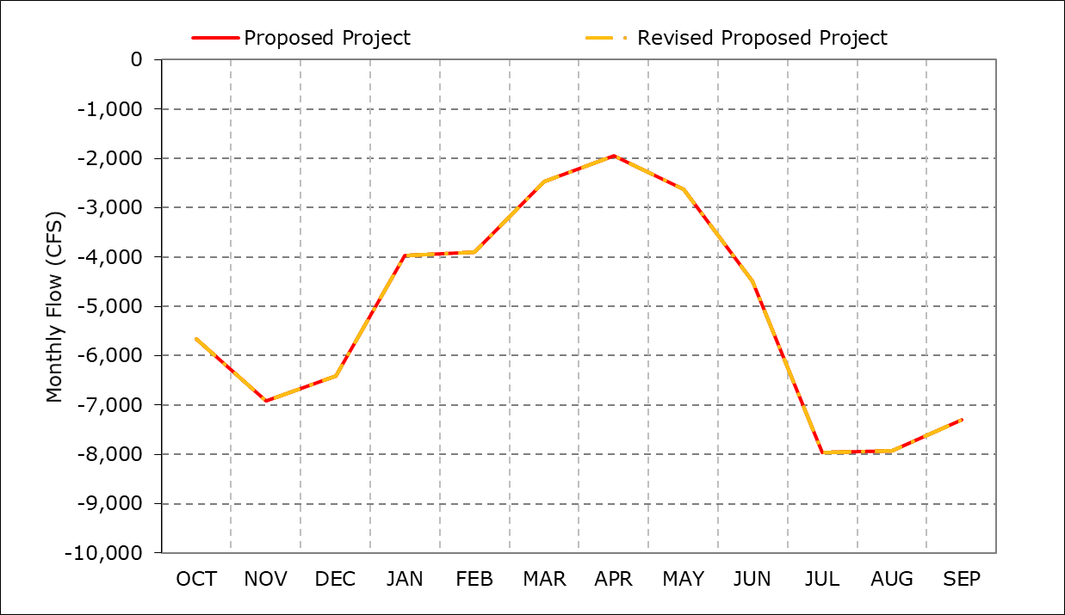

Figure 1 Combined Old and Middle River Monthly Flow for the Proposed Project and Revised Proposed Project

As shown in Figures 2 and 3, January and February diversions are similar at SWP Banks Pumping Plant and Jones Pumping Plant under the Revised Proposed Project as compared to the Proposed Project.

Considering changes described above, modeled hydrology for the Revised Proposed Project is similar to the Proposed Project. Therefore, conclusions of water quality and aquatic effects analyses in the EIR would be identical under the Revised Proposed Project as compared to the Proposed Project.

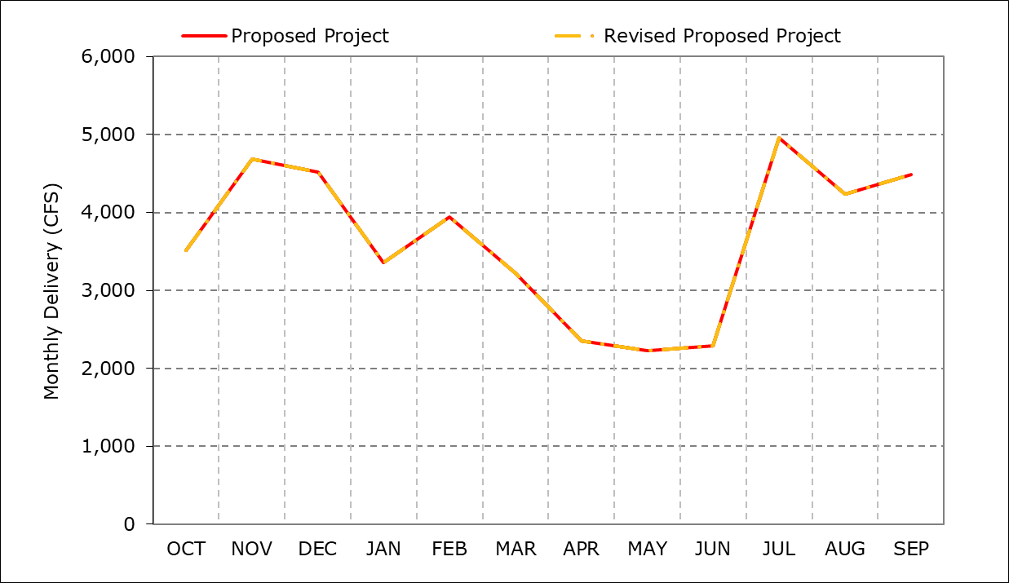

Figure 2 SWP Banks Pumping Plant Monthly Exports for the Proposed Project and Revised Proposed Project

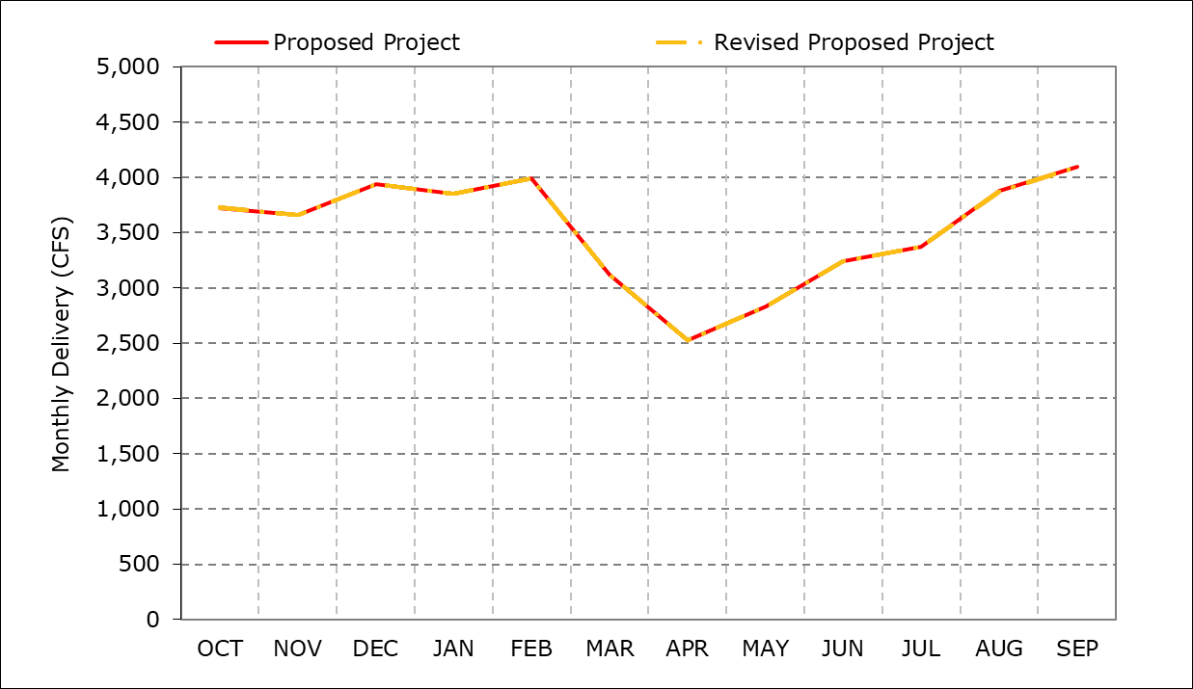

Figure 3 Jones Pumping Plant Monthly Exports for the Proposed Project and Revised Proposed Project

This page intentionally left blank

Appendix H Attachment 2-5   
Alternatives 2a and 3 Hydrology Analysis

* **Alternative 2a** – Evaluates the expected change in the Proposed Project if the SWP were to add additional outflow in the April to May period through export reductions down to the proportional share of the SJR IE (Action IV.2.1 from NMFS 2009 BiOp). Under this alternative it is possible for CVP to re-operate and adjust CVP exports to offset SWP actions.
* **Alternative 3** – Evaluates the expected change in the Proposed Project if the SWP were to include the installation of the Head of Old River Barrier (HORB).

# Approach to Analysis

The analyses herein are based on a simplified postprocessing analysis that focuses on changes to the April and May time period. The CalSim II output for the Proposed Project were used as the basis for comparison where simplified assumptions were used to estimate changes in Delta outflow, Old and Middle River (OMR) flows and Exports for both CVP and SWP. This was a Delta centric analysis where the following assumptions that were used in developing these estimates:

* Only export changes were assumed while analyzing these alternatives,
* Only export changes during excess conditions[1] were assumed to have a resulting increase or decrease in Delta outflow,
* Any water quality changes were assumed to be insignificant.

# Alternative 2a Method

Evaluates the expected change in the Proposed Project if the SWP were to add additional outflow in the April to May period through export reductions down to the proportional share of the SJR IE. Under this alternative it is possible for CVP to re-operate and adjust CVP exports to offset SWP actions.

To estimate the reduction in the SWP exports at Banks, the potential increase in the CVP at Jones, the resulting change to OMR, and the increase in Delta outflow, the following method was employed:

* Starting with the Proposed Project SWP and CVP exports as estimated by CalSim, determine the difference between the Proposed Project SWP exports and what would be required under a SJR IE criteria.
* CVP exports were assumed able to pick up difference in SWP exports between Proposed Project and SJR IE up to the full plant capacity or space available in CVP San Luis.
* The remaining volume was used to determine the change in OMR flow and the increase in Delta Outflow.

Figures 1 to 10 and Tables 1 to 20 illustrate the results of Alternative 2a for Delta outflow, OMR, total exports, Jones exports, and Banks exports.

# Alternative 3 Method

Evaluates the expected change in the Proposed Project if the SWP were to include the installation of the HORB. The OMR flow is dependent on 3 main parameters 1) Exports level, local diversions and the San Joaquin River flow into Old River. The installation of the HORB reduces the contribution of the San Joaquin River flow into Old River and either forces a reduction in exports or causes more negative OMR flow. To estimate the response in an installation of the HORB with the Proposed Project the following method was implemented:

* The estimated reduction in San Joaquin flow into Old River was determined using the simulated OMR flow, San Joaquin flow and the change in coefficient used in calculating OMR.
* The reduction in San Joaquin contribution was used to determine the export quantity to offset that reduction. It was assumed that exports would only be reduced down to a combined 1,500 cfs.
* The San Joaquin flow that could not be offset by a reduction in exports was used to calculate the increase in more negative OMR flow.
* The change in exports were used to determine additional Delta outflow.

Figures 11 to 20 and Tables 21 to 40 illustrate the results of Alternative 3 for Delta outflow, OMR, total exports, Jones exports, and Banks exports.

## Alternative 2a Output

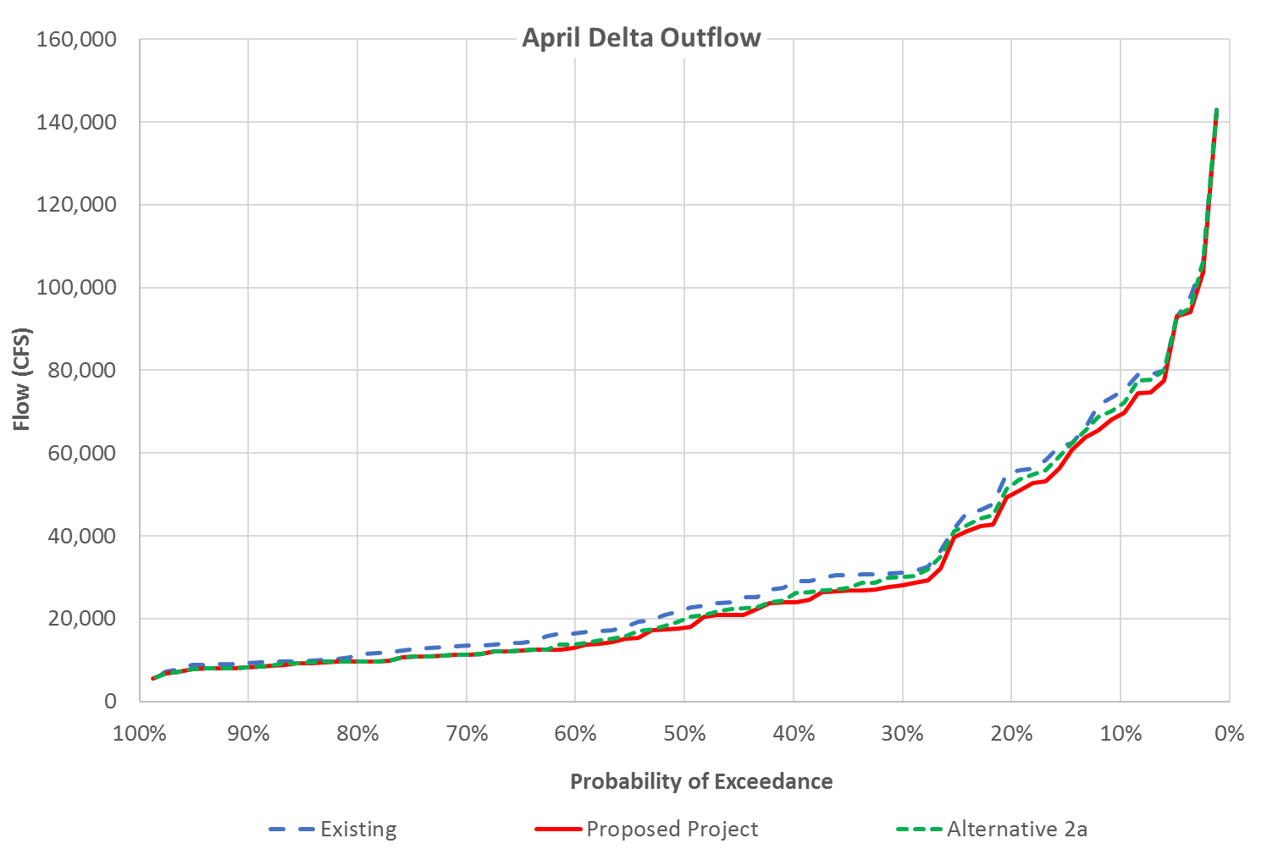

Figure 1: Probability of exceedance of Delta outflow in April

Table 1: Average Delta outflow in April

|  |  |  |  |  |  |
| --- | --- | --- | --- | --- | --- |
| Water Year Type | Existing | Proposed Project | Alternative 2a | Existing vs. Alternative 2a | Proposed Project vs. Alternative 2a |
| W | 56933 | 53084 | 54871 | -2062 (-4%) | 1787 (3%) |
| AN | 33562 | 29851 | 31227 | -2335 (-7%) | 1377 (5%) |
| BN | 23217 | 20278 | 21428 | -1789 (-8%) | 1151 (6%) |
| D | 15097 | 13225 | 13265 | -1832 (-12%) | 41 (0%) |
| C | 9410 | 8916 | 8916 | -494 (-5%) | 0 (0%) |
| Average | 31618 | 28870 | 29843 | -1776 (-6%) | 973 (3%) |

Table 2: Probability of exceedance of Delta outflow in April

| Probability of Exceedance | Existing | Proposed Project | Alternative 2a | Existing vs. Alternative 2a | Proposed Project vs. Alternative 2a |
| --- | --- | --- | --- | --- | --- |
| 10% | 74775 | 69331 | 71575 | -3199 (-4%) | 2245 (3%) |
| 20% | 55367 | 49987 | 52335 | -3032 (-5%) | 2348 (5%) |
| 30% | 31129 | 28197 | 30047 | -1081 (-3%) | 1850 (7%) |
| 40% | 28790 | 23989 | 25790 | -2999 (-10%) | 1801 (8%) |
| 50% | 22248 | 17845 | 19860 | -2388 (-11%) | 2015 (11%) |
| 60% | 16523 | 13030 | 13854 | -2669 (-16%) | 824 (6%) |
| 70% | 13456 | 11221 | 11221 | -2234 (-17%) | 0 (0%) |
| 80% | 11145 | 9673 | 9673 | -1472 (-13%) | 0 (0%) |
| 90% | 9317 | 8280 | 8280 | -1037 (-11%) | 0 (0%) |

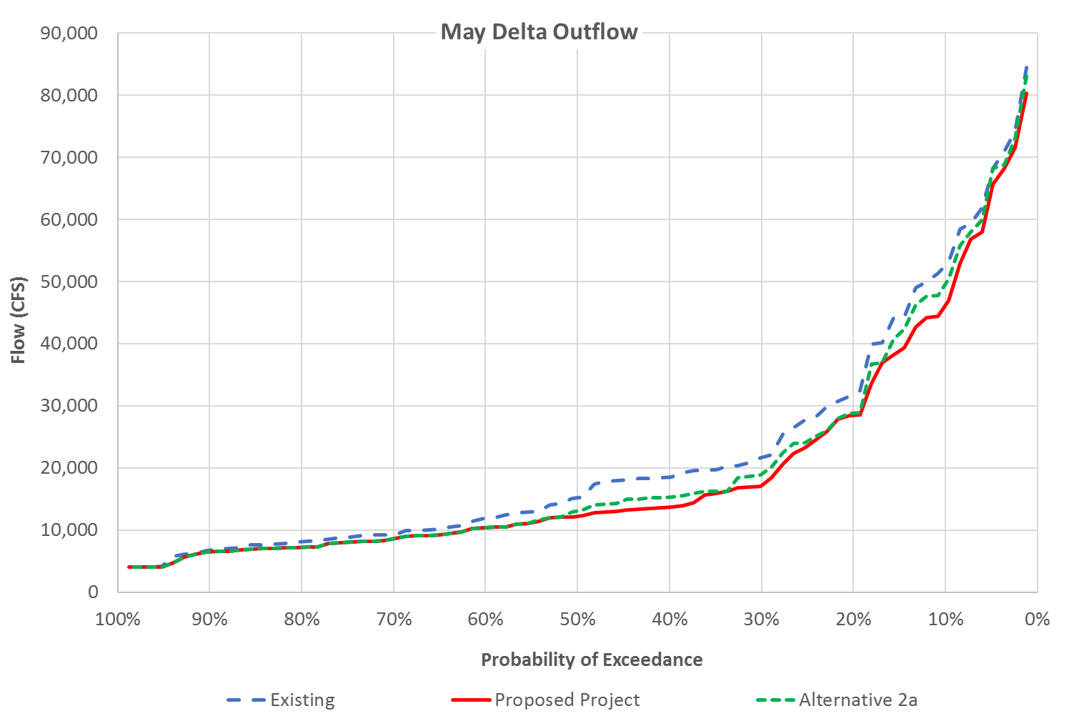Figure 2: Probability of exceedance of Delta outflow in May

Table 3: Average Delta outflow in May

| Water Year Type | Existing | Proposed Project | Alternative 2a | Existing vs. Alternative 2a | Proposed Project vs. Alternative 2a |
| --- | --- | --- | --- | --- | --- |
| W | 39709 | 35402 | 37022 | -2687 (-7%) | 1620 (5%) |
| AN | 24582 | 20521 | 21541 | -3041 (-12%) | 1020 (5%) |
| BN | 15806 | 13073 | 13886 | -1920 (-12%) | 813 (6%) |
| D | 9920 | 8909 | 8958 | -962 (-10%) | 49 (1%) |
| C | 5821 | 5628 | 5628 | -194 (-3%) | 0 (0%) |
| Average | 21916 | 19239 | 20052 | -1864 (-9%) | 813 (4%) |

Table 4: Probability of exceedance of Delta outflow in May

| Probability of Exceedance | Existing | Proposed Project | Alternative 2a | Existing vs. Alternative 2a | Proposed Project vs. Alternative 2a |
| --- | --- | --- | --- | --- | --- |
| 10% | 52644 | 46156 | 49582 | -3062 (-6%) | 3425 (7%) |
| 20% | 31925 | 28454 | 28791 | -3134 (-10%) | 337 (1%) |
| 30% | 21645 | 17182 | 19042 | -2603 (-12%) | 1860 (11%) |
| 40% | 18496 | 13649 | 15301 | -3195 (-17%) | 1652 (12%) |
| 50% | 15195 | 12246 | 13066 | -2128 (-14%) | 820 (7%) |
| 60% | 11871 | 10365 | 10365 | -1506 (-13%) | 0 (0%) |
| 70% | 9237 | 8661 | 8661 | -576 (-6%) | 0 (0%) |
| 80% | 8154 | 7188 | 7188 | -967 (-12%) | 0 (0%) |
| 90% | 6815 | 6451 | 6451 | -364 (-5%) | 0 (0%) |

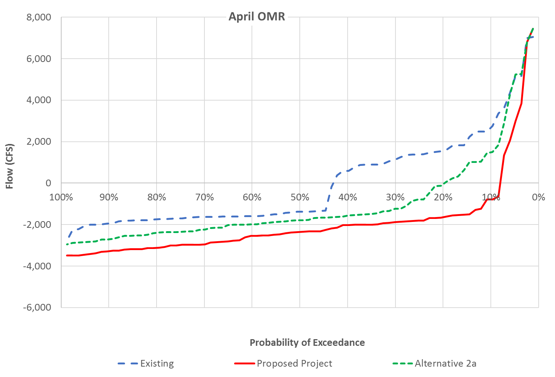

Figure 3: Probability of exceedance of OMR flow in April

Table 5: Average OMR flows in April

| Water Year Type | Existing | Proposed Project | Alternative 2a | Existing vs. Alternative 2a | Proposed Project vs. Alternative 2a |
| --- | --- | --- | --- | --- | --- |
| W | 1945 | -1208 | 426 | -1519 (-78%) | 1635 (135%) |
| AN | 104 | -2740 | -1486 | -1590 (-1522%) | 1254 (46%) |
| BN | -415 | -2495 | -1447 | -1032 (-249%) | 1048 (42%) |
| D | -1586 | -2300 | -2249 | -663 (-42%) | 51 (2%) |
| C | -1748 | -1592 | -1592 | 156 (9%) | 0 (0%) |
| Average | -43 | -1948 | -1056 | -1013 (-2368%) | 892 (46%) |

Table 6: Probability of exceedance of OMR flow in April

| Probability of Exceedance | Existing | Proposed Project | Alternative 2a | Existing vs. Alternative 2a | Proposed Project vs. Alternative 2a |
| --- | --- | --- | --- | --- | --- |
| 10% | 2669 | -789 | 1481 | -1188 (-45%) | 2270 (288%) |
| 20% | 1567 | -1652 | -56 | -1622 (-104%) | 1597 (97%) |
| 30% | 1136 | -1875 | -1235 | -2371 (-209%) | 640 (34%) |
| 40% | 595 | -2024 | -1569 | -2164 (-364%) | 454 (22%) |
| 50% | -1385 | -2352 | -1795 | -410 (-30%) | 557 (24%) |
| 60% | -1593 | -2538 | -1988 | -396 (-25%) | 550 (22%) |
| 70% | -1637 | -2951 | -2247 | -610 (-37%) | 704 (24%) |
| 80% | -1753 | -3125 | -2404 | -650 (-37%) | 721 (23%) |
| 90% | -1951 | -3289 | -2706 | -755 (-39%) | 583 (18%) |

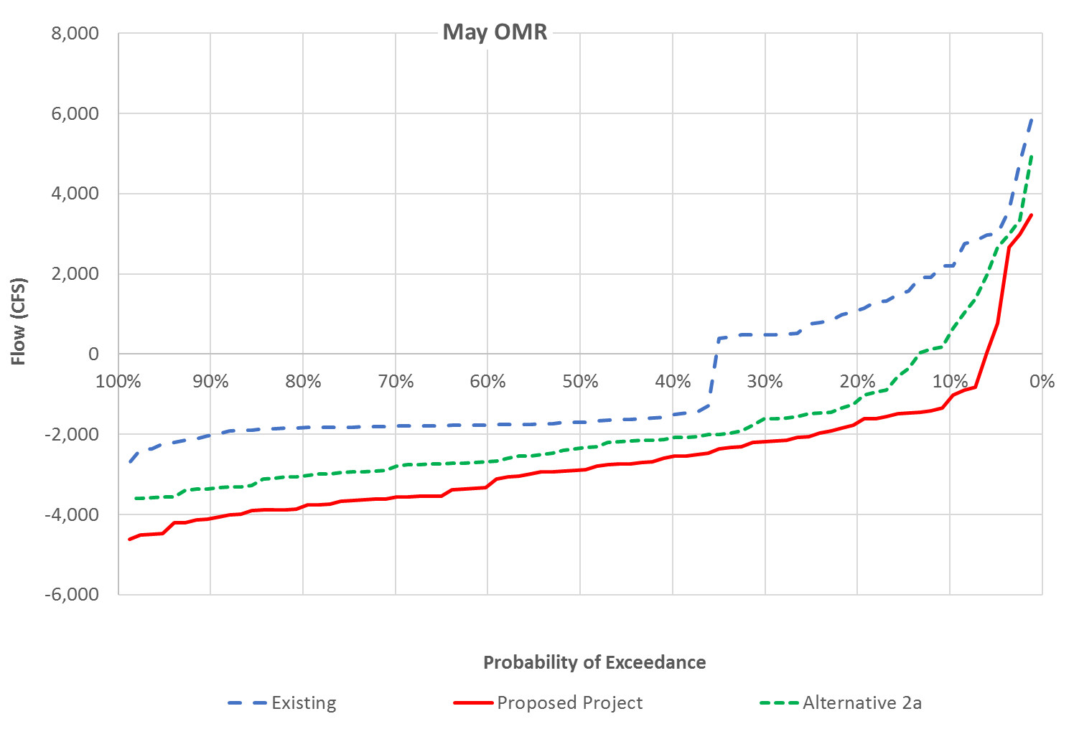 Figure 4: Probability of exceedance of OMR flow in May

Table 7: Average OMR flows in May

| Water Year Type | Existing | Proposed Project | Alternative 2a | Existing vs. Alternative 2a | Proposed Project vs. Alternative 2a |
| --- | --- | --- | --- | --- | --- |
| W | 812 | -2388 | -908 | -1720 (-212%) | 1481 (62%) |
| AN | -383 | -3585 | -2656 | -2273 (-593%) | 929 (26%) |
| BN | -695 | -3268 | -2481 | -1786 (-257%) | 787 (24%) |
| D | -1773 | -2548 | -2503 | -731 (-41%) | 44 (2%) |
| C | -1881 | -1522 | -1522 | 359 (19%) | 0 (0%) |
| Average | -582 | -2622 | -1872 | -1290 (-222%) | 750 (29%) |

Table 8: Probability of exceedance of OMR flow in May

| Probability of Exceedance | Existing | Proposed Project | Alternative 2a | Existing vs. Alternative 2a | Proposed Project vs. Alternative 2a |
| --- | --- | --- | --- | --- | --- |
| 10% | 2194 | -1126 | 498 | -1696 (-77%) | 1624 (144%) |
| 20% | 1088 | -1711 | -1164 | -2252 (-207%) | 547 (32%) |
| 30% | 488 | -2189 | -1612 | -2100 (-430%) | 577 (26%) |
| 40% | -1517 | -2560 | -2096 | -580 (-38%) | 463 (18%) |
| 50% | -1706 | -2897 | -2342 | -636 (-37%) | 555 (19%) |
| 60% | -1767 | -3284 | -2683 | -916 (-52%) | 601 (18%) |
| 70% | -1797 | -3564 | -2809 | -1012 (-56%) | 755 (21%) |
| 80% | -1835 | -3806 | -3043 | -1207 (-66%) | 763 (20%) |
| 90% | -2022 | -4102 | -3353 | -1331 (-66%) | 749 (18%) |

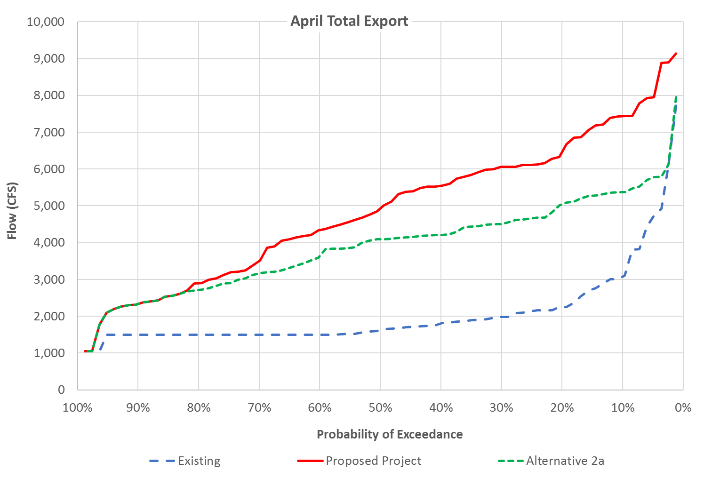

Figure 5: Probability of exceedance of total exports in April

Table 9: Average total exports in April

| Water Year Type | Existing | Proposed Project | Alternative 2a | Existing vs. Alternative 2a | Proposed Project vs. Alternative 2a |
| --- | --- | --- | --- | --- | --- |
| W | 2791 | 6606 | 4819 | 2028 (73%) | -1787 (-27%) |
| AN | 1765 | 5702 | 4325 | 2560 (145%) | -1377 (-24%) |
| BN | 1651 | 4931 | 3781 | 2129 (129%) | -1151 (-23%) |
| D | 1813 | 3643 | 3587 | 1774 (98%) | -56 (-2%) |
| C | 1570 | 2121 | 2121 | 550 (35%) | 0 (0%) |
| Average | 2053 | 4881 | 3904 | 1851 (90%) | -977 (-20%) |

Table 10: Probability of exceedance of total exports in April

| Probability of Exceedance | Existing | Proposed Project | Alternative 2a | Existing vs. Alternative 2a | Proposed Project vs. Alternative 2a |
| --- | --- | --- | --- | --- | --- |
| 10% | 3080 | 7432 | 5372 | 2292 (74%) | -2060 (-28%) |
| 20% | 2250 | 6465 | 5045 | 2795 (124%) | -1419 (-22%) |
| 30% | 1978 | 6054 | 4509 | 2531 (128%) | -1545 (-26%) |
| 40% | 1804 | 5547 | 4207 | 2403 (133%) | -1340 (-24%) |
| 50% | 1625 | 4929 | 4094 | 2469 (152%) | -836 (-17%) |
| 60% | 1500 | 4339 | 3642 | 2142 (143%) | -697 (-16%) |
| 70% | 1500 | 3507 | 3164 | 1664 (111%) | -343 (-10%) |
| 80% | 1500 | 2898 | 2716 | 1216 (81%) | -182 (-6%) |
| 90% | 1500 | 2332 | 2332 | 832 (55%) | 0 (0%) |

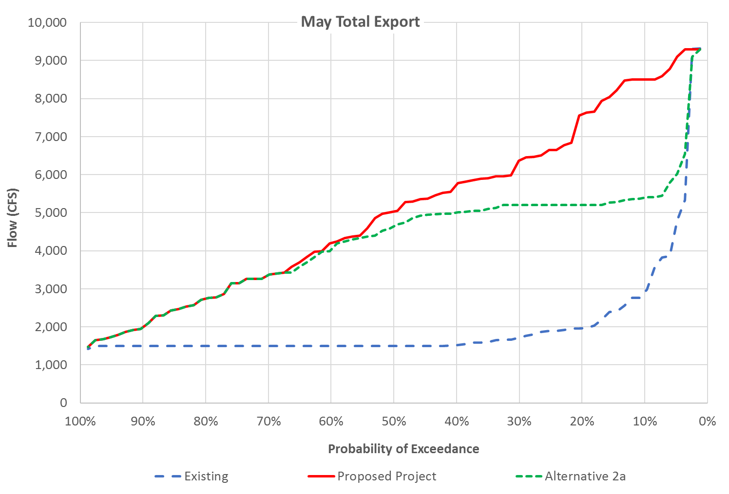

Figure 6: Probability of exceedance of total exports in May

Table 11: Average total exports in May

| Water Year Type | Existing | Proposed Project | Alternative 2a | Existing vs. Alternative 2a | Proposed Project vs. Alternative 2a |
| --- | --- | --- | --- | --- | --- |
| W | 2861 | 7027 | 5407 | 2546 (89%) | -1620 (-23%) |
| AN | 1639 | 5966 | 4946 | 3306 (202%) | -1020 (-17%) |
| BN | 1580 | 5258 | 4394 | 2814 (178%) | -864 (-16%) |
| D | 1621 | 3495 | 3446 | 1825 (113%) | -49 (-1%) |
| C | 1644 | 1996 | 1996 | 351 (21%) | 0 (0%) |
| Average | 2013 | 5058 | 4237 | 2224 (110%) | -821 (-16%) |

Table 12: Probability of exceedance of total exports in May

| Probability of Exceedance | Existing | Proposed Project | Alternative 2a | Existing vs. Alternative 2a | Proposed Project vs. Alternative 2a |
| --- | --- | --- | --- | --- | --- |
| 10% | 2917 | 8502 | 5394 | 2477 (85%) | -3108 (-37%) |
| 20% | 1961 | 7591 | 5200 | 3239 (165%) | -2391 (-31%) |
| 30% | 1716 | 6372 | 5200 | 3484 (203%) | -1172 (-18%) |
| 40% | 1517 | 5731 | 5004 | 3487 (230%) | -728 (-13%) |
| 50% | 1500 | 5029 | 4636 | 3136 (209%) | -393 (-8%) |
| 60% | 1500 | 4201 | 4034 | 2534 (169%) | -167 (-4%) |
| 70% | 1500 | 3363 | 3363 | 1863 (124%) | 0 (0%) |
| 80% | 1500 | 2739 | 2739 | 1239 (83%) | 0 (0%) |
| 90% | 1500 | 1987 | 1987 | 487 (32%) | 0 (0%) |

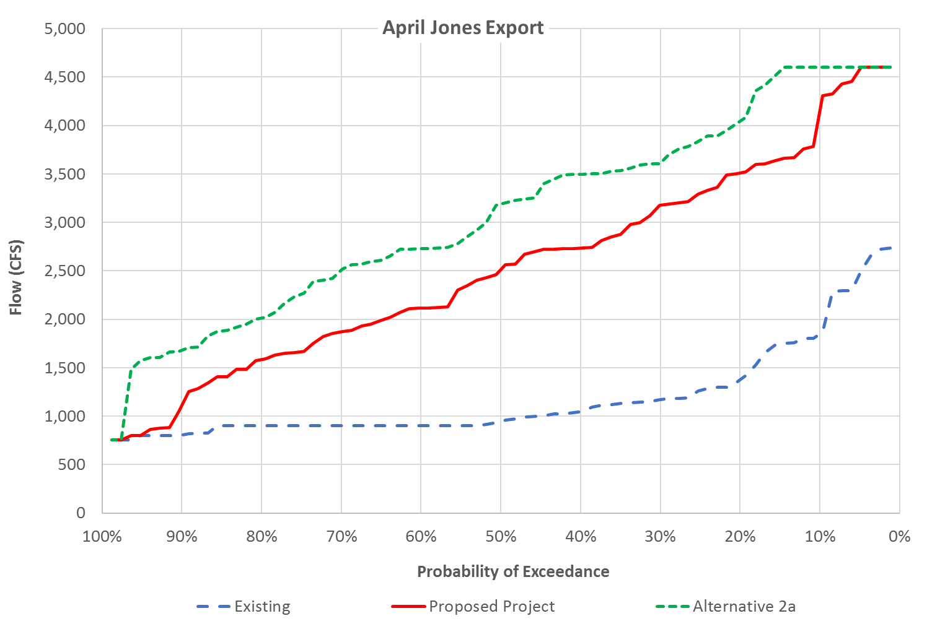

Figure 7: Probability of exceedance of Jones export in April

Table 13: Average Jones export in April

| Water Year Type | Existing | Proposed Project | Alternative 2a | Existing vs. Alternative 2a | Proposed Project vs. Alternative 2a |
| --- | --- | --- | --- | --- | --- |
| W | 1527 | 3364 | 3612 | 2085 (137%) | 248 (7%) |
| AN | 1059 | 3033 | 3604 | 2545 (240%) | 571 (19%) |
| BN | 980 | 2416 | 3115 | 2135 (218%) | 699 (29%) |
| D | 1118 | 2007 | 2945 | 1828 (164%) | 939 (47%) |
| C | 878 | 1122 | 1571 | 693 (79%) | 449 (40%) |
| Average | 1180 | 2528 | 3081 | 1901 (161%) | 553 (22%) |

Table 14: Probability of exceedance of Jones export in April

| Probability of Exceedance | Existing | Proposed Project | Alternative 2a | Existing vs. Alternative 2a | Proposed Project vs. Alternative 2a |
| --- | --- | --- | --- | --- | --- |
| 10% | 1848 | 4152 | 4600 | 2752 (149%) | 448 (11%) |
| 20% | 1379 | 3510 | 4044 | 2666 (193%) | 534 (15%) |
| 30% | 1173 | 3176 | 3616 | 2444 (208%) | 440 (14%) |
| 40% | 1046 | 2733 | 3497 | 2451 (234%) | 764 (28%) |
| 50% | 948 | 2511 | 3187 | 2239 (236%) | 676 (27%) |
| 60% | 900 | 2114 | 2730 | 1830 (203%) | 617 (29%) |
| 70% | 900 | 1871 | 2512 | 1612 (179%) | 641 (34%) |
| 80% | 900 | 1584 | 2014 | 1114 (124%) | 430 (27%) |
| 90% | 806 | 1113 | 1680 | 874 (108%) | 567 (51%) |

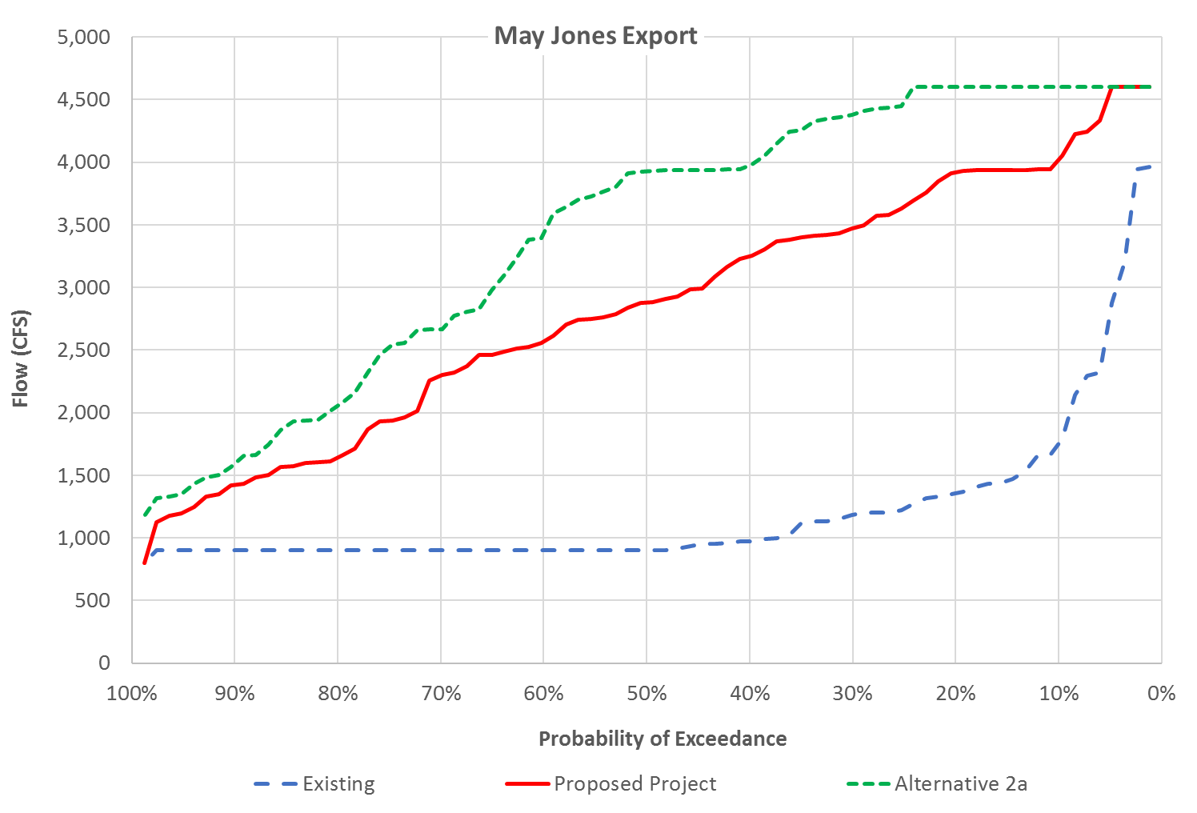

Figure 8: Probability of exceedance of Jones export in May

Table 15: Average Jones export in May

| Water Year Type | Existing | Proposed Project | Alternative 2a | Existing vs. Alternative 2a | Proposed Project vs. Alternative 2a |
| --- | --- | --- | --- | --- | --- |
| W | 1591 | 3634 | 4162 | 2571 (162%) | 529 (15%) |
| AN | 984 | 3264 | 4283 | 3299 (335%) | 1019 (31%) |
| BN | 948 | 3037 | 3755 | 2808 (296%) | 719 (24%) |
| D | 992 | 2161 | 2834 | 1841 (186%) | 673 (31%) |
| C | 1190 | 1436 | 1557 | 367 (31%) | 121 (8%) |
| Average | 1202 | 2833 | 3438 | 2235 (186%) | 605 (21%) |

Table 16: Probability of exceedance of Jones export in May

| Probability of Exceedance | Existing | Proposed Project | Alternative 2a | Existing vs. Alternative 2a | Proposed Project vs. Alternative 2a |
| --- | --- | --- | --- | --- | --- |
| 10% | 1750 | 4019 | 4600 | 2850 (163%) | 581 (14%) |
| 20% | 1357 | 3921 | 4600 | 3243 (239%) | 679 (17%) |
| 30% | 1183 | 3473 | 4380 | 3197 (270%) | 906 (26%) |
| 40% | 975 | 3246 | 3976 | 3001 (308%) | 730 (22%) |
| 50% | 900 | 2879 | 3928 | 3028 (336%) | 1049 (36%) |
| 60% | 900 | 2570 | 3434 | 2534 (282%) | 864 (34%) |
| 70% | 900 | 2299 | 2665 | 1765 (196%) | 366 (16%) |
| 80% | 900 | 1644 | 2055 | 1155 (128%) | 411 (25%) |
| 90% | 900 | 1421 | 1594 | 694 (77%) | 173 (12%) |

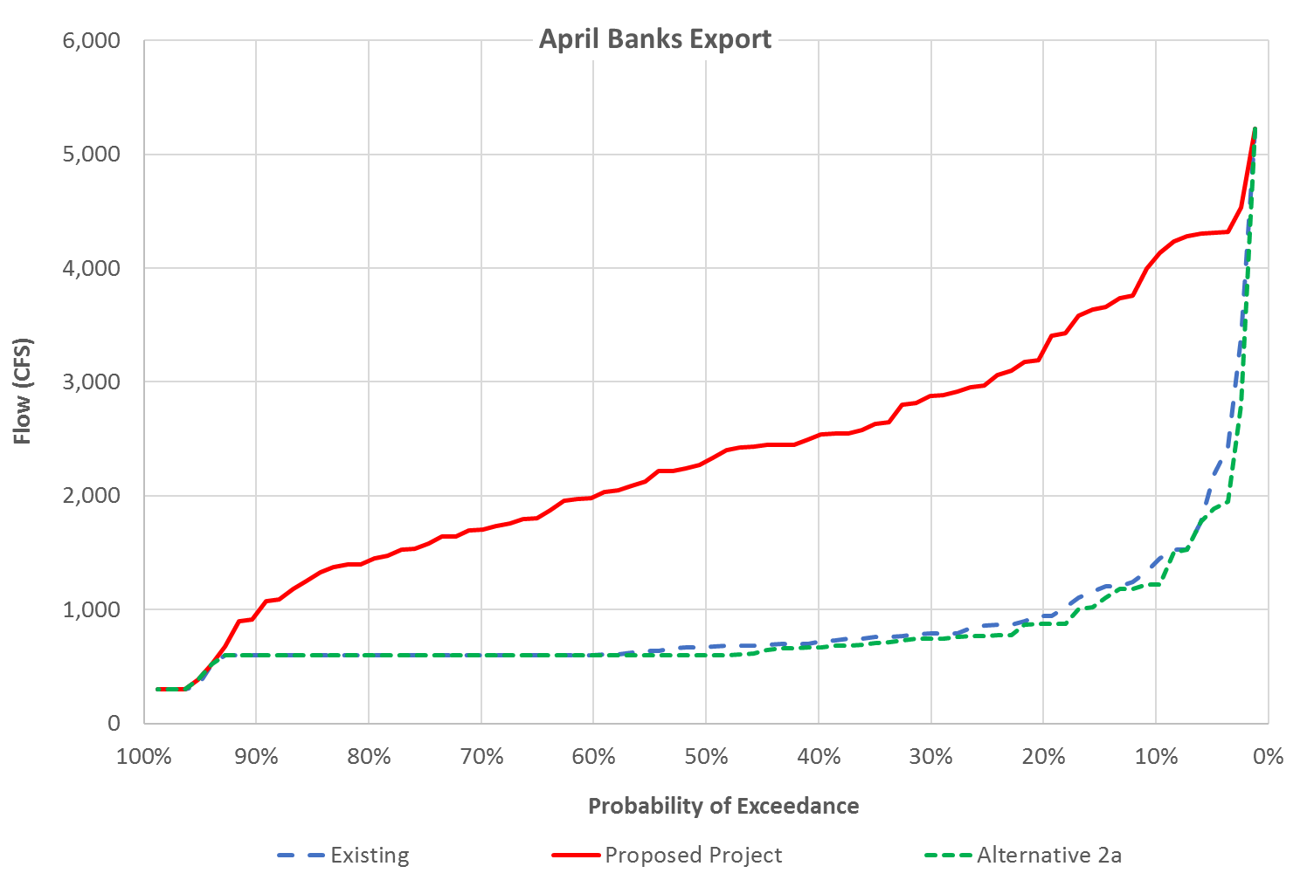

Figure 9: Probability of exceedance of Banks export in April

Table 17: Average Banks export in April

| Water Year Type | Existing | Proposed Project | Alternative 2a | Existing vs. Alternative 2a | Proposed Project vs. Alternative 2a |
| --- | --- | --- | --- | --- | --- |
| W | 1264 | 3241 | 1206 | -58 (-5%) | -2035 (-63%) |
| AN | 706 | 2669 | 721 | 15 (2%) | -1948 (-73%) |
| BN | 672 | 2515 | 666 | -6 (-1%) | -1850 (-74%) |
| D | 695 | 1636 | 642 | -53 (-8%) | -994 (-61%) |
| C | 692 | 999 | 550 | -143 (-21%) | -449 (-45%) |
| Average | 873 | 2353 | 823 | -50 (-6%) | -1530 (-65%) |

Table 18: Probability of exceedance of Banks export in April

| Probability of Exceedance | Existing | Proposed Project | Alternative 2a | Existing vs. Alternative 2a | Proposed Project vs. Alternative 2a |
| --- | --- | --- | --- | --- | --- |
| 10% | 1415 | 4093 | 1220 | -195 (-14%) | -2872 (-70%) |
| 20% | 945 | 3277 | 872 | -72 (-8%) | -2405 (-73%) |
| 30% | 790 | 2878 | 743 | -47 (-6%) | -2135 (-74%) |
| 40% | 716 | 2532 | 670 | -47 (-7%) | -1862 (-74%) |
| 50% | 673 | 2305 | 601 | -72 (-11%) | -1704 (-74%) |
| 60% | 604 | 1988 | 600 | -4 (-1%) | -1388 (-70%) |
| 70% | 600 | 1703 | 600 | 0 (0%) | -1103 (-65%) |
| 80% | 600 | 1429 | 600 | 0 (0%) | -829 (-58%) |
| 90% | 600 | 963 | 600 | 0 (0%) | -363 (-38%) |

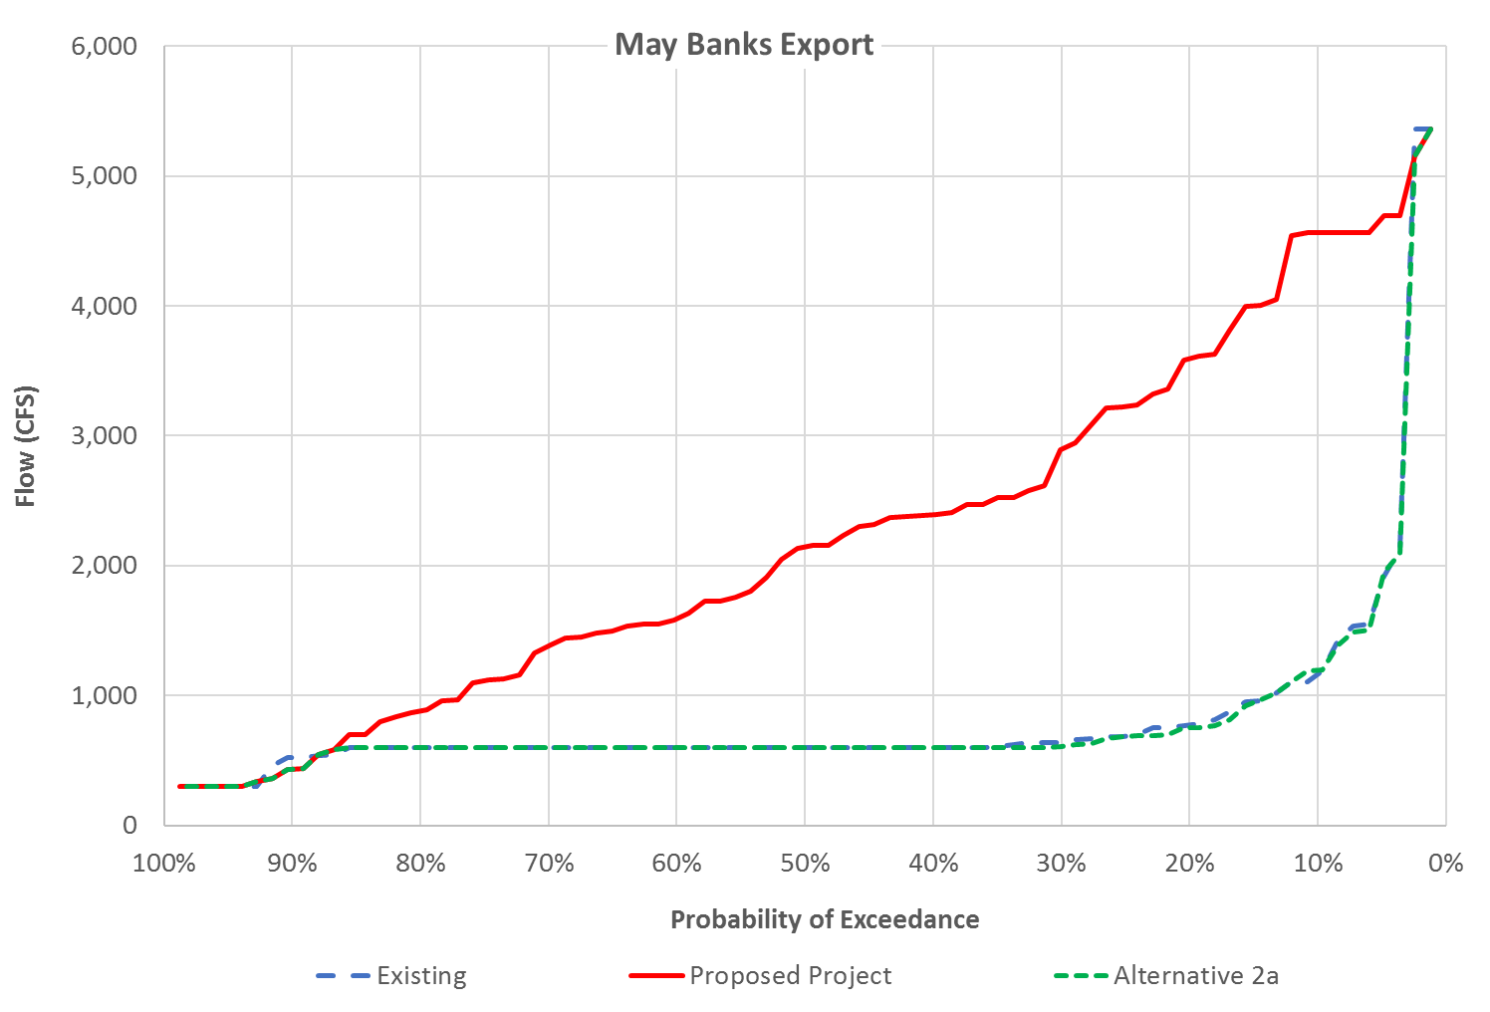

Figure 10: Probability of exceedance of Banks export in May

Table 19: Average Banks export in May

| Water Year Type | Existing | Proposed Project | Alternative 2a | Existing vs. Alternative 2a | Proposed Project vs. Alternative 2a |
| --- | --- | --- | --- | --- | --- |
| W | 1270 | 3393 | 1244 | -26 (-2%) | -2149 (-63%) |
| AN | 656 | 2702 | 663 | 7 (1%) | -2039 (-75%) |
| BN | 632 | 2221 | 638 | 7 (1%) | -1583 (-71%) |
| D | 628 | 1334 | 612 | -16 (-3%) | -721 (-54%) |
| C | 454 | 559 | 439 | -16 (-3%) | -121 (-22%) |
| Average | 811 | 2225 | 799 | -12 (-1%) | -1426 (-64%) |

Table 20: Probability of Exceedance of Banks export in May

| Probability of Exceedance | Existing | Proposed Project | Alternative 2a | Existing vs. Alternative 2a | Proposed Project vs. Alternative 2a |
| --- | --- | --- | --- | --- | --- |
| 10% | 1167 | 4562 | 1194 | 28 (2%) | -3368 (-74%) |
| 20% | 776 | 3597 | 755 | -21 (-3%) | -2842 (-79%) |
| 30% | 640 | 2897 | 609 | -31 (-5%) | -2287 (-79%) |
| 40% | 600 | 2390 | 600 | 0 (0%) | -1790 (-75%) |
| 50% | 600 | 2144 | 600 | 0 (0%) | -1544 (-72%) |
| 60% | 600 | 1591 | 600 | 0 (0%) | -991 (-62%) |
| 70% | 600 | 1384 | 600 | 0 (0%) | -784 (-57%) |
| 80% | 600 | 880 | 600 | 0 (0%) | -280 (-32%) |
| 90% | 525 | 433 | 433 | -92 (-18%) | 0 (0%) |

## Alternative 3 Output

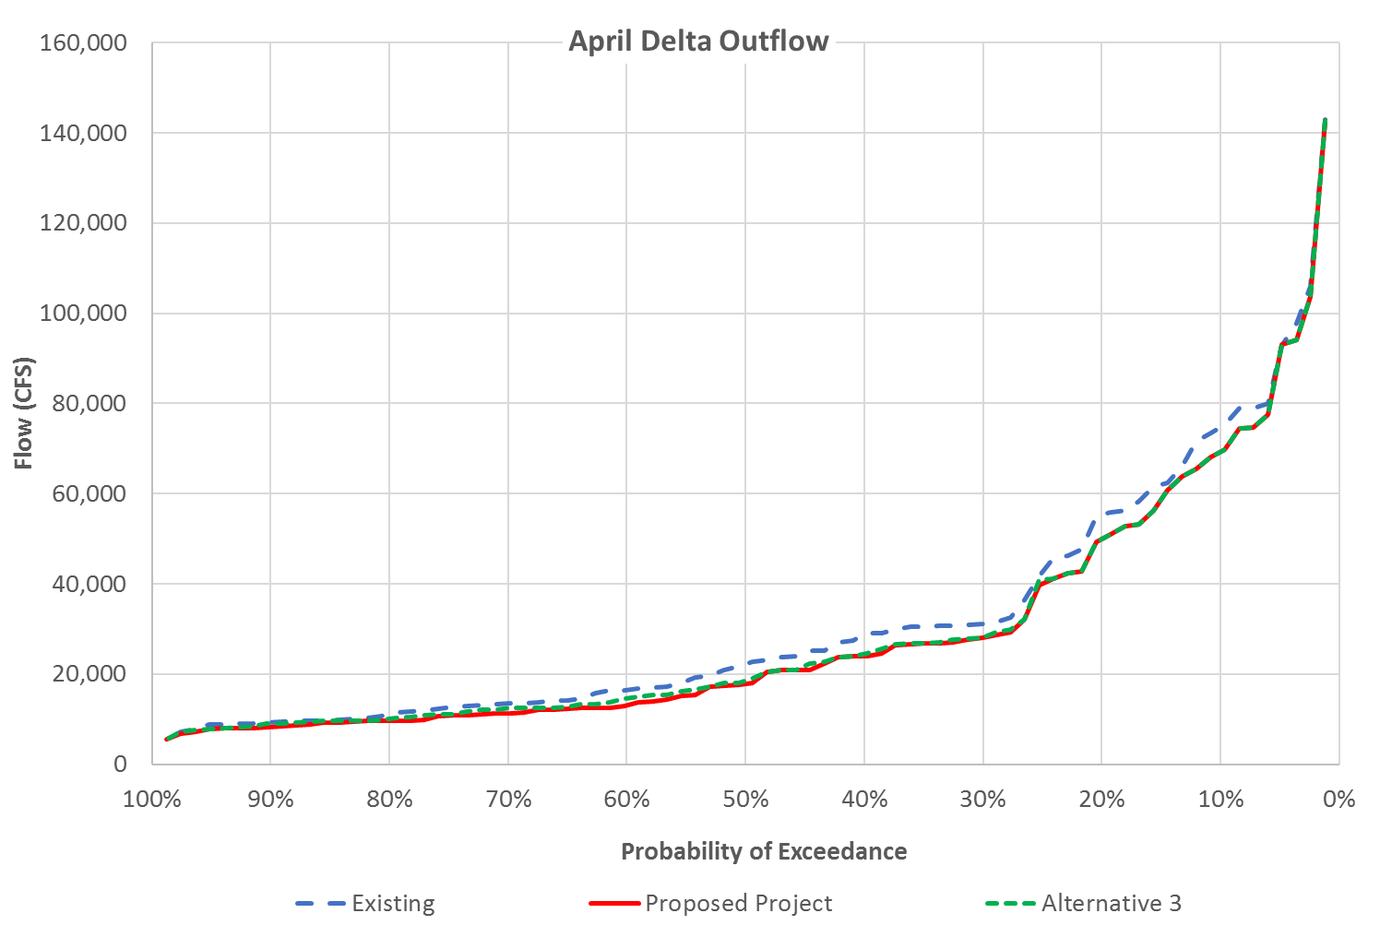

Figure 11: Probability of exceedance of Delta outflow in April

Table 21: Average Delta outflow in April

| Water Year Type | Existing | Proposed Project | Alternative 3 | Existing vs. Alternative 3 | Proposed Project vs. Alternative 3 |
| --- | --- | --- | --- | --- | --- |
| W | 56933 | 53084 | 53325 | -3608 (-6%) | 241 (0%) |
| AN | 33562 | 29851 | 30298 | -3264 (-10%) | 447 (1%) |
| BN | 23217 | 20278 | 20997 | -2220 (-10%) | 720 (4%) |
| D | 15097 | 13225 | 13784 | -1313 (-9%) | 560 (4%) |
| C | 9410 | 8916 | 9140 | -270 (-3%) | 224 (3%) |
| Average | 31618 | 28870 | 29290 | -2328 (-7%) | 420 (1%) |

Table 22: Probability of exceedance of Delta outflow in April

| Probability of Exceedance | Existing | Proposed Project | Alternative 3 | Existing vs. Alternative 3 | Proposed Project vs. Alternative 3 |
| --- | --- | --- | --- | --- | --- |
| 10% | 74775 | 69331 | 69331 | -5444 (-7%) | 0 (0%) |
| 20% | 55367 | 49987 | 49987 | -5381 (-10%) | 0 (0%) |
| 30% | 31129 | 28197 | 28246 | -2883 (-9%) | 49 (0%) |
| 40% | 28790 | 23989 | 24429 | -4360 (-15%) | 440 (2%) |
| 50% | 22248 | 17845 | 18612 | -3635 (-16%) | 768 (4%) |
| 60% | 16523 | 13030 | 14555 | -1969 (-12%) | 1525 (12%) |
| 70% | 13456 | 11221 | 12383 | -1073 (-8%) | 1162 (10%) |
| 80% | 11145 | 9673 | 10123 | -1022 (-9%) | 450 (5%) |
| 90% | 9317 | 8280 | 9010 | -307 (-3%) | 730 (9%) |

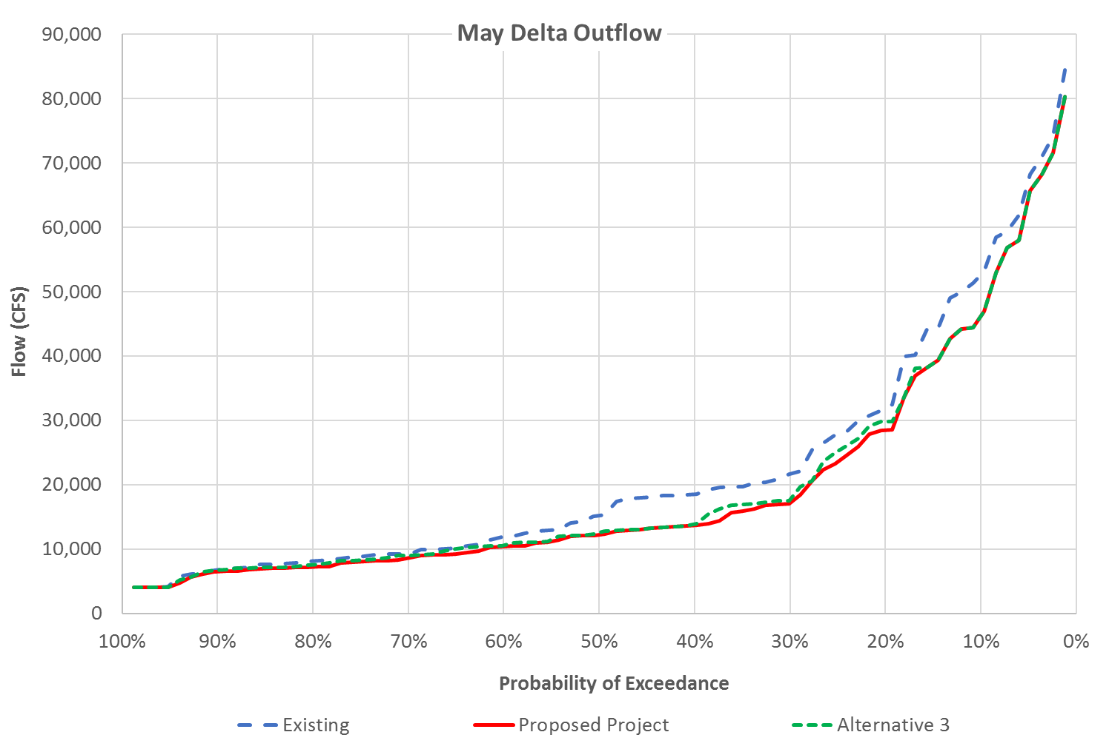

Figure 12: Probability of exceedance of Delta outflow in May

Table 23: Average Delta outflow in May

| Water Year Type | Existing | Proposed Project | Alternative 3 | Existing vs. Alternative 3 | Proposed Project vs. Alternative 3 |
| --- | --- | --- | --- | --- | --- |
| W | 39709 | 35402 | 35917 | -3792 (-10%) | 515 (1%) |
| AN | 24582 | 20521 | 21198 | -3384 (-14%) | 677 (3%) |
| BN | 15806 | 13073 | 13415 | -2392 (-15%) | 342 (3%) |
| D | 9920 | 8909 | 9201 | -718 (-7%) | 292 (3%) |
| C | 5821 | 5628 | 5768 | -53 (-1%) | 141 (3%) |
| Average | 21916 | 19239 | 19645 | -2271 (-10%) | 406 (2%) |

Table 24: Probability of exceedance of Delta outflow in May

| Probability of Exceedance | Existing | Proposed Project | Alternative 3 | Existing vs. Alternative 3 | Proposed Project vs. Alternative 3 |
| --- | --- | --- | --- | --- | --- |
| 10% | 52644 | 46156 | 46156 | -6488 (-12%) | 0 (0%) |
| 20% | 31925 | 28454 | 29831 | -2095 (-7%) | 1377 (5%) |
| 30% | 21645 | 17182 | 17772 | -3873 (-18%) | 590 (3%) |
| 40% | 18496 | 13649 | 13896 | -4600 (-25%) | 247 (2%) |
| 50% | 15195 | 12246 | 12600 | -2594 (-17%) | 354 (3%) |
| 60% | 11871 | 10365 | 10575 | -1296 (-11%) | 210 (2%) |
| 70% | 9237 | 8661 | 9009 | -228 (-2%) | 348 (4%) |
| 80% | 8154 | 7188 | 7594 | -560 (-7%) | 406 (6%) |
| 90% | 6815 | 6451 | 6753 | -62 (-1%) | 302 (5%) |

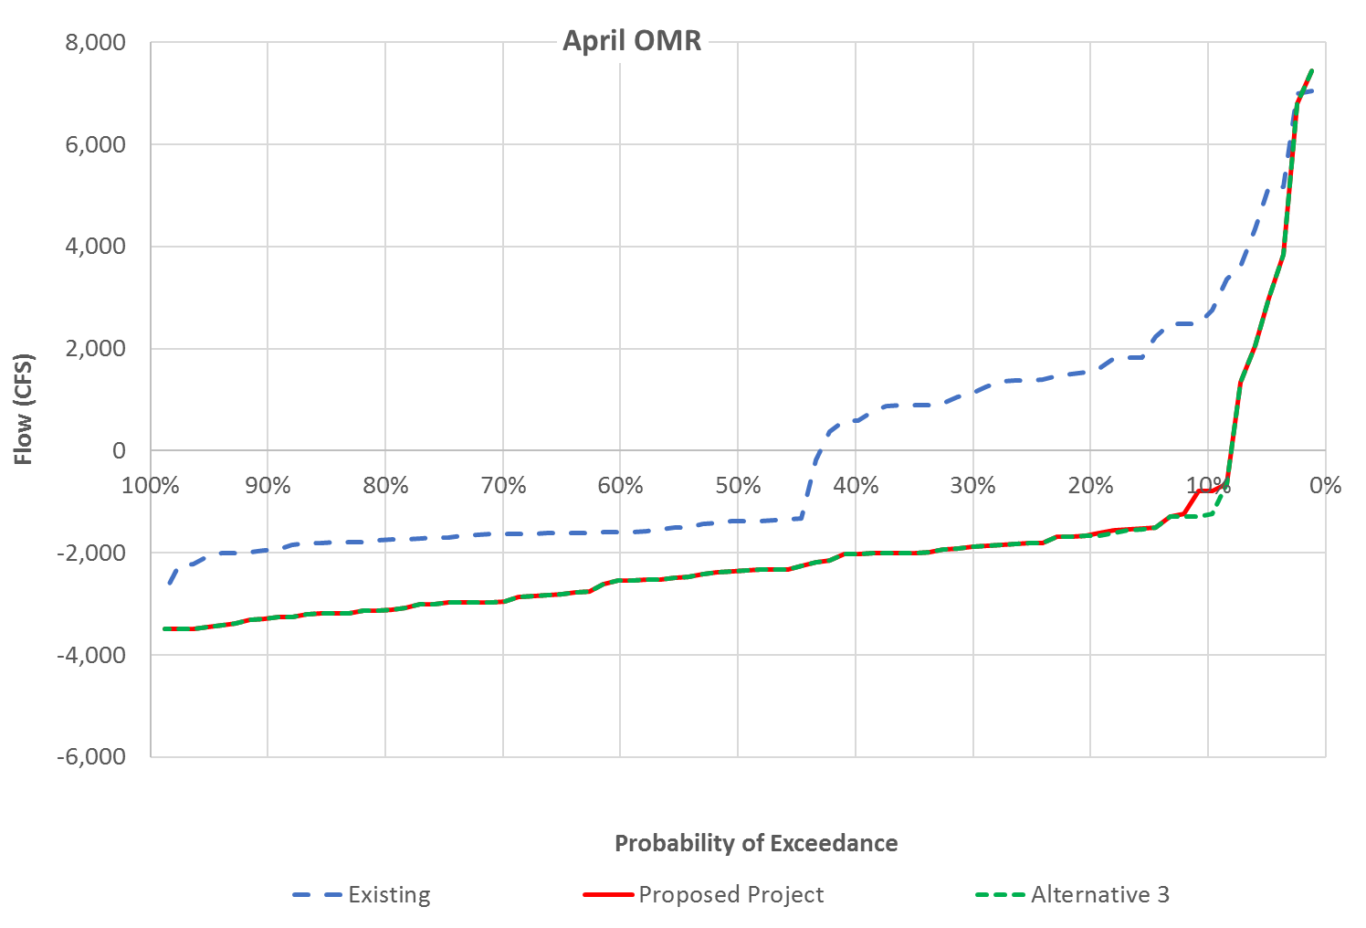

Figure 13: Probability of exceedance of OMR flow in April

Table 25: Average OMR flow in April

| Water Year Type | Existing | Proposed Project | Alternative 3 | Existing vs. Alternative 3 | Proposed Project vs. Alternative 3 |
| --- | --- | --- | --- | --- | --- |
| W | 1945 | -1208 | -1208 | -3154 (-162%) | 0 (0%) |
| AN | 104 | -2740 | -2740 | -2844 (-2722%) | 0 (0%) |
| BN | -415 | -2495 | -2495 | -2080 (-501%) | 0 (0%) |
| D | -1586 | -2300 | -2300 | -714 (-45%) | 0 (0%) |
| C | -1748 | -1592 | -1688 | 60 (3%) | -96 (-6%) |
| Average | -43 | -1948 | -1962 | -1919 (-4486%) | -14 (-1%) |

Table 26: Probability of exceedance of OMR flow in April

| Probability of Exceedance | Existing | Proposed Project | Alternative 3 | Existing vs. Alternative 3 | Proposed Project vs. Alternative 3 |
| --- | --- | --- | --- | --- | --- |
| 10% | 2669 | -789 | -1257 | -3926 (-147%) | -469 (-59%) |
| 20% | 1567 | -1652 | -1671 | -3238 (-207%) | -19 (-1%) |
| 30% | 1136 | -1875 | -1875 | -3011 (-265%) | 0 (0%) |
| 40% | 595 | -2024 | -2024 | -2619 (-440%) | 0 (0%) |
| 50% | -1385 | -2352 | -2352 | -967 (-70%) | 0 (0%) |
| 60% | -1593 | -2538 | -2538 | -945 (-59%) | 0 (0%) |
| 70% | -1637 | -2951 | -2951 | -1314 (-80%) | 0 (0%) |
| 80% | -1753 | -3125 | -3125 | -1371 (-78%) | 0 (0%) |
| 90% | -1951 | -3289 | -3289 | -1338 (-69%) | 0 (0%) |

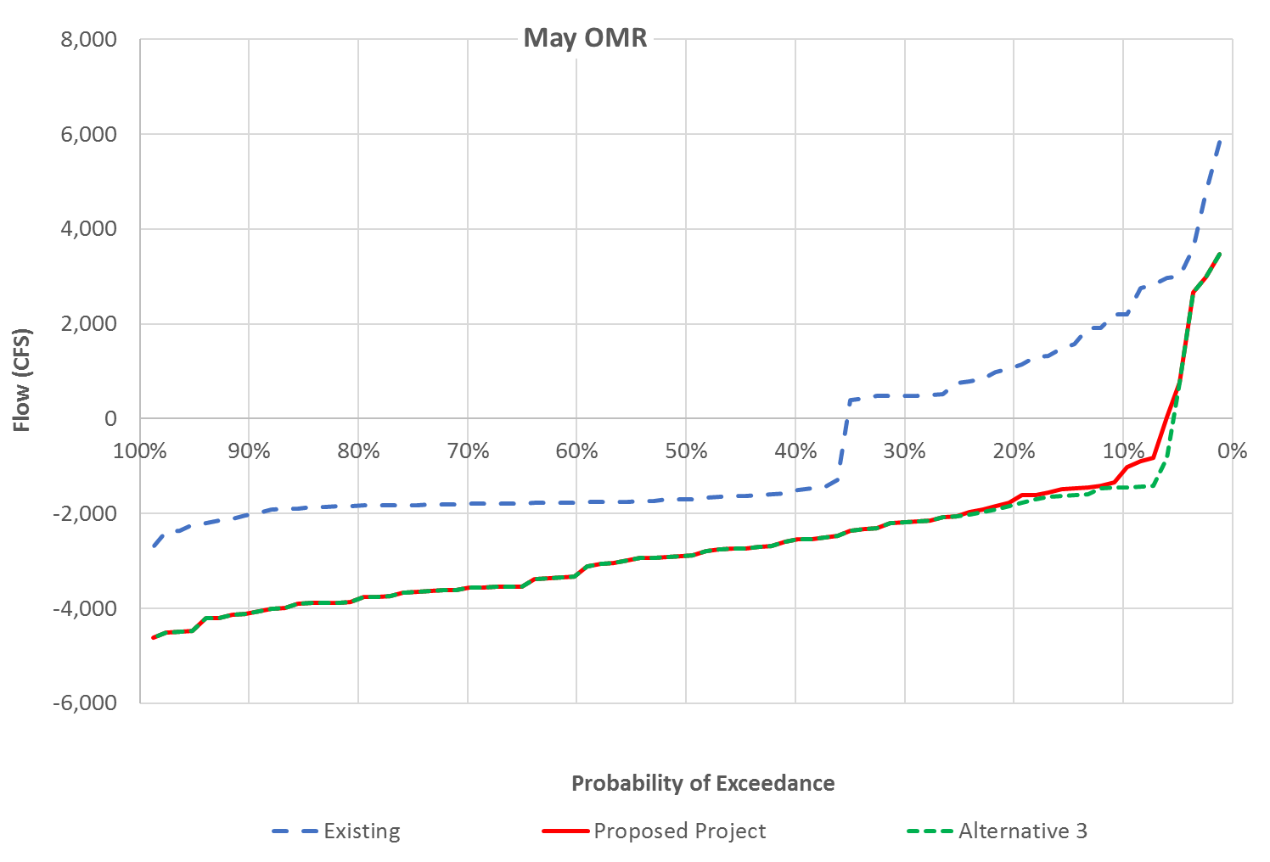

Figure 14: Probability of exceedance of OMR flow in May

Table 27: Average OMR flow in May

| Water Year Type | Existing | Proposed Project | Alternative 3 | Existing vs. Alternative 3 | Proposed Project vs. Alternative 3 |
| --- | --- | --- | --- | --- | --- |
| W | 812 | -2388 | -2451 | -3263 (-402%) | -63 (-3%) |
| AN | -383 | -3585 | -3585 | -3202 (-835%) | 0 (0%) |
| BN | -695 | -3268 | -3268 | -2573 (-370%) | 0 (0%) |
| D | -1773 | -2548 | -2548 | -775 (-44%) | 0 (0%) |
| C | -1881 | -1522 | -1684 | 197 (10%) | -163 (-11%) |
| Average | -582 | -2622 | -2666 | -2084 (-358%) | -44 (-2%) |

Table 28: Probability of exceedance of OMR flow in May

| Probability of Exceedance | Existing | Proposed Project | Alternative 3 | Existing vs. Alternative 3 | Proposed Project vs. Alternative 3 |
| --- | --- | --- | --- | --- | --- |
| 10% | 2194 | -1126 | -1450 | -3644 (-166%) | -324 (-29%) |
| 20% | 1088 | -1711 | -1818 | -2906 (-267%) | -107 (-6%) |
| 30% | 488 | -2189 | -2189 | -2677 (-549%) | 0 (0%) |
| 40% | -1517 | -2560 | -2560 | -1043 (-69%) | 0 (0%) |
| 50% | -1706 | -2897 | -2897 | -1191 (-70%) | 0 (0%) |
| 60% | -1767 | -3284 | -3284 | -1517 (-86%) | 0 (0%) |
| 70% | -1797 | -3564 | -3564 | -1767 (-98%) | 0 (0%) |
| 80% | -1835 | -3806 | -3806 | -1970 (-107%) | 0 (0%) |
| 90% | -2022 | -4102 | -4102 | -2079 (-103%) | 0 (0%) |

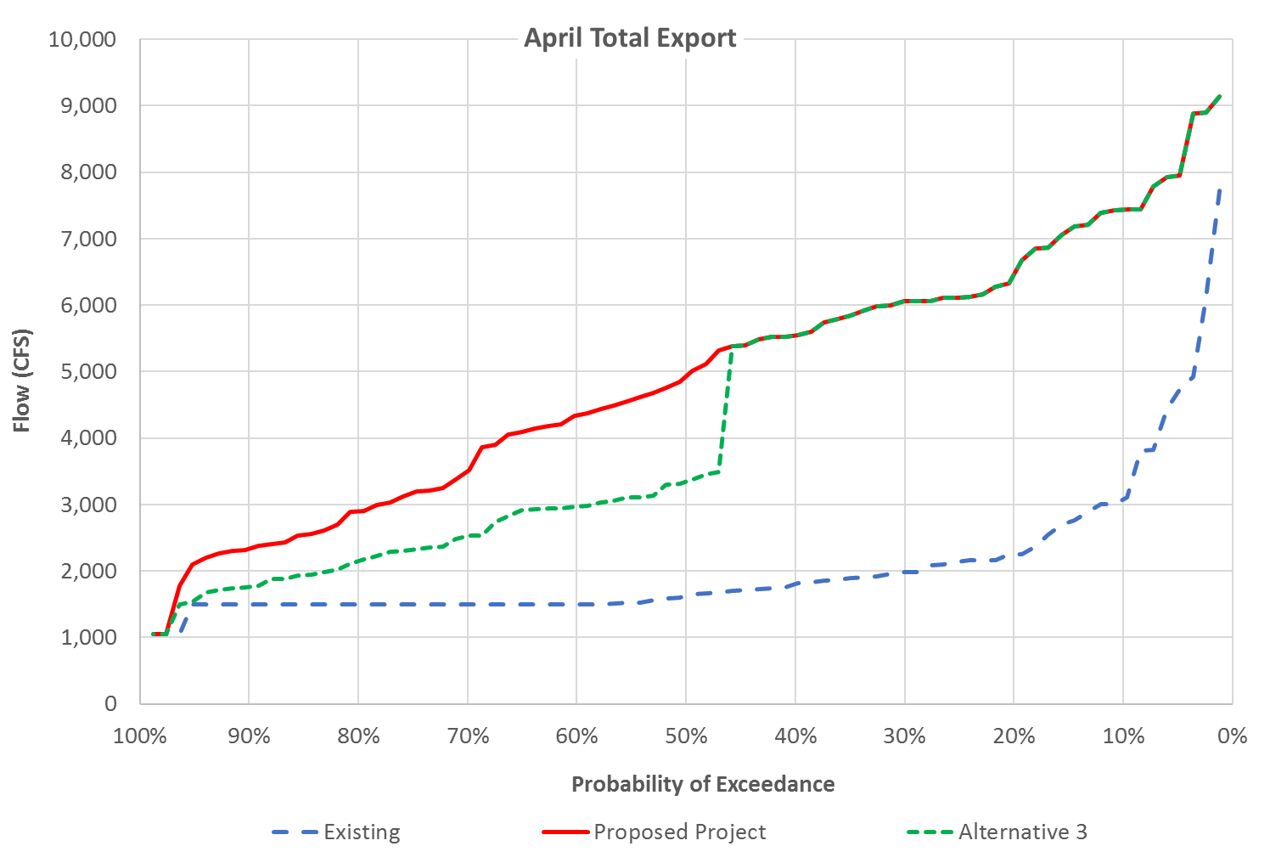

Figure 15: Probability of exceedance of total exports in April

Table 29: Average total exports in April

| Water Year Type | Existing | Proposed Project | Alternative 3 | Existing vs. Alternative 3 | Proposed Project vs. Alternative 3 |
| --- | --- | --- | --- | --- | --- |
| W | 2791 | 6606 | 6364 | 3573 (128%) | -241 (-4%) |
| AN | 1765 | 5702 | 5255 | 3490 (198%) | -447 (-8%) |
| BN | 1651 | 4931 | 4212 | 2560 (155%) | -720 (-15%) |
| D | 1813 | 3643 | 2799 | 987 (54%) | -843 (-23%) |
| C | 1570 | 2121 | 1665 | 94 (6%) | -456 (-22%) |
| Average | 2053 | 4881 | 4364 | 2311 (113%) | -517 (-11%) |

Table 30: Probability of exceedance of total exports in April

| Probability of Exceedance | Existing | Proposed Project | Alternative 3 | Existing vs. Alternative 3 | Proposed Project vs. Alternative 3 |
| --- | --- | --- | --- | --- | --- |
| 10% | 3080 | 7432 | 7432 | 4352 (141%) | 0 (0%) |
| 20% | 2250 | 6465 | 6465 | 4215 (187%) | 0 (0%) |
| 30% | 1978 | 6054 | 6054 | 4076 (206%) | 0 (0%) |
| 40% | 1804 | 5547 | 5547 | 3743 (207%) | 0 (0%) |
| 50% | 1625 | 4929 | 3347 | 1723 (106%) | -1582 (-32%) |
| 60% | 1500 | 4339 | 2976 | 1476 (98%) | -1363 (-31%) |
| 70% | 1500 | 3507 | 2522 | 1022 (68%) | -985 (-28%) |
| 80% | 1500 | 2898 | 2150 | 650 (43%) | -747 (-26%) |
| 90% | 1500 | 2332 | 1763 | 263 (18%) | -569 (-24%) |

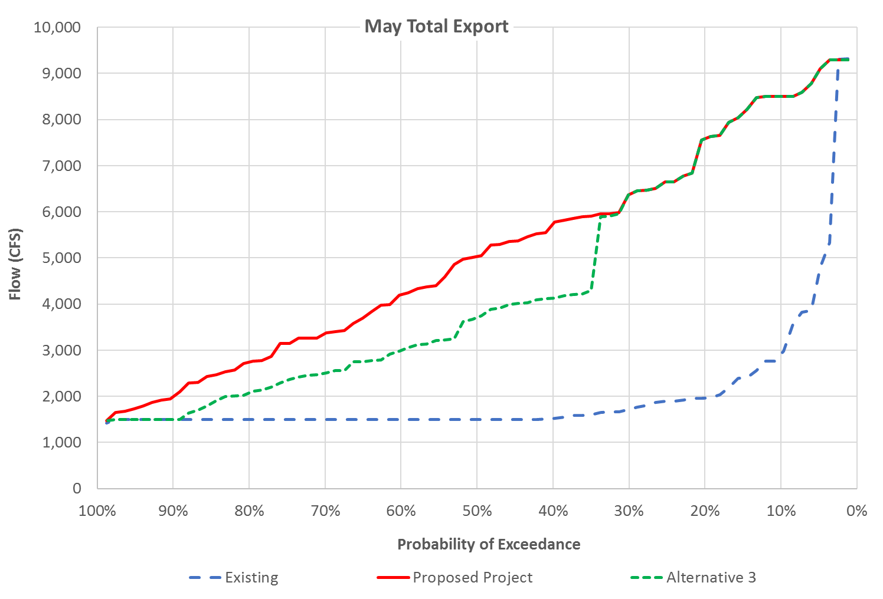

Figure 16: Probability of exceedance of total exports in May

Table 31: Average total exports in May

| Water Year Type | Existing | Proposed Project | Alternative 3 | Existing vs. Alternative 3 | Proposed Project vs. Alternative 3 |
| --- | --- | --- | --- | --- | --- |
| W | 2861 | 7027 | 6505 | 3644 (127%) | -522 (-7%) |
| AN | 1639 | 5966 | 5176 | 3536 (216%) | -790 (-13%) |
| BN | 1580 | 5258 | 4607 | 3028 (192%) | -651 (-12%) |
| D | 1621 | 3495 | 2678 | 1058 (65%) | -816 (-23%) |
| C | 1644 | 1996 | 1585 | -59 (-4%) | -411 (-21%) |
| Average | 2013 | 5058 | 4426 | 2413 (120%) | -632 (-12%) |

Table 32: Probability of exceedance of total exports in May

| Probability of Exceedance | Existing | Proposed Project | Alternative 3 | Existing vs. Alternative 3 | Proposed Project vs. Alternative 3 |
| --- | --- | --- | --- | --- | --- |
| 10% | 2917 | 8502 | 8502 | 5585 (191%) | 0 (0%) |
| 20% | 1961 | 7591 | 7591 | 5630 (287%) | 0 (0%) |
| 30% | 1716 | 6372 | 6372 | 4656 (271%) | 0 (0%) |
| 40% | 1517 | 5731 | 4122 | 2605 (172%) | -1610 (-28%) |
| 50% | 1500 | 5029 | 3710 | 2210 (147%) | -1319 (-26%) |
| 60% | 1500 | 4201 | 2995 | 1495 (100%) | -1206 (-29%) |
| 70% | 1500 | 3363 | 2502 | 1002 (67%) | -861 (-26%) |
| 80% | 1500 | 2739 | 2074 | 574 (38%) | -666 (-24%) |
| 90% | 1500 | 1987 | 1500 | 0 (0%) | -487 (-25%) |

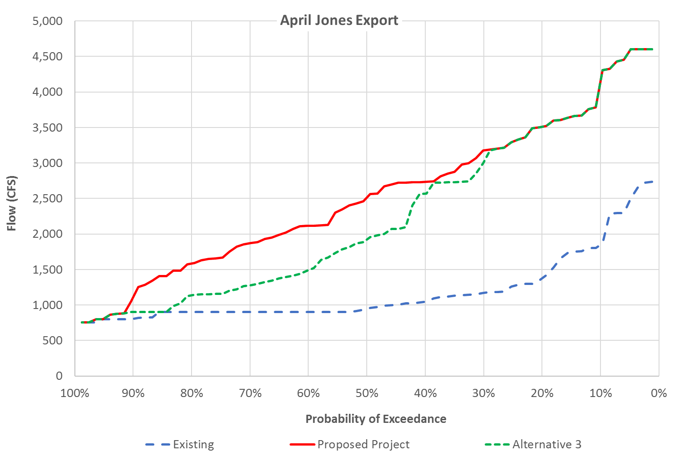

Figure 17: Probability of exceedance of Jones export in April

Table 33: Average Jones export in April

| Water Year Type | Existing | Proposed Project | Alternative 3 | Existing vs. Alternative 3 | Proposed Project vs. Alternative 3 |
| --- | --- | --- | --- | --- | --- |
| W | 1527 | 3364 | 3219 | 1692 (111%) | -145 (-4%) |
| AN | 1059 | 3033 | 2772 | 1713 (162%) | -261 (-9%) |
| BN | 980 | 2416 | 1995 | 1015 (104%) | -421 (-17%) |
| D | 1118 | 2007 | 1516 | 398 (36%) | -491 (-24%) |
| C | 878 | 1122 | 954 | 76 (9%) | -168 (-15%) |
| Average | 1180 | 2528 | 2239 | 1059 (90%) | -288 (-11%) |

Table 34: Probability of exceedance of Jones export in April

| Probability of Exceedance | Existing | Proposed Project | Alternative 3 | Existing vs. Alternative 3 | Proposed Project vs. Alternative 3 |
| --- | --- | --- | --- | --- | --- |
| 10% | 1848 | 4152 | 4152 | 2304 (125%) | 0 (0%) |
| 20% | 1379 | 3510 | 3510 | 2132 (155%) | 0 (0%) |
| 30% | 1173 | 3176 | 3013 | 1840 (157%) | -163 (-5%) |
| 40% | 1046 | 2733 | 2567 | 1521 (145%) | -167 (-6%) |
| 50% | 948 | 2511 | 1922 | 973 (103%) | -589 (-23%) |
| 60% | 900 | 2114 | 1492 | 592 (66%) | -621 (-29%) |
| 70% | 900 | 1871 | 1277 | 377 (42%) | -594 (-32%) |
| 80% | 900 | 1584 | 1136 | 236 (26%) | -448 (-28%) |
| 90% | 806 | 1113 | 900 | 94 (12%) | -213 (-19%) |

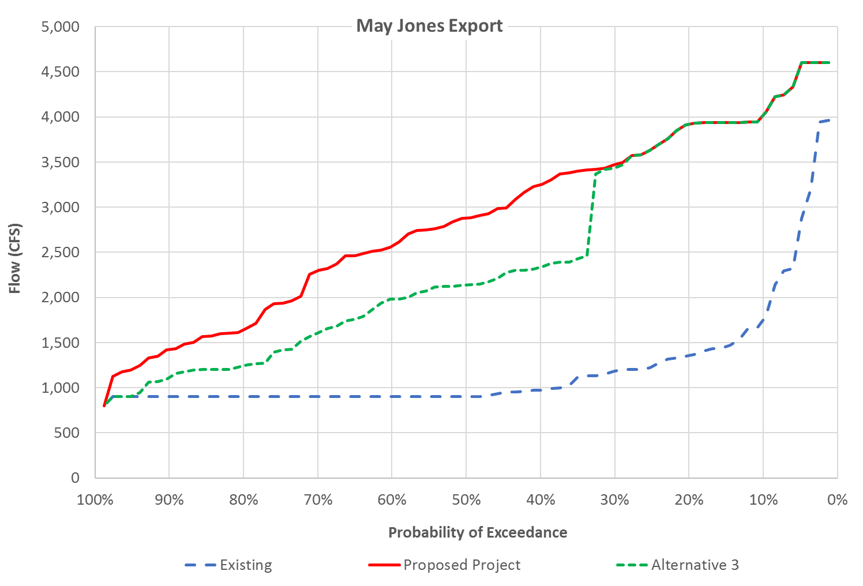

Figure 18: Probability of exceedance of Jones export in May

Table 35: Average Jones export in May

| Water Year Type | Existing | Proposed Project | Alternative 3 | Existing vs. Alternative 3 | Proposed Project vs. Alternative 3 |
| --- | --- | --- | --- | --- | --- |
| W | 1591 | 3634 | 3318 | 1727 (109%) | -316 (-9%) |
| AN | 984 | 3264 | 2790 | 1806 (184%) | -474 (-15%) |
| BN | 948 | 3037 | 2646 | 1699 (179%) | -390 (-13%) |
| D | 992 | 2161 | 1628 | 636 (64%) | -533 (-25%) |
| C | 1190 | 1436 | 1129 | -61 (-5%) | -308 (-21%) |
| Average | 1202 | 2833 | 2435 | 1232 (103%) | -398 (-14%) |

Table 36: Probability of exceedance of Jones export in May

| Probability of Exceedance | Existing | Proposed Project | Alternative 3 | Existing vs. Alternative 3 | Proposed Project vs. Alternative 3 |
| --- | --- | --- | --- | --- | --- |
| 10% | 1750 | 4019 | 4019 | 2269 (130%) | 0 (0%) |
| 20% | 1357 | 3921 | 3921 | 2564 (189%) | 0 (0%) |
| 30% | 1183 | 3473 | 3434 | 2252 (190%) | -39 (-1%) |
| 40% | 975 | 3246 | 2333 | 1358 (139%) | -912 (-28%) |
| 50% | 900 | 2879 | 2137 | 1237 (137%) | -741 (-26%) |
| 60% | 900 | 2570 | 1982 | 1082 (120%) | -588 (-23%) |
| 70% | 900 | 2299 | 1605 | 705 (78%) | -694 (-30%) |
| 80% | 900 | 1644 | 1242 | 342 (38%) | -401 (-24%) |
| 90% | 900 | 1421 | 1113 | 213 (24%) | -307 (-22%) |

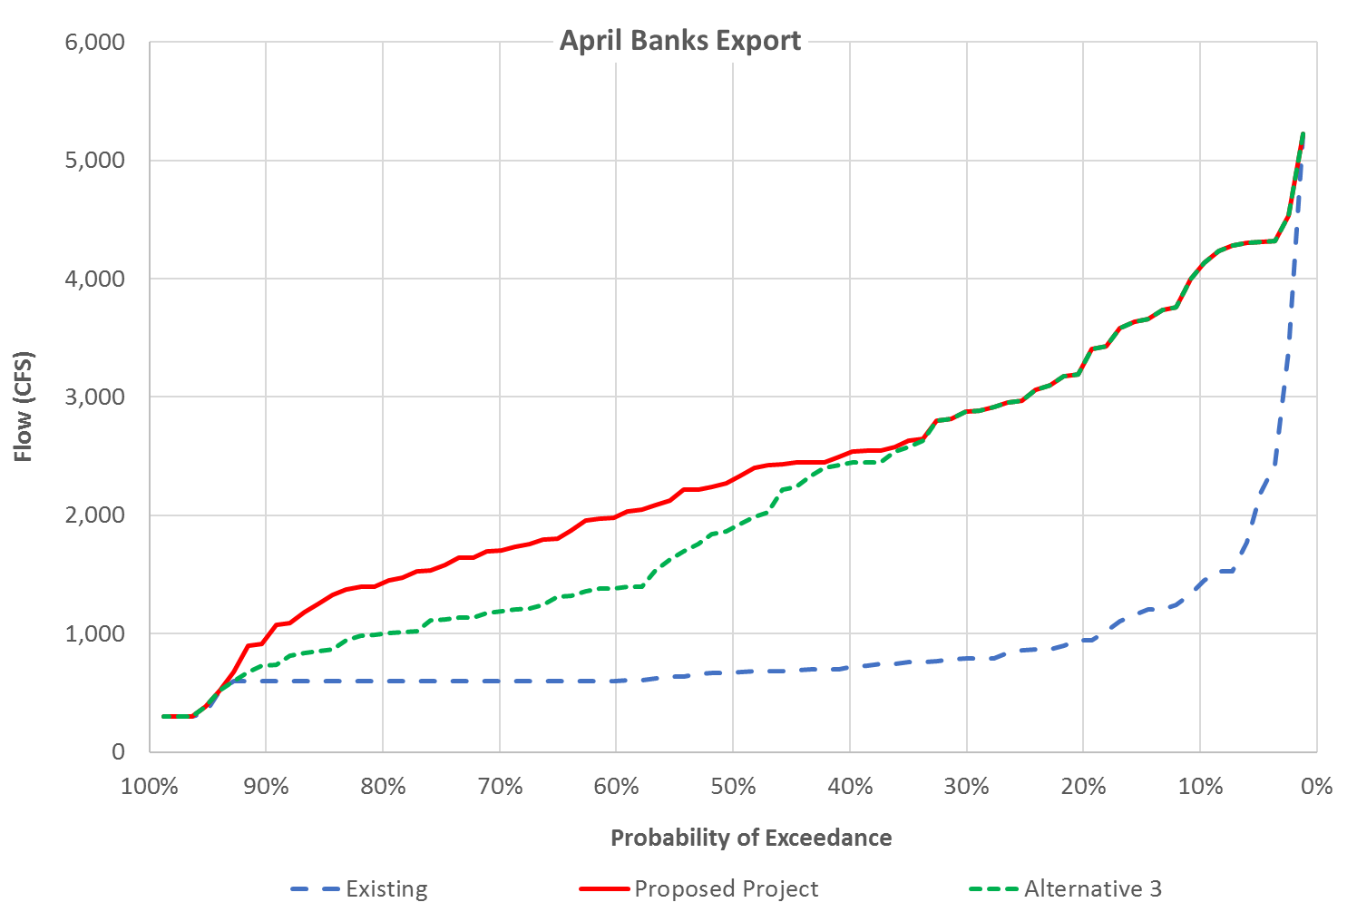

Figure 19: Probability of exceedance of Banks export in April

Table 37: Average Banks export in April

| Water Year Type | Existing | Proposed Project | Alternative 3 | Existing vs. Alternative 3 | Proposed Project vs. Alternative 3 |
| --- | --- | --- | --- | --- | --- |
| W | 1264 | 3241 | 3145 | 1881 (149%) | -97 (-3%) |
| AN | 706 | 2669 | 2483 | 1777 (252%) | -187 (-7%) |
| BN | 672 | 2515 | 2217 | 1545 (230%) | -298 (-12%) |
| D | 695 | 1636 | 1284 | 589 (85%) | -352 (-22%) |
| C | 692 | 999 | 710 | 18 (3%) | -288 (-29%) |
| Average | 873 | 2353 | 2125 | 1252 (143%) | -228 (-10%) |

Table 38: Probability of exceedance of Banks export in April

| Probability of Exceedance | Existing | Proposed Project | Alternative 3 | Existing vs. Alternative 3 | Proposed Project vs. Alternative 3 |
| --- | --- | --- | --- | --- | --- |
| 10% | 1415 | 4093 | 4093 | 2678 (189%) | 0 (0%) |
| 20% | 945 | 3277 | 3277 | 2333 (247%) | 0 (0%) |
| 30% | 790 | 2878 | 2878 | 2088 (264%) | 0 (0%) |
| 40% | 716 | 2532 | 2441 | 1725 (241%) | -91 (-4%) |
| 50% | 673 | 2305 | 1898 | 1225 (182%) | -407 (-18%) |
| 60% | 604 | 1988 | 1385 | 781 (129%) | -603 (-30%) |
| 70% | 600 | 1703 | 1188 | 588 (98%) | -515 (-30%) |
| 80% | 600 | 1429 | 999 | 399 (66%) | -430 (-30%) |
| 90% | 600 | 963 | 734 | 134 (22%) | -229 (-24%) |

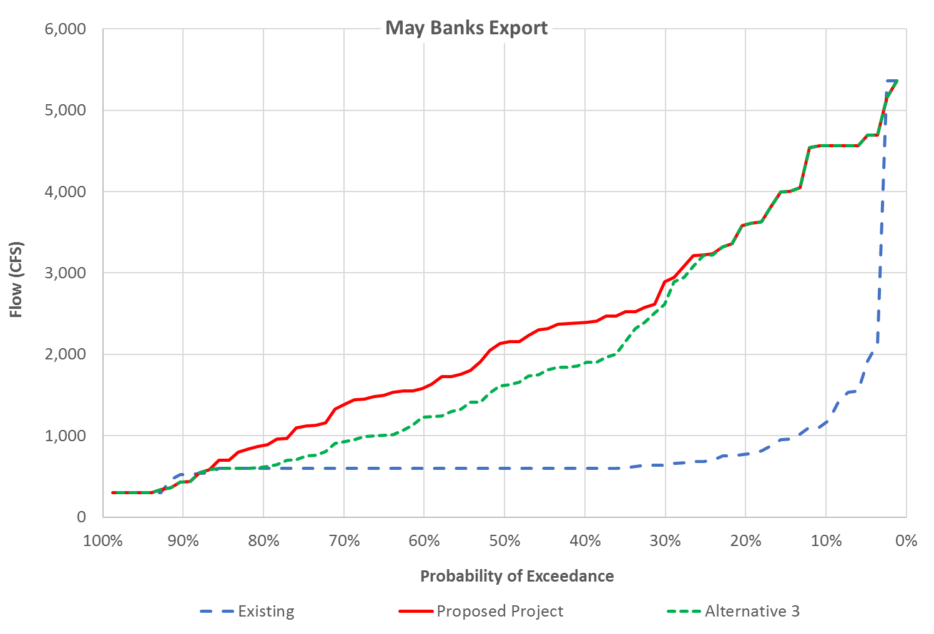 Figure 20: Probability of exceedance of Banks export in May

Table 39: Average Banks export in May

| Water Year Type | Existing | Proposed Project | Alternative 3 | Existing vs. Alternative 3 | Proposed Project vs. Alternative 3 |
| --- | --- | --- | --- | --- | --- |
| W | 1270 | 3393 | 3187 | 1917 (151%) | -206 (-6%) |
| AN | 656 | 2702 | 2386 | 1730 (264%) | -316 (-12%) |
| BN | 632 | 2221 | 1961 | 1329 (210%) | -260 (-12%) |
| D | 628 | 1334 | 1050 | 422 (67%) | -284 (-21%) |
| C | 454 | 559 | 457 | 2 (0%) | -103 (-18%) |
| Average | 811 | 2225 | 1992 | 1181 (146%) | -233 (-10%) |

Table 40: Probability of exceedance of Banks export in May

| Probability of Exceedance | Existing | Proposed Project | Alternative 3 | Existing vs. Alternative 3 | Proposed Project vs. Alternative 3 |
| --- | --- | --- | --- | --- | --- |
| 10% | 1167 | 4562 | 4562 | 3395 (291%) | 0 (0%) |
| 20% | 776 | 3597 | 3597 | 2821 (364%) | 0 (0%) |
| 30% | 640 | 2897 | 2646 | 2006 (313%) | -250 (-9%) |
| 40% | 600 | 2390 | 1891 | 1291 (215%) | -499 (-21%) |
| 50% | 600 | 2144 | 1622 | 1022 (170%) | -523 (-24%) |
| 60% | 600 | 1591 | 1229 | 629 (105%) | -361 (-23%) |
| 70% | 600 | 1384 | 926 | 326 (54%) | -458 (-33%) |
| 80% | 600 | 880 | 616 | 16 (3%) | -264 (-30%) |
| 90% | 525 | 433 | 433 | -92 (-18%) | 0 (0%) |

Appendix H Attachment 2-6   
Alternative 4 Hydrology Analysis

Alternative 4 applies additional water quality criteria to the summer/fall action described in the Proposed Project. These water quality criteria include the position of the 2 PPT isohaline from the golden gate bridge and a 4 PPT target at Beldons Landing from June to August.

This alternative is generally consistent with the summer/fall action in the Proposed Project, that is, with exception to the following additional criteria:

* Wet Years
  + 14 day running average below 80 km from June 1 to August 31
* Above Normal Years
  + 14 day running average below 80 km from June 1 to August 31
* Below Normal Years
  + Maintain 4 PPT at Beldons Landing between June 1 and August 31 by:
    - 14 day running average below 80 km
    - Or, 60 days of SMSCG operation
* Dry Years
  + Maintain 4 PPT at Beldons Landing between June 1 and August 31 by:
    - 60 days of SMSCG operation

Actions available to meet the 80 km criteria under this alternative include:

* Additional outflow maybe required to maintain X2 less than 80 km would likely come from SWP and CVP export reductions or increased reservoir releases.

Actions available to meet the 4 PPT criteria at Beldons Landing under this alternative include:

* Operations of the SMSCG – This would require a compensating flow action of either export reduction or increase in reservoir release from the SWP and CVP to maintain interior Delta salinity.
* Additional outflow maybe required in conjunction with SMSCG operation in order to meet the 4 PPT at Beldons Landing. This additional outflow would likely come from SWP and CVP export reductions or increased reservoir releases.

# Method of Analysis

Historical data (2009 to 2019) was analyzed to indicate if an additional action would have been required under historical conditions to meet the requirements under this alternative. In the last 11 years there have been 3 Wet years, 0 above normal years, 4 below normal years, 2 dry years, and 2 critical years.

When evaluating the historical conditions for periods where a modified operation would be required to meet the X2 criteria listed in the alternative, an estimated increment of additional Delta outflow needed to maintain the criteria was estimated with the following equation developed by Jassby et. al. 1995.

(1)

## Wet and Above Normal Years

Historical conditions from wet years 2011, 2017, and 2019 indicates that with the conditions under this alternative, the SWP and CVP have been required to modify operations to meet the 80 km criteria in 2 of the 3 wet years used for this analysis, as shown in Figure 1. The required change in operations would have likely been from reduced exports, however this could have also been met through an increase in reservoir releases. There were no above normal years within the time period analyzed but the D-1641 requirements are very close and so it is expected that above normal years would likely be very similar to wet years and likely require an additional action in the late summer.

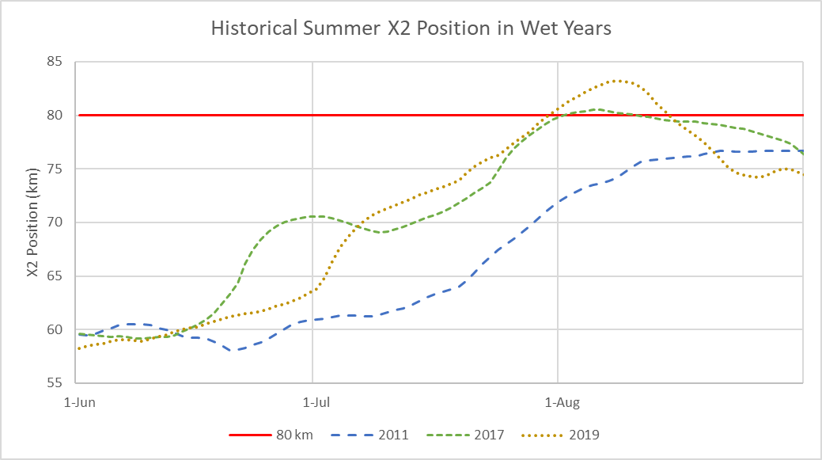

Figure 1. Historical summer 14-day running average X2 position in wet years

As shown in Figure 1, the historical data indicates that 2011 would not have needed additional flow, however 2017 and 2019 would have required a relatively small amount of additional outflow to keep the X2 below 80 km. Using equation 1 the additional Delta outflow to maintain an X2 position at 80 km was estimated.

Table 1. Estimated additional Delta outflow needed to meet a 14-day average X2 of 80 km from June 1 to August 31

|  | 2011 | 2017 | 2019 |
| --- | --- | --- | --- |
| Additional Delta Outflow (TAF) | 0 | 12 | 67 |

For wet and above normal years, the Proposed Project includes SMSCG gate operations up to 60 days as potential habitat management tool. The estimated compensating flow needed for a 60-day SMSCG gate operation is roughly 60 TAF. Given that the water costs are very close it is reasonable to assume that the additional Delta outflow in wet years is within the water cost of the 60-day SMSCG operation. Above normal years are expected to perform the same and result in similar water costs.

## Below Normal Years

Historical conditions from below normal years 2010, 2012, 2016, and 2018 were used to evaluate the potential need for additional actions under this alternative.

The historical X2 position indicates that maintaining the 80 km criteria in below normal years would have required modification to the SWP and CVP operations. As shown in Figure 2, 3 of the 4 below normal years would have required an action by mid-June. The 4th year would have required an action beginning mid-July.

As shown in Figure 2, historical below normal years tend to exceed 80 km beginning mid-June. In below normal years 80 km criteria would be a substantial water cost. Using equation 1, the water cost for each of these years was estimated. Table 1 shows that the potential cost from maintaining an X2 of 80 km in below normal years can be upwards of 500 TAF.

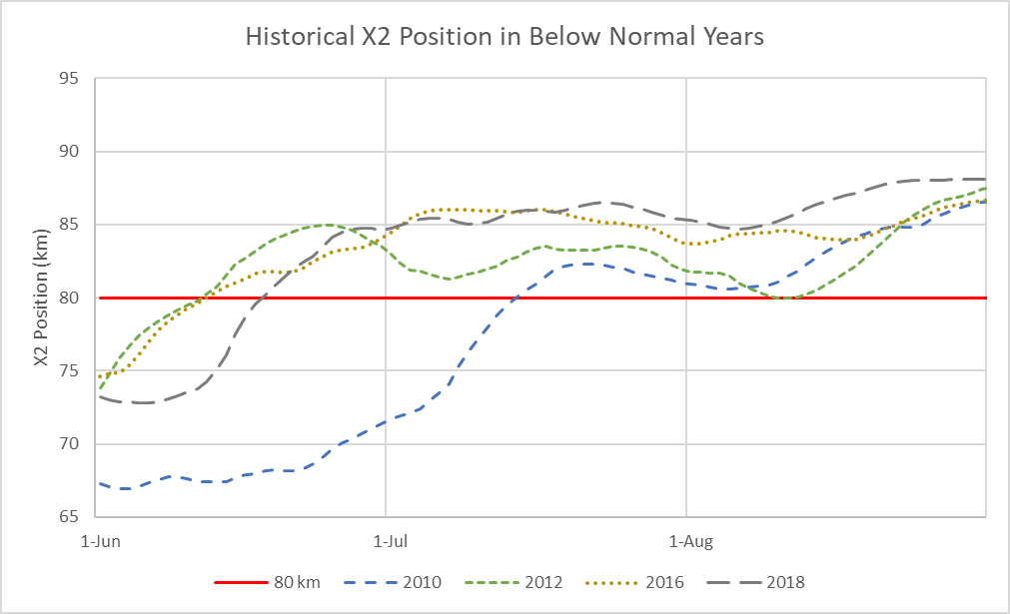

Figure 2. Historical summer 14-day running average X2 position in below normal years

Table 2. Estimated additional Delta outflow needed to meet a 14-day average X2 of 80 km from June 1 to August 31

|  |  |  |  |  |
| --- | --- | --- | --- | --- |
|  | 2010 | 2012 | 2016 | 2018 |
| Additional Delta Outflow (TAF) | 218 | 329 | 440 | 499 |

The historical salinity at Beldons Landing as shown in Figure 3, indicates that a SMSCG operation or additional X2 action would be required as early as mid-June in 3 out of 4 below normal years in order to attempt maintaining a salinity of less than 4 ppt. Most of the years show an increasing trend, except for 2018 which shows a significant reduction in the early part of August and holding through the month. The data from 2018 is reflecting a SMSCG operation where the gate was operated beginning August 2nd and continued until September 7th. That gate operation was estimated to have had a water cost of 37 TAF of compensating flow to offset the water quality effects of the SMSCG operation.

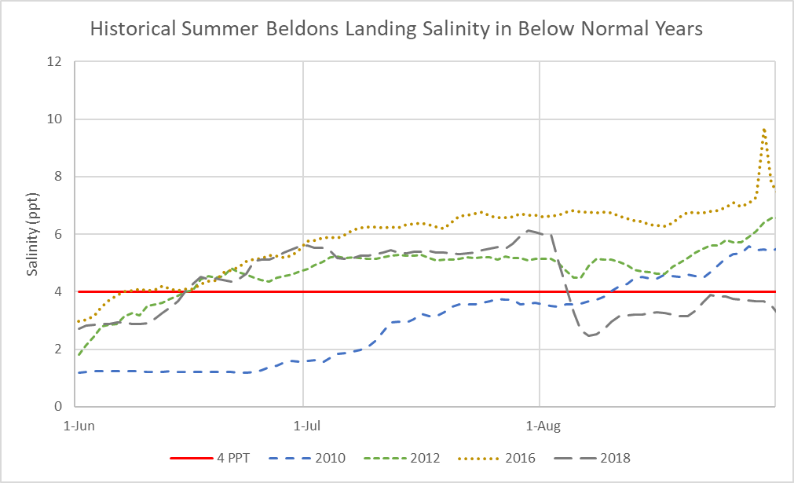

Figure 3. Historical daily average salinity at Beldons Landing in parts per thousand (ppt) in below normal years 2010, 2012, 2016, and 2018

The criteria in below normal years is a salinity at Beldons Landing of less than 4 ppt. This criterion can generally be achieved by maintaining X2 near the confluence of the Sacramento and San Joaquin Rivers (80 km is just downstream of this location). As shown in Figure 2 the transition between less than 80 and greater than 80 occurs about the same time as the salinity transition to above 4 ppt at Beldons Landing, as shown in Figure 3. This occurs for years 2012, 2016, and 2018, however in 2010 Beldons Landing was less than 4 ppt while the X2 was greater than 80.

The Proposed Project includes 60 days of SMSCG operation which, based on the performance of 2018 would likely be sufficient to meet the 4 ppt requirement at Beldons Landing. However, as shown in Figure 3, the requirement would likely need to extend beyond 60 days. Years 2012, 2016, and 2018 indicate that the required number of days for an action could exceed the 60 days by 15 to 20 days.

The additional action could either be provided by additional gate operations or additional Delta outflow. But because of the water cost associated with additional Delta outflow, this action would likely add additional days of gate operations. With gate operations alone the water cost of the additional days of operations would roughly be 20 to 30 TAF. This additional water, if needed, would come from either reduced exports or increased reservoir releases.

## Dry Years

Historical conditions from dry years were used to evaluate the potential need for SMSCG operations. Historically there have not been SMSCG operations in the summer of dry years. Under this alternative the Beldons Landing salinity less than 4 ppt would be the determining criteria for an action. Based on the historical data, as shown in Figure 4, a SMSCG action would have been required by the end of June in both dry years used in the evaluation. Operating the SMSCG during this time period would have required a compensating action from the SWP and the CVP.

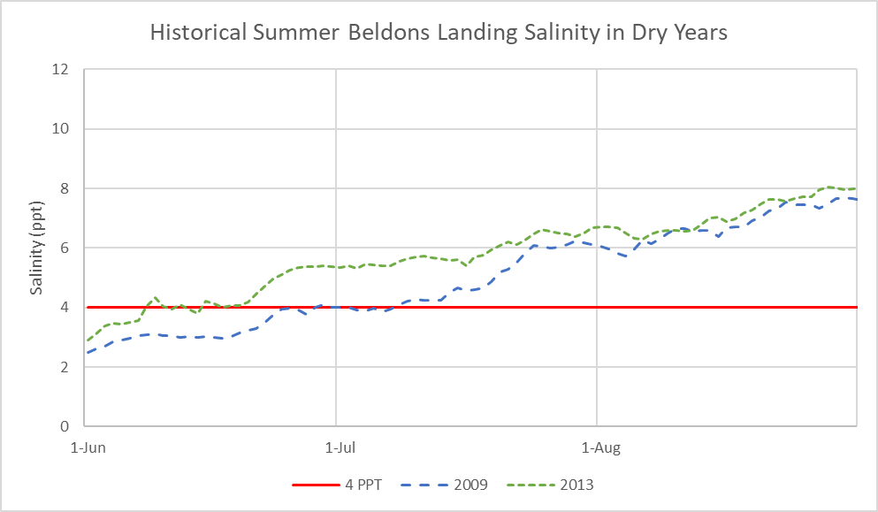 Figure 4. Historical daily average salinity at Beldons Landing in parts per thousand (ppt) in dry years 2009 and 2013.

The criteria in dry years is a salinity at Beldons Landing of less than 4 ppt. Operation of the SMSCG is the only tool required to be used in dry years. The Proposed Project does not include any summer actions in dry years and so any required SMSCG operation would result in additional water cost. As shown in Figure 4, dry years 2009 and 2013 would suggest that gate operations would have been required between roughly 50 to 80 days. The water cost associated with operating the SMSCG for this duration is about 60 to 100 TAF. The compensating action most likely would have been in the form of export reductions but increases in reservoir release could have been used as well.

## Conclusion

Based on historical data, it is expected that this alternative would require:

* In wet and above normal years, the SWP and CVP would need to adjust operations somewhat in the late summer to maintain an 80 km criteria.
* Compared to the exiting condition this would slightly increase the Delta outflow in wet and above normal years.
* Compared to the proposed project this would slightly increase the Delta outflow in wet and above normal years.
* In below normal years, the SMSCG would be operated as early as mid-June, however this is within the bounds of the Propose Project. The historical data indicated that additional gate actions or additional Delta outflow would likely be required. However, it is expected that if needed gate actions would be the desired method since it would require less water, but could result in compensating water costs up to 30 TAF originating from reduced exports or increased releases.
* Compared to existing conditions the Delta outflow would be higher during the summer months
* Compared to the Proposed Project the Delta outflow would be slightly higher during the summer months.
* In dry years the historical data indicates a SMSCG action would be needed starting in June. A compensating export reduction or reservoir release increase would be required by the SWP and CVP. The historical data indicated that additional gate actions would likely be required. This would result in compensating water costs up to 100 TAF originating from reduced exports or increased releases.
* Compared to existing conditions the Delta outflow would be higher during the summer months

Compared to the Proposed Project the Delta outflow would be higher during the summer months.

This page intentionally left blank

1. Excess conditions are periods when the amount of water in the Delta is above what is needed to meet the water quality and flow requirements in D1641. During these conditions reservoir releases are controlled by upstream requirements (i.e. minimum releases or flood control).