CNRA: Justice Rising Environmental Justice and Equity Summit – BIOs

Opening Remarks Speaker

CNRA Secretary Wade Crowfoot
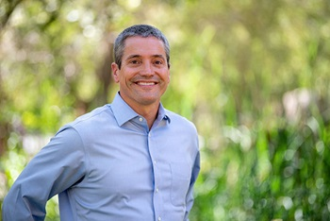
Wade Crowfoot serves as California’s Natural Resources Secretary, leading efforts to conserve California’s environment and natural resources. He has served as Secretary since 2019 and advises Governor Newsom as a member of his cabinet.
Secretary Crowfoot oversees an agency of over 25,000 employees spread across 26 departments, commissions, and conservancies. His agency is charged with stewarding California’s forests and natural lands, rivers and water supplies, and coast and ocean. It also protects natural places, wildlife and biodiversity, and helps oversee the state’s world-leading clean energy transition.
Secretary Crowfoot is leading efforts to achieve Governor Newsom’s ambitious environmental vision, including a commitment to conserve 30 percent of California’s land and coastal waters by 2030. He oversees billions of dollars of public investment to protect people and natural places from climate change impacts, and has led efforts to navigate California’s record-breaking droughts, floods, and wildfires. Secretary Crowfoot has also initiated a new era of partnerships with California Native American Tribes and is shifting how the agency operates to better support all California residents and communities.
Secretary Crowfoot has been on the frontlines of environmental leadership throughout his career. He served in Governor Jerry Brown’s Administration as deputy cabinet secretary and senior advisor to the Governor, driving climate action. He led the non-profit Water Foundation to build water resilience across the American West. He spearheaded efforts to establish and defend California’s landmark climate change policies as West Coast regional director for the Environmental Defense Fund. As an environmental advisor to then-San Francisco Mayor Gavin Newsom, he helped establish many first-in-the-nation urban environmental policies. Secretary Crowfoot received a bachelor’s degree from the University of Wisconsin-Madison and a master’s degree from the London School of Economics.
Wade grew up in Michigan spending summers at a YMCA camp and in the woods around his family’s remote cabin in Northern Ontario. He moved to California in the mid-1990s and discovered backcountry camping with friends. His first time in the redwoods at Big Basin State Park is still one of his defining California moments. He loves to camp with his wife and daughter and learn new things in the outdoors, currently including fly fishing and soon backcountry skiing. He says his best days as Natural Resources Secretary are spent outdoors with local groups that are conserving land and connecting people to nature.

Keynote Speaker

Assemblymember Isaac G. Bryan
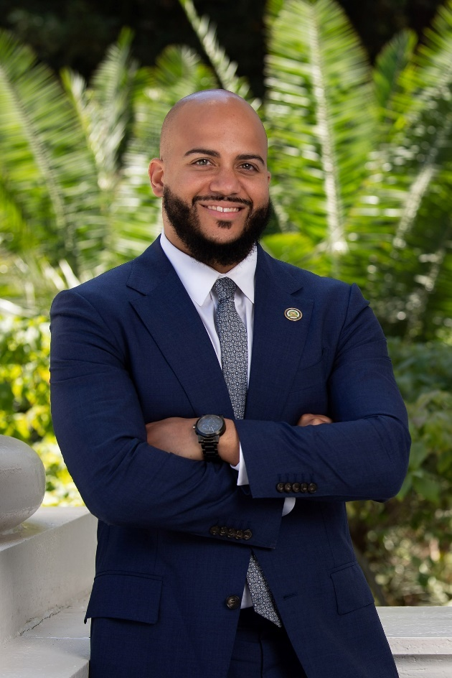
Isaac G. Bryan represents California's 55th Assembly District, which consists of Baldwin Hills, the Crenshaw district, Culver City, Ladera Heights, Mar Vista, Del Rey, Palms, Pico-Robertson, Beverly Grove, Mid-Wilshire, and parts of South Los Angeles.
Assemblymember Bryan serves as Chair of the Natural Resources Committee and Chair of the Assembly's first Select Committee on Poverty and Economic Inclusion. Assemblymember Byran is a member of the following committees: Appropriations, Government Organization, Judiciary, and Privacy & Consumer Protection. In 2022, he was elected Secretary and Treasurer of the California Legislative Black Caucus. He is Vice Chair and a founding member of the Renters Caucus.
Assemblymember Bryan secured funding to found the Center on Reproductive Health, Law, and Policy at UCLA School of Law, the first Climate Change Education Center in the community college system at West L.A. College; a stipend program for students in the trades to earn a living wage while studying for certificates, and millions of dollars for other projects across his District. Isaac's legislative accomplishments include phasing out the Inglewood Oil Field and other drilling near homes and communities (SB 1137), ending prison gerrymandering (AB1848), ending punishing fees for parents with children in foster care (AB1686), protecting students from predatory insurance practices (AB 1823) and strengthening campaign finance disclosure requirements (AB 1848).
Isaac is a community organizer, highly regarded policy expert, and a published academic. Before his election to the Assembly, Isaac led a ballot measure that brought millions of dollars a year to address racial injustice and strengthen communities in Los Angeles. He served as the founding Director of the UCLA Black Policy Project, a think tank dedicated to advancing racial equity through rigorous policy analysis, served as the first Director of Public Policy at the UCLA Ralph J. Bunche Center, as well as Director of Organizing for the nationally recognized Million Dollar Hoods project, a community-based participatory research project. He authored the first holistic report for the City of Los Angeles on the needs of the formerly incarcerated Angelenos and exposed a gap in youth justice policy. For years, his academic and organizing work has been at the intersection of environmental, economic, education and housing justice.

Moderators

Sarah Rubin
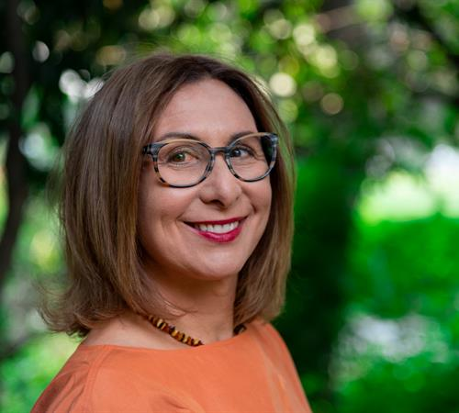
Sarah Rubin is the Outreach and Engagement Advisor at the California Department of Conservation. Specializing in public engagement, she is experienced in a wide range of policy and regulatory issues as well as rural, urban, and suburban communities. National involvement includes the National Civic League and the Divided Communities Project at The Ohio State Law School. Rubin has her M.S. in Conflict Analysis and Resolution from George Mason University in Fairfax, Virginia.

Nicole Cropper
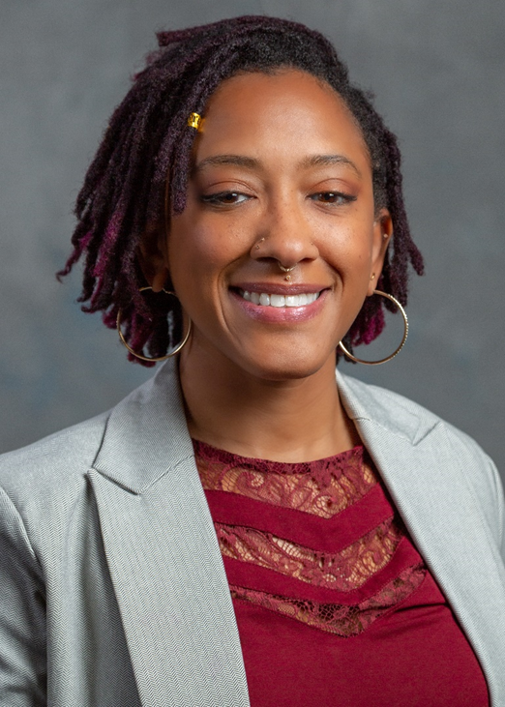
Nicole Cropper is the Deputy Director of Equity, Environmental Justice, and Tribal Affairs at the California Department of Fish and Wildlife. Previously, Nicole served as the Special Assistant to the Office of the Commission at the California Public Utilities Commission (CPUC) leading the implementation of the Environmental and Social Justice Action Plan and DEI activities. She also supported the CPUC’s regulatory efforts regarding equity, transportation electrification, affordability, and decarbonization. Nicole’s expertise is in using change management principles to help organizations address inequities in health, access, socio-economic opportunities, and the decision-making process. Nicole has her Bachelor of Arts in English, and Master of Public Policy and Administration with a focus on embedding equity and justice into Natural Resource Agencies.

Amanda Martin
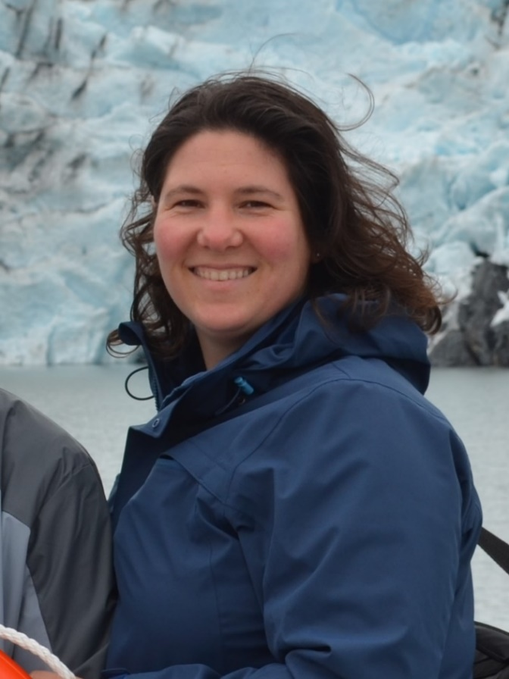
Amanda Martin has been serving as a Deputy Assistant Secretary for Administration & Finance at the Natural Resources Agency since 2019. She oversees the Agency’s Monitoring and Stewardship Unit, serves as the Secretary’s delegate on several state Conservancies, and is the primary point of contact on budget issues for several large departments. Prior to joining the Resources Agency, she worked at the Department of Finance on a broad range of issues including Natural Resources, Transportation, Information Technology, and Health issues. She holds Bachelor of Arts degrees in both Political Science and Spanish from CSU Chico, a Juris Doctor (J.D.) from McGeorge School of Law, and is a member of the CA State Bar. Away from work she volunteers at various community events, is a lifetime Girl Scout and enjoys camping with her husband, kids, and dogs.

Morgan Carvajal
Morgan Carvajal was appointed by Governor Newsom in June 2020 to serve as Chief Deputy Appointments Secretary.
Prior to her appointment, Ms. Carvajal served as a Legislative Advocate for the California Medical Association where she led advocacy efforts for public and women’s health. Prior to joining the California Medical Association, she was a Legislative Advocate at Hernandez Strategy Group, LLC where she developed and led advocacy efforts on behalf of client interested in the consumer, civil justice, and energy related fields. She served as a Legislative Aide for State Senator Fran Pavley from 2010 to 2013.
Ms. Carvajal received a B.A., in Mass Communications from California State University, Sonoma.

Noaki Schwartz
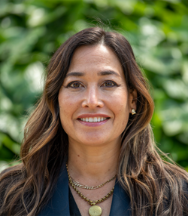
Noaki Schwartz joined the Natural Resources Agency in March 2022. As the Deputy Secretary for Equity and Environmental Justice, Noaki will work to embed the principles of environmental justice, equity, diversity, and inclusion into the work of the Agency and its 26 member departments. She was the Deputy Director of Communications, Environmental Justice and Tribal Affairs at the California Coastal Commission, where she worked for eight years and where she helped lead the development of the agency’s environmental justice policy. Prior to that, she spent more than a decade writing for the Associated Press, Miami Herald, Los Angeles Times and other publications. Noaki received her BA from UC Santa Cruz and an MSc from the London School of Economics and Political Science. She was born and raised in Long Beach.

Amanda Hansen
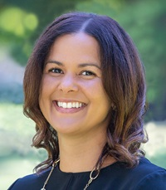
Amanda Hansen joined the California Natural Resources Agency in April 2019 as the Natural Resources Agency's Deputy Secretary for Climate Change. In this role, she drives the Agency's efforts to build California's resilience to climate impacts and accelerate the contribution of nature-based solutions to meeting our ambitious climate goals. She also coordinates the Agency's national and international climate engagement. Amanda previously worked on climate issues for the Governor of New York, the White House Council on Environmental Quality, and U.S. Department of State. She grew up in Takoma Park, Maryland, and earned a Masters of Public Policy from the University of Maryland and a Bachelor's degree from Wesleyan University. Amanda lives in El Dorado Hills with her husband, children, and dog. They enjoy traveling, hiking, biking, camping, games, and sports such as tennis, baseball, and soccer.

Geneva E.B. Thompson
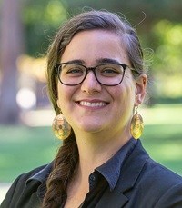
Geneva E. B. Thompson (she/her/hers) joined the California Natural Resources Agency in 2021 as the Deputy Secretary for Tribal Affairs. Geneva cultivates and ensures the participation and inclusion of tribal governments and communities within the Agency’s work. She previously served as Associate General Counsel for the Yurok Tribe, where she practiced environmental and cultural resource law and represented the Yurok Tribe in tribal, state, and federal forums. She also served as Staff Attorney for the Wishtoyo Foundation and clerked with the Department of Justice Indian Resource Section, the Natural Resources Defense Council, Earthjustice, and the Tribal Law and Policy Institute. Geneva graduated from the University of California, Los Angeles School of Law, with specializations in Critical Race Studies and Public Interest Law and Policy. She has published several law review articles and has served in leadership positions across multiple bar associations, including the National Native American Bar Association, California Indian Law Association, and the American Bar Association. Geneva is a citizen of the Cherokee Nation and enjoys beading, gardening, and hiking with her spouse in state and national parks.

Amy Hutzel
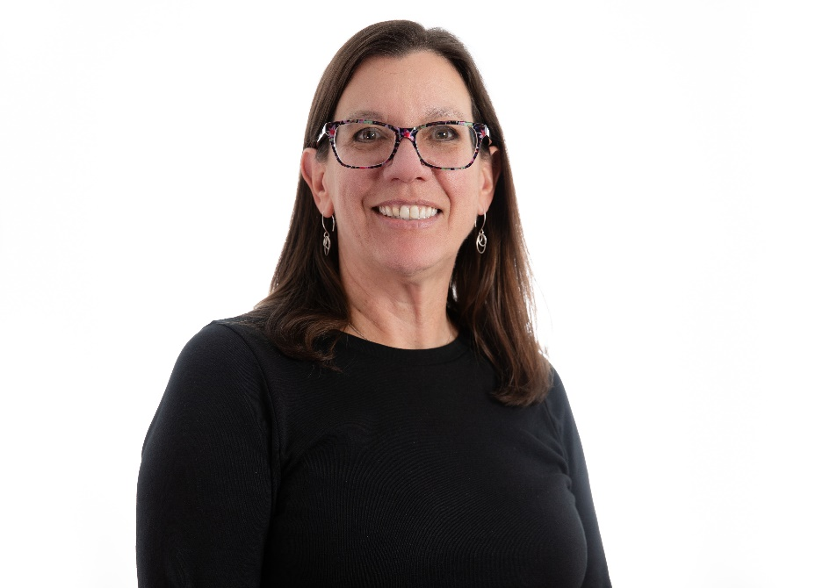
Amy Hutzel is Executive Officer at the State Coastal Conservancy, which works to protect and restore habitats, increase public access and recreation, and plan and implement nature-based climate change adaptation along the California Coast and in the San Francisco Bay Area. The Conservancy’s approximately 80 staff develop and manage multiple state grant programs and have undertaken thousands of projects from Del Norte County to San Diego County. Prior to being appointed EO in November 2021, she served at the Conservancy as Deputy Executive Officer and as San Francisco Bay Area Program Manager. She has a bachelor’s degree in urban and environmental planning from the University of Virginia.

Meghan Hertel
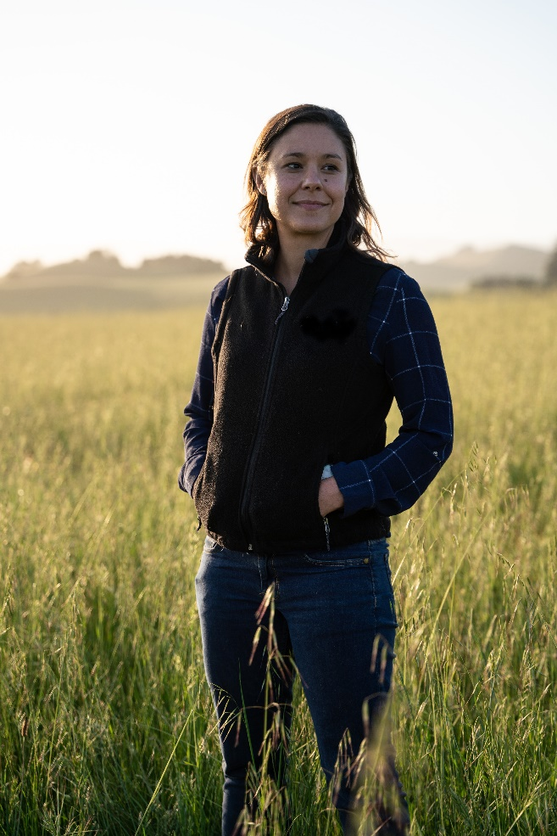
Meghan Hertel joined the California Natural Resources Agency in 2024 as Deputy Secretary of Biodiversity and Habitat. Meghan leads the Agency’s efforts to conserve biodiversity and improve habitat across the state by implementing California’s 30x30 strategy and associated efforts, including the Cutting Green Tape initiative and supporting the implementation of large-scale habitat projects. Meghan previously served as North American Director for Land Life, a technology-driven, nature restoration company, and spent over a decade with Audubon California, holding several positions including Director of Land and Water Conservation where she led statewide conservation programs focused on inland water and working lands strategies. In her free time, you can find Meghan and her husband enjoying California’s incredible outdoors - backpacking, biking and paddleboarding – or trying to keep up with their foster dogs. Meghan holds a Master of Arts in environmental science and policy from Clark University and Bachelor of Arts in Political Science from the University of Florida.

Madeline Drake
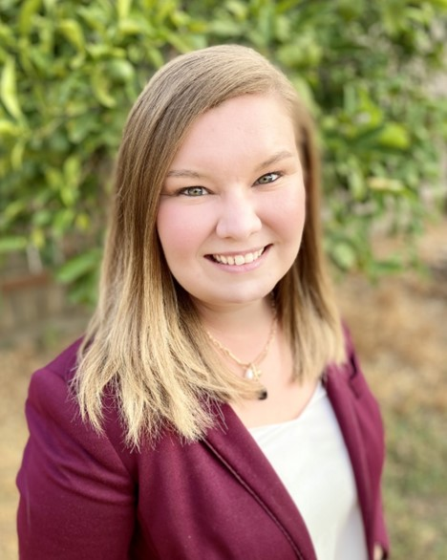
Madeline Drake serves as the California Natural Resources Agency Assistant Secretary for Biodiversity and Habitat where she advises and coordinates with external stakeholders and CNRA departments, boards and conservancies to implement California’s 30x30 strategy. Before this role, Madeline served as the Biodiversity Coordinator for the California Department of Fish and Wildlife, where led the team that developed California's “Pathways to 30x30” document, the strategic framework for conserving 30 percent of California's land and coastal waters by 2030. Madeline received her Bachelor of Science in Marine Science from the University of South Carolina, and Master of Science in Animal Biology from the University of California, Davis.

Bianca Sievers
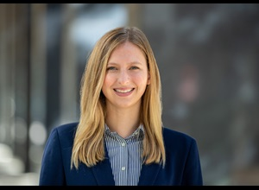
Bianca Sievers was appointed Deputy Director for Special Initiatives at the Department of Water Resources on October 15, 2021. In this capacity, Sievers will be working to implement the Department’s Human Right to Water Policy; build and strengthen partnerships with vulnerable communities and environmental justice organizations; and align Department strategic thinking and actions related the Water Resilience Portfolio, DWR Strategic Plan, and organizational health efforts. Sievers has been Policy Advisor to the Director of the Department of Water Resources since 2018.
Sievers held multiple positions at the Governor’s Office of Business and Economic Development from 2014 to 2018, including Senior Business Development Specialist and California Competes Tax Credit Specialist. Sievers was Legislative Assistant for the Office of Governor Edmund G. Brown Jr. from 2012 to 2014. Sievers earned her Master of Business Administration from the University of California, Davis, Graduate School of Management, and Bachelor of Arts in Political Science and Economics from the University of California, Davis.

Nancy Vogel
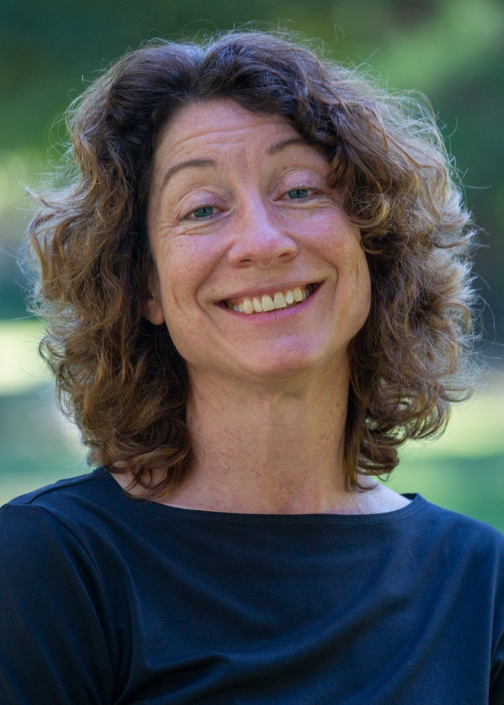
Nancy Vogel joined the Natural Resources Agency as director of the Governor's Water Portfolio Program in May 2019 and was appointed deputy secretary for water in April 2021. Nancy had been director of communications at the Resources Legacy Fund from 2017 to 2019. She was deputy secretary for communications at the California Natural Resources Agency from 2015 to 2017 and assistant director for communications at the Department of Water Resources from 2012 to 2015. Nancy was a principal consultant for the Senate Office of Oversight and Outcomes from 2008 to 2012. She was a staff writer for the Los Angeles Times from 2000 to 2008 and for the Sacramento Bee from 1991 to 2000. She earned a Bachelor of Science degree in Conservation and Resource Studies and a Master of Arts degree in journalism, both from the University of California, Berkeley.

Le-Quyen Nguyen
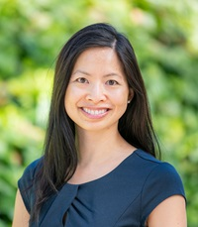
Le-Quyen Nguyen joined the California Natural Resources Agency in April 2022 as the Deputy Secretary for Energy. In this role, she guides the Agency’s energy policies and programs in support of California’s energy and decarbonization goals. Before her appointment, Le-Quyen worked at the California Energy Commission, where she held a variety of positions. This included Chief of Staff to the Chair, Manager of the Supply Analysis Office, and special advisor to a Commissioner. Le-Quyen earned a bachelor’s degree in Biological Sciences from the University of California, Riverside. When not at work, Le-Quyen enjoys spending time with family and friends, reading, and gardening.

Panelists

Armando Quintero
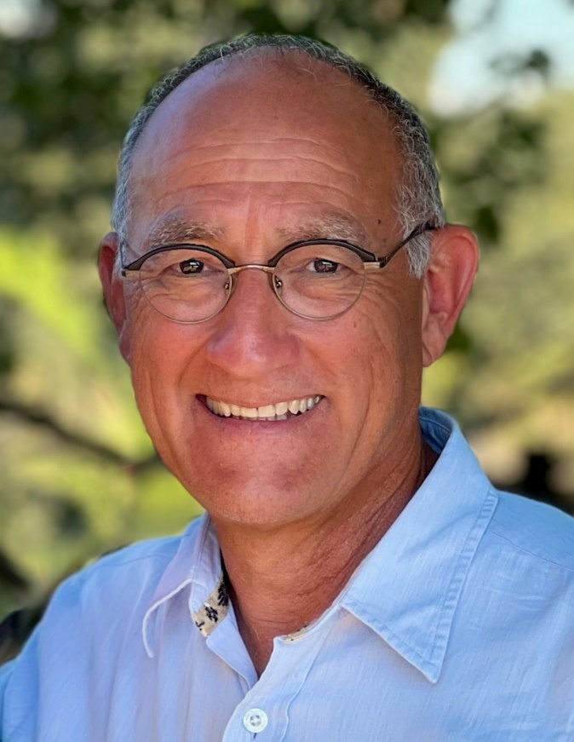
Armando Quintero was named director for the California Department of Parks and Recreation on Aug. 18, 2020. An experienced parks professional with expertise in park operations, outdoor education, equity and access, and diversity and inclusion in hiring and retention. Since 1976 his work has included experience with National Parks, UC Merced, non-profits, the California Water Commission and as an elected member of the Marin Water Board.

Luis Olmedo
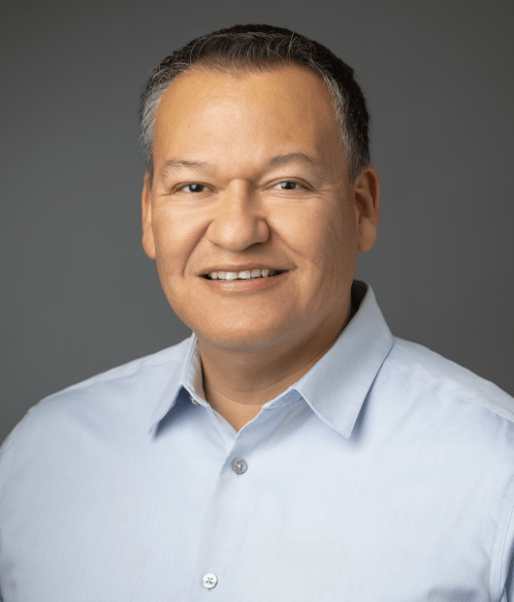
As Executive Director of Comite Civico del Valle, Inc. (CCV), Luis Olmedo maintains the grassroots integrity and core mission of the organization to improve the lives of disadvantaged communities, yet its scope and influence continues to expand in environmental justice circles, not by talk but by action. CCV’s focus on public health, and environmental and social justice issues has established the organization as a leading light among its peers. Olmedo himself is a seasoned community advocate, collaborator and organizer who is regularly called upon to advise on local, regional, and state environmental health programs affecting Imperial County. He is also a member of various state and national networks that focus on environmental policy, civic participation, and environmental justice, mostly recently serving on Gov. Newsom’s Blue Ribbon Lithium Valley Commission. Comite Civico del Valle has partnered with academic and research institutions to expand research in the Salton Sea region. CCV currently has partnerships with several nonprofit institutions, health agencies, and governmental entities working on various projects focusing on asthma, air-quality monitoring, Salton Sea education, and advocacy.

David Diaz
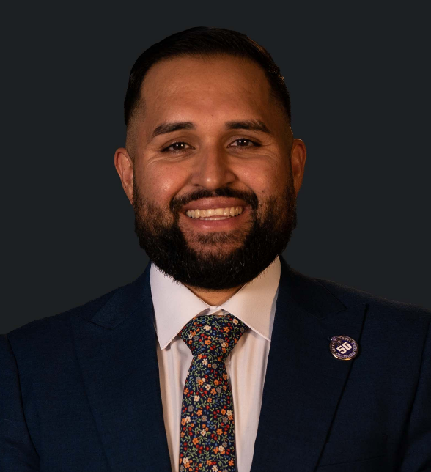
David is a public health professional offering extensive experience in planning, developing, and implementing community-based initiatives in Los Angeles County. He is a dedicated public servant and advocate with project management and coalition building experience and has worked with youth, schools, businesses, nonprofit organizations, and cities to advance environmental justice, equity, and community development. As the Executive Director of ActiveSGV, David is responsible for organization management, strategic leadership, communications, development, and financial management. David serves on the Metro San Gabriel Valley Service Council, the Measure W Scoring Committee, and the Measure W Upper San Gabriel River Watershed Area Steering Committee. David lives in the City of El Monte with his wife, Anais, their children, Dael and Maceo, and pets, Xoco and Xavi.

Yessica Ramirez
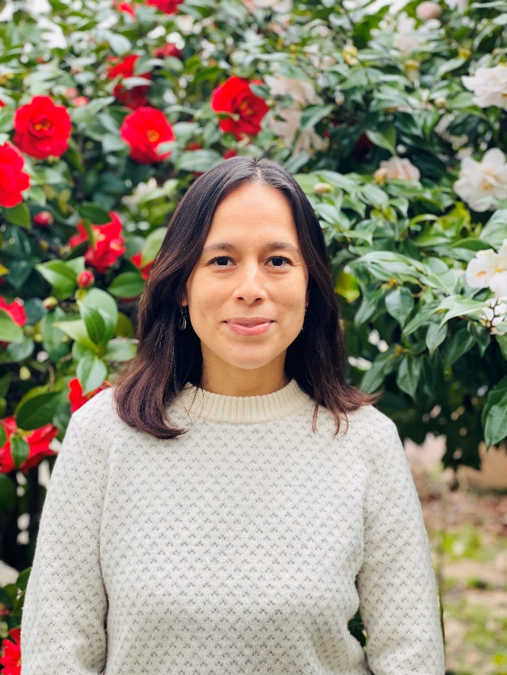
Yessica Ramirez serves as the Environmental Justice and Tribal Liaison for the State Lands Commission. In her role she works on the implementation of the Commission’s Environmental Justice Policy and Tribal Consultation Policy. Before joining the Commission, Yessica was the Development Manager for United Way Monterey County.

Marce Gutierrez-Graudins
Marce Gutierrez-Graudins used to sell fish, now she saves them. An environmental justice advocate who began her career in the commercial fishing and aquaculture fields, Marce is the Founder and Executive Director of Azul, which works with Latinxs to protect coasts and oceans. Through her work, she has helped design and implement a statewide network of marine protected areas as well as a sustainability and marketing program for local California fisheries. As a leader in the campaign to ban single-use plastic bags in California, she has worked to reduce marine pollution and protect ocean wildlife. Recently, she participated in the first Congressional roundtable on Environmental Justice on Capitol Hill and was the principal author of a white paper on Latino Environmental Leadership lauded as “a blueprint for diversity in the Environmental Movement” by Representative Raul Grijalva, the ranking member of the House Committee of the Natural Resources.
Marce is a founding member of the Latino Conservation Alliance, a proud graduate of the HOPE’s (Hispanas Organized for Political Equality) Leadership institute 2013 class, and currently serves as a mentor for the RAY Marine Conservation Diversity Fellowship as well as the advisory board for the Ocean Foundation. She has been a speaker at Stanford University, UCSB, UC Davis, The Explorers Club and the UN in Geneva. She has been recognized as an “inspiring Latina working for a cause” by Latina magazine (2014) and as an Aspen Environment Forum Scholar by the Aspen Institute (2012). A native of Tijuana, Mexico, Marce now makes San Diego home

Anecita Agustinez
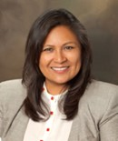
Anecita Agustinez is an enrolled citizen of the Dine (Navajo) Nation. She is born to the Tó dích’íinii (Bitter Water Clan) and born for the Ilocano Clan. Her area of expertise is in water policy and legislative advocacy on behalf of Tribal governments in California. She was appointed Tribal Policy Advisor for the Department of Water Resources in 2013. She advises the department on regional water planning, flood management, climate change, energy issues, drought, ecosystem restoration, sustainable groundwater management, water bond grant funding, and disadvantaged community engagement. She coordinates communication outreach with other state agencies and facilitates and conducts Tribal Consultation and Tribal engagement.

Dr. Kate Huckelbridge
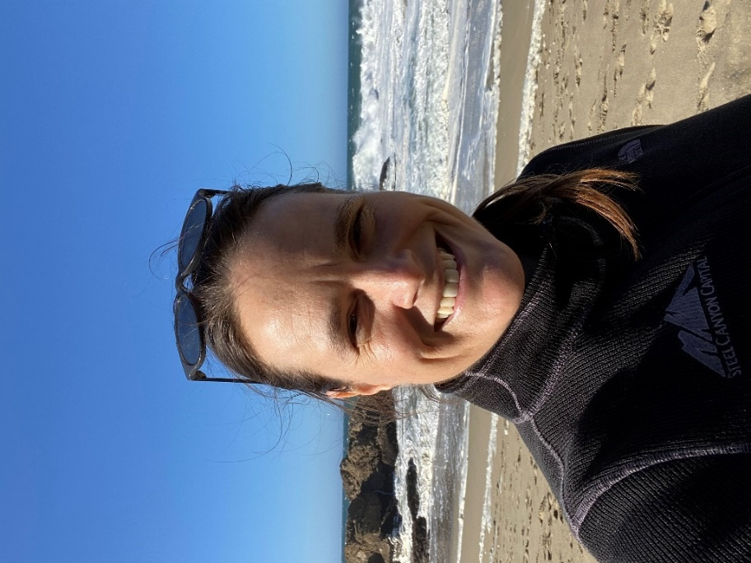
Dr. Kate Huckelbridge began serving as the Executive Director of the California Coastal Commission in February of 2023. Before this appointment, Dr. Huckelbridge served as the Commission’s Senior Deputy Director and has worked for the agency since 2009 in a number of different roles, including as a senior environmental scientist and as the Deputy Director over the Energy, Ocean Resources and Federal Consistency Unit, Transportation Unit, and the North Coast District. She also served as the Tribal Liaison for the Commission and served as one of the Commission’s representatives at the Government Alliance on Race and Equity, which was a two-year state agency training on advancing racial equity in California government. Kate has undergraduate and graduate degrees in environmental engineering with a focus on the dynamics of wetland ecosystems.

Regina Chichizola
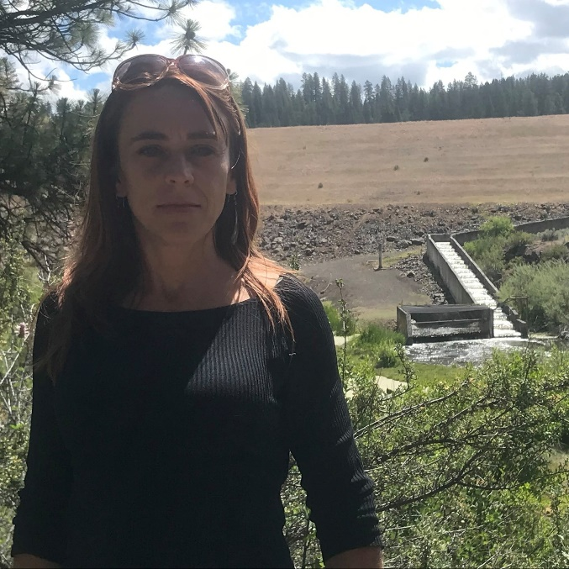
Regina Chichizola is the Executive Director of Save California’s Salmon, and the former Water Policy Analyst for the Pacific Coast Federation of Fisheries Associations and former communications coordinator for the Hoopa Valley Tribe. Regina has lived on, and worked for the restoration of, the Klamath River for over twenty-five years.
She is a long-term advocate for tribal water rights, clean water, wild salmon, prescribed fire, education reform and environmental justice. Save California Salmon has offices and/or organizers in Sacramento, the Central Valley, the Bay Area, Round Valley, Eureka, and on the Klamath River.

Veronica Eady
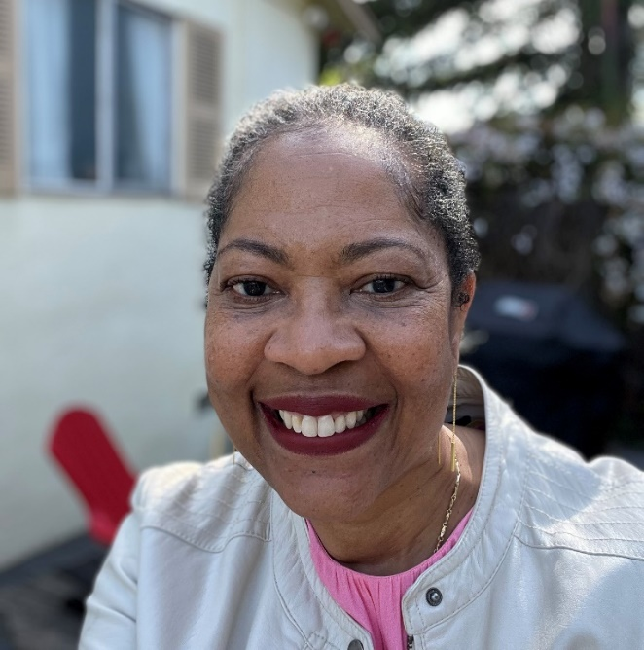
Veronica Eady is Vice President for Equity & Justice at the Resources Legacy Fund, a nonprofit environmental grantmaking organization. Prior to joining RLF, Veronica held senior leadership positions at the Bay Area Air Quality Management District and the California Air Resources Board. She led the development of the environmental justice policy and other innovative programs for Massachusetts’ statewide environmental agencies. Veronica is a graduate of the University of Southern California and Hastings Law School (now UC Law San Francisco). She’s served on several faculties, including Stanford Law School, UC Davis Law School, and is currently an adjunct professor at UC Berkeley Law where she teaches a course on environmental justice.

Geneva E.B. Thompson
Geneva E. B. Thompson (she/her/hers) joined the California Natural Resources Agency in 2021 as the Deputy Secretary for Tribal Affairs. Geneva cultivates and ensures the participation and inclusion of tribal governments and communities within the Agency’s work. She previously served as Associate General Counsel for the Yurok Tribe, where she practiced environmental and cultural resource law and represented the Yurok Tribe in tribal, state, and federal forums. She also served as Staff Attorney for the Wishtoyo Foundation and clerked with the Department of Justice Indian Resource Section, the Natural Resources Defense Council, Earthjustice, and the Tribal Law and Policy Institute. Geneva graduated from the University of California, Los Angeles School of Law, with specializations in Critical Race Studies and Public Interest Law and Policy. She has published several law review articles and has served in leadership positions across multiple bar associations, including the National Native American Bar Association, California Indian Law Association, and the American Bar Association. Geneva is a citizen of the Cherokee Nation and enjoys beading, gardening, and hiking with her spouse in state and national parks.

Adriana Dominique Guerrero-Nardone
Adriana is the current Executive Director of Salted Roots (formerly operating as Brown Girl Surf). Adriana’s work and passion includes working to build a more inclusive surf culture both locally and nationally through community programming, collaboration with ally organizations, and advocacy for equitable and inclusive coastal policies, all while centering joy as a form of community building and healing. A common thread that weaves Adriana’s professional aspirations and beliefs together is their pursuit of social justice with a youth development-lens and community-based approach. Over the last decade and a half, they have worked in a variety of capacities in the nonprofit sector across the globe with communities ranging in their socioeconomic, cultural, and language backgrounds. Recently, in recognition of their impactful contributions, Adriana was recently awarded and acknowledged by Sachamama on 'The 100 Most Influential Latinos’ list, a prestigious accolade supported by various organizations.

Sedrick Mitchell
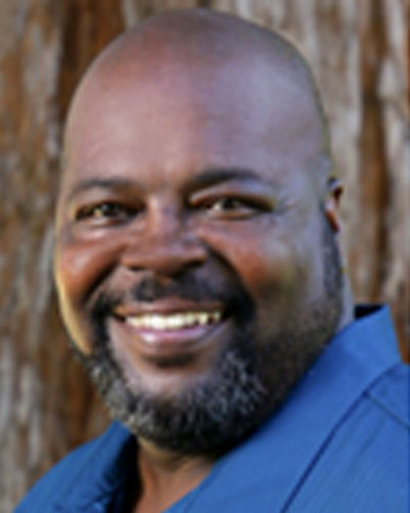
Sedrick Mitchell is the Deputy Director of Community Engagement, for California State Parks. Appointed by Governors Gray Davis, Arnold Schwarzenegger, Edmund G. Brown Jr., and Gavin Newsom. Mr. Mitchell is responsible for overseeing the general operations of the Office of Grants and Local Services, and the Office of Community Involvement. Under Mr. Mitchell’s guidance, California State Parks has become the recognized leader in the development, implementation and management of innovative park grant programs in excess of $3 billion.

Anna Gruben
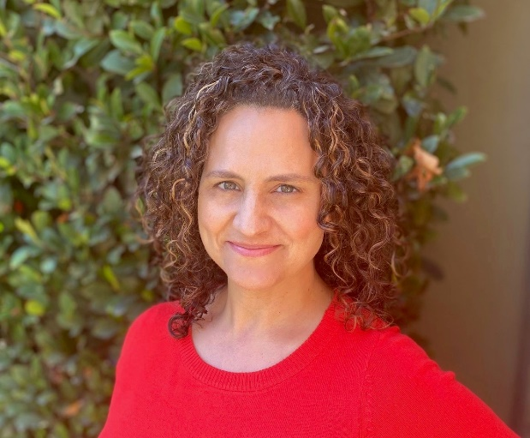
Anna Gruben, Program Director, Los Angeles Neighborhood Land Trust, is a dedicated advocate for collaborative community engagement, communication, and project development. Previously, as the Executive Director of the environmental organization People for Parks, Anna spearheaded the Community School Parks (CSP) program, which transformed schoolyards in dense urban neighborhoods into vibrant green spaces. Currently, at the Los Angeles Neighborhood Land Trust, Anna leads the organization’s Community Park Stewards Program, manages the organization’s community engagement and programming projects and represents the organization in a range of coalition spaces.

Walter Passmore
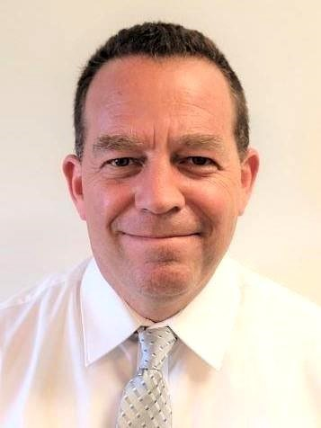
Walter Passmore is the State Urban Forester for the California Department of Forestry and Fire Protection (CAL FIRE). He is responsible for managing the Urban and Community Forestry Program which provides technical assistance, information, outreach, education, and administers grants, with focus on disadvantaged communities and environmental justice. Walter earned a Bachelor’s degree in Forestry and Natural Resources Management from Cal Poly, San Luis Obispo and a Master of Public Administration degree from Cal State, Dominguez Hills. He held previous positions as Urban Forester for the cities of Palo Alto, California, Austin, Texas, Dallas, Texas, Community Assistance Forester for the Mississippi Forestry Commission, and Forester with the USDA Forest Service.

Dr. Alexis Jackson
Dr. Alexis Jackson is the Ocean Policy and Plastics Lead for the California Chapter of The Nature Conservancy. There she leads a cross-functional team focused on reducing plastics pollution and oversees the California Oceans Team’s ocean policy and management portfolio, engaging on topics from restoring coastal marine habitats to advancing sustainable fisheries management and promoting island resilience. Previous to TNC, Alexis worked at The Pew Charitable Trusts and NOAA Fisheries engaging in domestic and international policy around highly migratory species. She also currently serves on the Board of Trustees for the Ocean Science Trust and is a sixth generation Californian. Alexis holds a B.S. in Ecology and Evolutionary Biology from Yale University and a Masters and Ph.D. in Ecology and Evolutionary Biology from the University of California Santa Cruz.

Dawn Blake
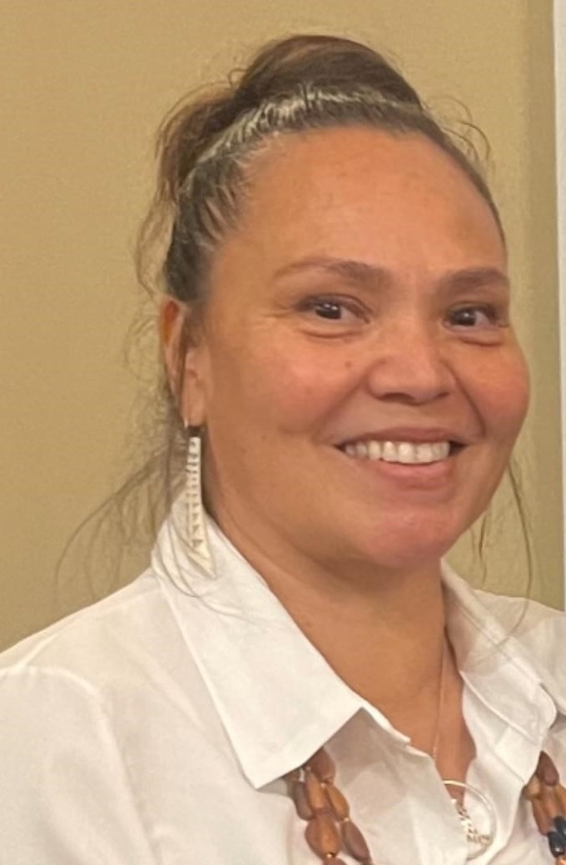
Dawn Blake serves on the California State Board of Forestry and Fire Protection and is the first Native Woman appointed to serve on the board. Dawn is also the Yurok Forestry Director, managing over 70,000 acres of Yurok-owned forest to benefit current and future generations of Yurok people. She oversees the Tribe’s 15,000-acre Old-Growth Forest and Salmon Sanctuary on Blue Creek, a critically important tributary of the Klamath River. Dawn holds a Masters of Science Degree in Natural Resources, is a Hoopa Tribal member, and is a Yurok descendent.

Effie Turnbull-Sanders
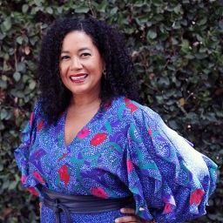
Effie Turnbull Sanders is the USC Vice President of Civic Engagement and Economic Partnerships, where she leads university civic stewardship programs and directs economic inclusion and environmental sustainability initiatives.
Effie has served as a Deputy City Attorney, Assistant General Counsel to the Los Angeles Unified School District, and most recently as Executive Director of the South Los Angeles Transit Empowerment Zone where she implemented comprehensive inclusive economic development programs with over 71 nonprofit and government agency partners. Effie is a Governor’s appointee to the California Coastal Commission and serves on the board of Destination Crenshaw.

Noemí Gallardo
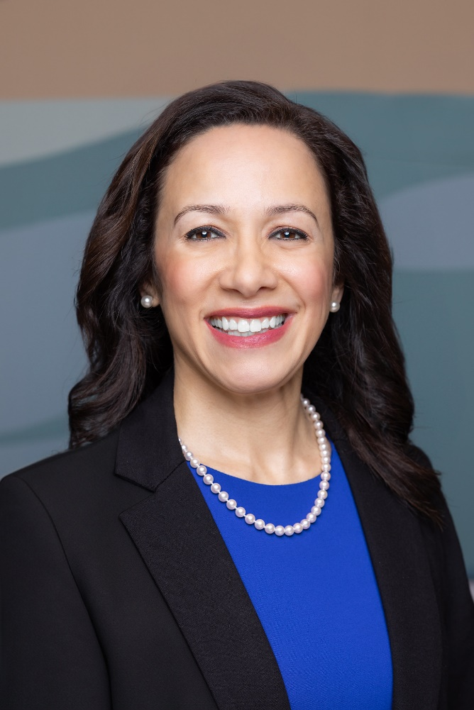
Noemí Gallardo is serving her first term on the California Energy Commission. She was appointed by Governor Gavin Newsom in February 2023 to serve as the CEC’s attorney member. She is the first Latina appointed as a CEC commissioner. Gallardo joined the CEC in 2019 as its Public Advisor. She later became chief of staff for CEC Chair David Hochschild. Before joining the Energy Commission, she was senior manager of public policy at Sunrun Inc. Her professional experiences include serving as a program fellow at the Evelyn and Walter Haas Jr. Fund, a consultant at Gallardo Law and Policy Consulting, an energy and telecommunications legal fellow at the Greenlining Institute, and a principal investigator at the Public Law Research Institute at the University of California College of the Law, San Francisco (UC Law SF, formerly known as UC Hastings). Gallardo is also a state-certified interpreter in Spanish who established and ran a translation and interpretation services business in her native Ventura County. She is the daughter of Mexican immigrants and a proud mother of two. She is a first-generation college graduate who earned a Juris Doctor degree from UC Law SF, a Master of Public Policy degree from the University of Southern California, and a Bachelor of Arts degree from Pepperdine University.

David McNeill
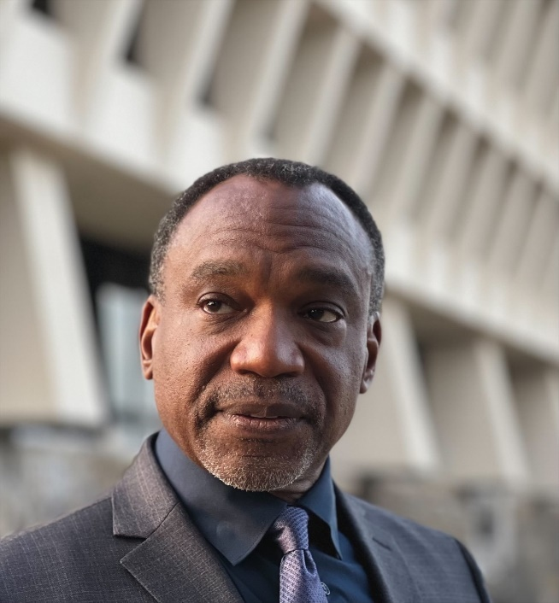
David McNeill is the Executive Officer of the Baldwin Hills Conservancy which operates under the Natural Resources Agency for the State of California. He oversees the long-term acquisition and planned development of approximately two-square miles of industrial open space into much needed parkland for urban Southwest Los Angeles County.
With over 20 years of real estate, public outreach, and administration experience, Mr. McNeill has helped re-imagine the outdoor landscape in underserved communities. Since 2001, he has led a wide range of land acquisition, planning and design efforts culminating in the creation of community-based pocket parks, citizen science, habitat restoration and multi-benefit water quality projects, regional recreation facilities, as well as miles of trails providing access to parkland for the most diverse and densely populated neighborhoods in the State.
As a founding member of the Los Angeles Neighborhood Land Trust, and a supporter of local non-profits, he has been a driving force behind implementing urban environmental initiatives such as the City of L.A.’s landmark Walking to the Park Report and L.A. Audubon Society’s Baldwin Hills Greenhouse Internship Program. Through his work, Mr. McNeill strives to bridge community, public and private partnerships to help sustain new park projects and inspire the next generation of open space stewards.
David is a graduate of Oregon State University with a Bachelor of Science in Speech Communication and a minor in Human Services. He has served as a member of the City of Los Angeles Recycled Water Advisory Group, Safe, Clean Water Stakeholder Advisory Committee, South Coast Air Management District Environmental Justice Advisory Group, L.A. County Appointee to the Community Advisory Panel for the Baldwin Hills Community Standards District Overlay Zone, Board of Directors for the California Invasive Plant Council, and Board of Directors for Nature Nexus Institute.

Lucas Zucker
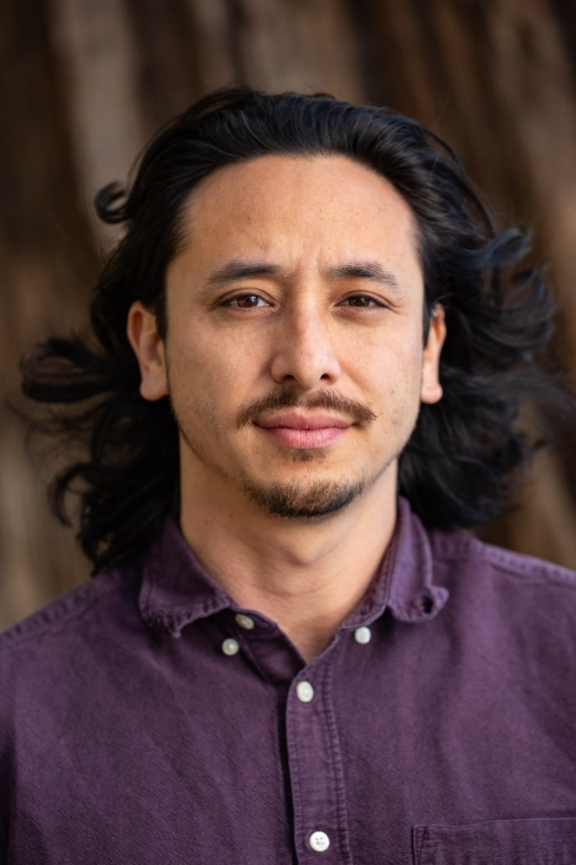
Lucas Zucker is Co-Executive Director at CAUSE. He was raised in Oakland and Ventura, CA and graduated from UC Berkeley with a bachelor’s degree in political economy. First volunteering for CAUSE at 13 years old, Lucas joined the CAUSE staff in 2012 as a youth organizer and researcher and went on to serve as the organization's Policy Director. Lucas was the lead staff member on CAUSE's efforts to stop the Puente power plant from being built in Oxnard, respond to the Thomas Fire disaster, and create the Ventura County Farmworker Resource Program.

Larissa Estes, DrPH
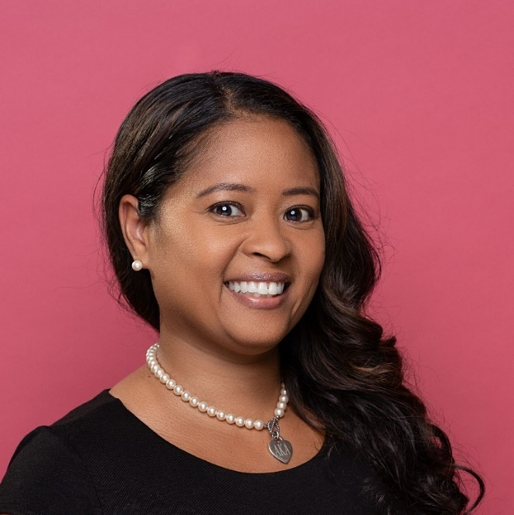
Larissa Estes, DrPH serves as the Executive Director of the Racial Equity Commission established through Executive Order 16-22. She has over 20 years of experience in allied health, healthcare, and public health with a focus on community and equity. Dr. Estes is interested in integrating evidence-informed strategies into policy and practice across sectors that fortify equity and impact community wellbeing. Dr. Estes received her BS in Athletic Training from Duquesne University, an MPH in Family and Child Health from the University of Arizona, and a DrPH in Community Health Practice from the University of Texas Health Science Center, Houston. She is a sustaining member of Junior League of Oakland-East Bay and an active member of Alpha Kappa Alpha Sorority, Incorporated.

Taylor Pennewell
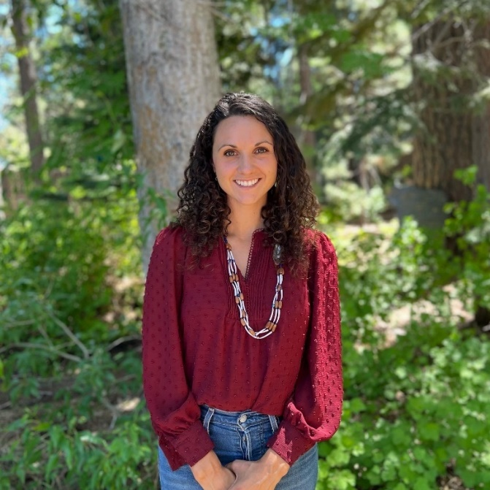
Taylor Pennewell is the Founder and Executive Director of Redbud Resource Group. She is a tribal member at Berry Creek Band of Maidu Indians of California. Taylor has trained thousands of people on ways to build strong tribal relationships that are mutually beneficial for all people and ecosystems. She currently serves on the Governor’s Council for Holocaust and Genocide Education for the state of California.

Amee Raval
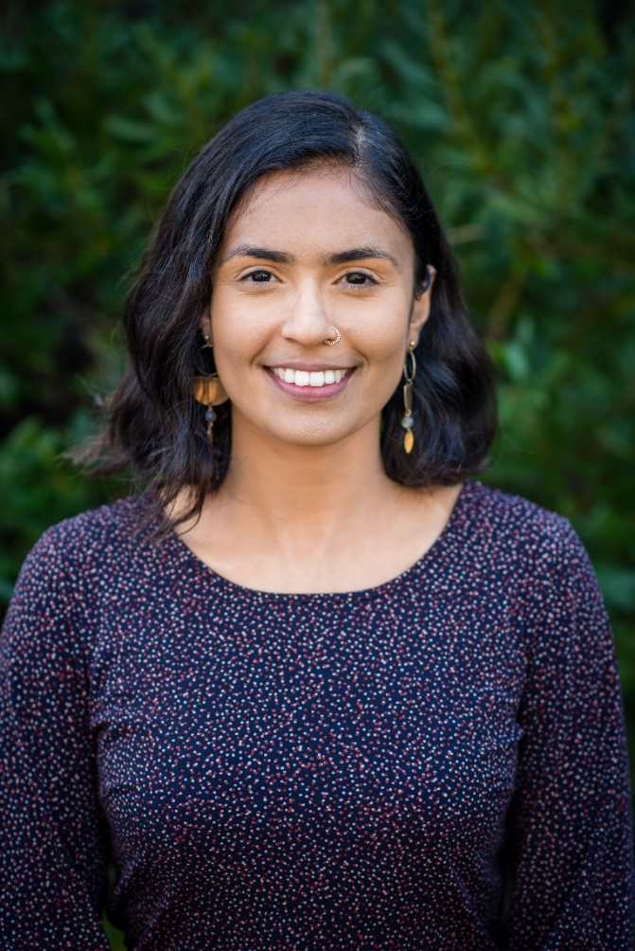
Amee Raval is Policy & Research Director at the Asian Pacific Environmental Network (APEN), an environmental justice organization that empowers Asian immigrant and refugee communities across California through grassroots organizing, voter engagement, and policy advocacy. Through her role at APEN, she offers an environmental justice and health equity lens to climate and energy policy in California. She is the lead author of Mapping Resilience: A Blueprint for Thriving in the Face of Climate Disasters and contributing author to Resilience Before Disaster: The Need to Build Equitable, Community-Driven Social Infrastructure, two foundational reports that are directly influencing statewide decisions to address climate change. In 2021, Amee received the ‘Grist Fixer’ award and was a finalist for the Rachel’s Network Catalyst award. She is an alumna of the Solis Policy Institute, Clean Energy Leadership Institute, and the RWJF Culture of Health Leaders program. Amee holds a Master of Science degree from UC Berkeley School of Public Health.

Closing Comments Speaker

José G. González
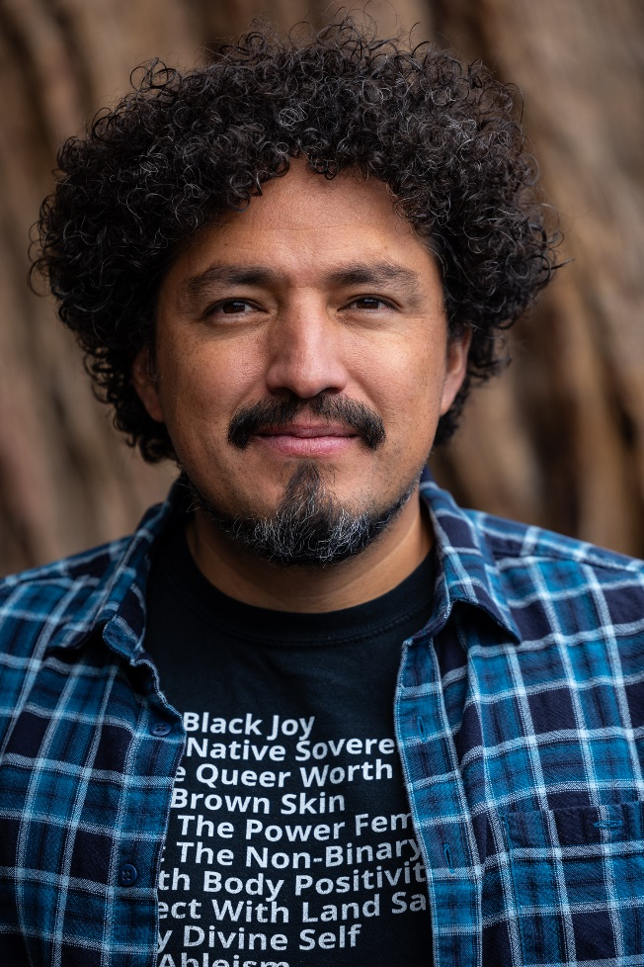
José G. González is a professional educator with training in the fields of education and conservation. He is the Founder of Latino Outdoors as well as having served as a consultant at large as a Partner at the Avarna Group and through his own consulting. His work focuses on Equity & Inclusion frameworks and practices in the environmental, outdoor, and conservation fields. He is also an illustrator and science communicator. He currently serves as the Equity Officer for East Bay Regional Park District.
He received his B.A. at the University of California, Davis, with teaching coursework at the Bilingual, Multicultural, Education Department at Sacramento State. He received his M.S. at the University of Michigan School of Natural Resources & Environment. He serves as a board member at Parks CA as well as a Commissioner for the California Boating & Waterways Commission.

